03 FEB 2026

BLUETOOTH LE IOT DEVICE MANAGER

version:1.0.0

- OVERVIEW:
The Bluetooth LE IoT Device Manager is a VoltMX custom native component designed to demonstrate seamless communication between a VoltMX mobile application and nearby Bluetooth Low Energy (BLE) IoT devices.
This component enables developers to:
- Discover nearby BLE IoT devices
- Display user‑friendly device information
- Connect and disconnect from BLE devices
- Receive real‑time data from connected devices
- Manage Bluetooth permissions and lifecycle clean‑up
The primary goal of this component is to showcase the capabilities of VoltMX in handling real‑time IoT device data transfer using BLE, while remaining fully compliant with iOS and Android platform restrictions.
Note: This component is intended for BLE‑based IoT devices (sensors, wearables, custom hardware, etc.) and does not target classic Bluetooth audio devices.

Requirements:
- Volt MX Iris is installed and configured
- Devices:
- Mobile devices with BLE support

- Platforms:
- Android
- iOS

- GETTING STARTED

- Prerequisites
Before using the Bluetooth LE IoT Device Manager, ensure that:
- Volt MX Iris is installed and configured
- A valid Volt MX account is available
- BLE‑enabled mobile devices are available for testing
- IoT devices support Bluetooth Low Energy (BLE) - We have attached the same application(IoT device application) for testing purposes.
- Create a sample app and import the Component
To import the Bluetooth LE IoT Device Manager into your workspace, follow these steps:
- Open Volt MX Iris.
- Click on project ->New Project
- Select the Native app and click on Next.
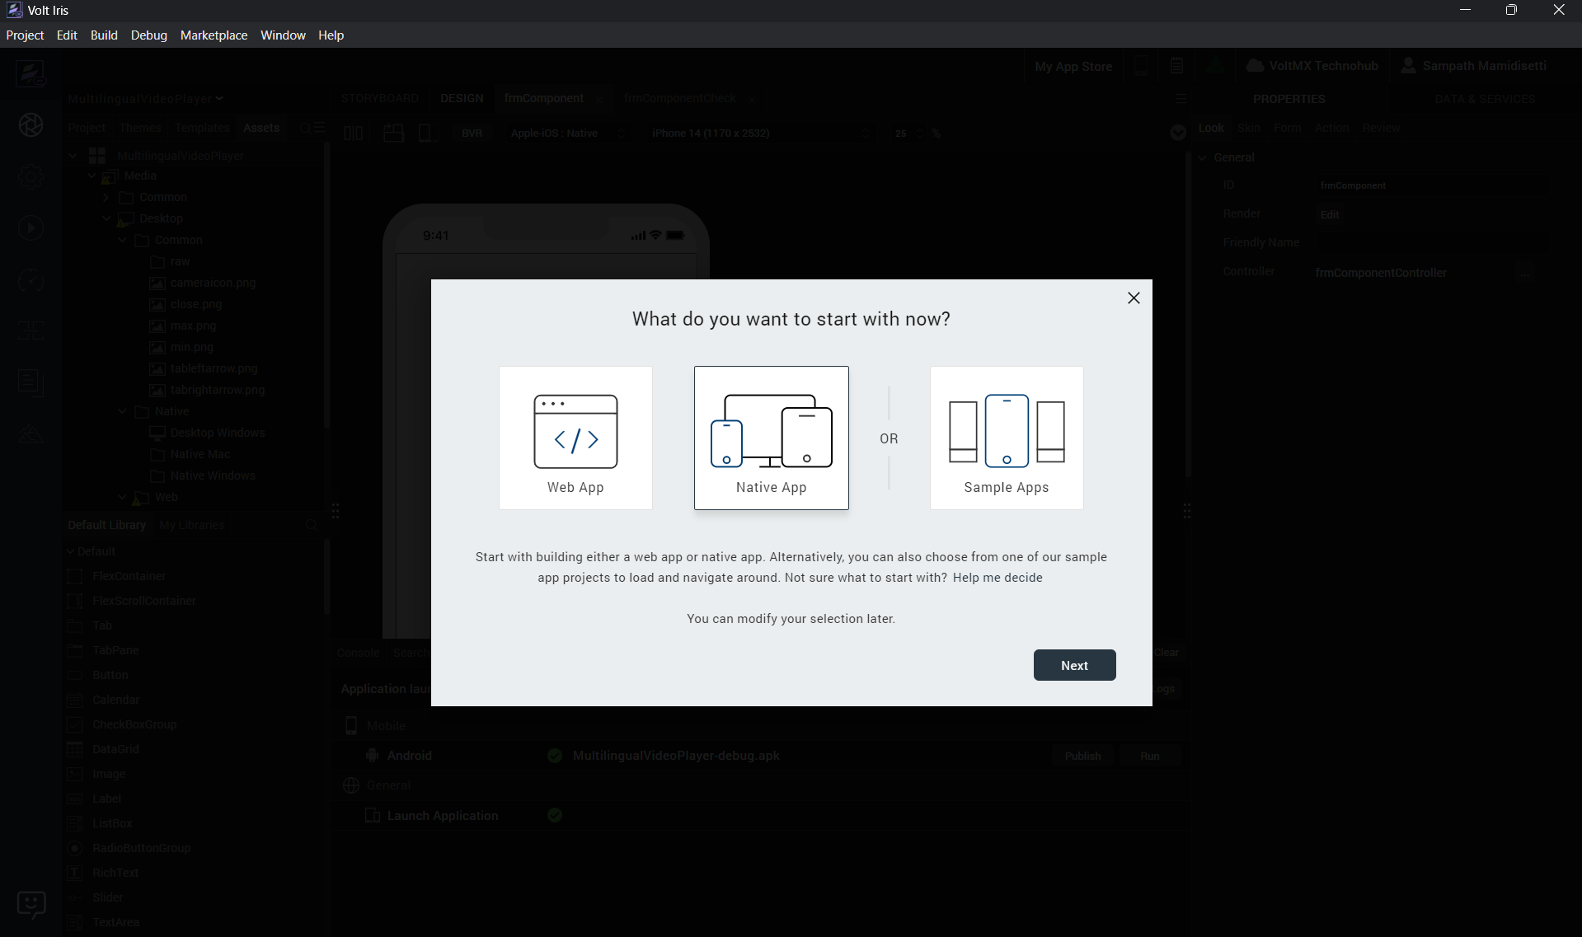
- Select Mobile and click on Next.
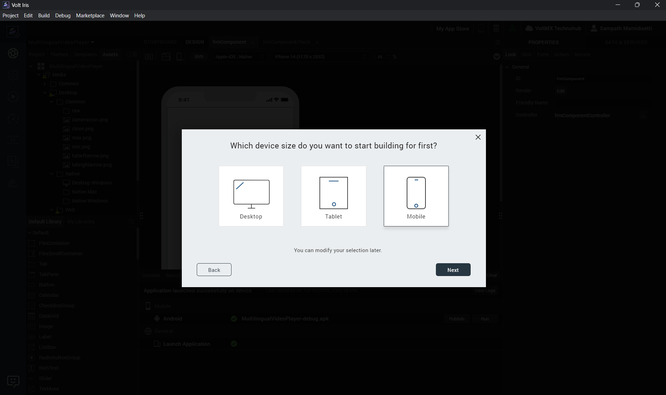
- Provide the name of the project and click on create.
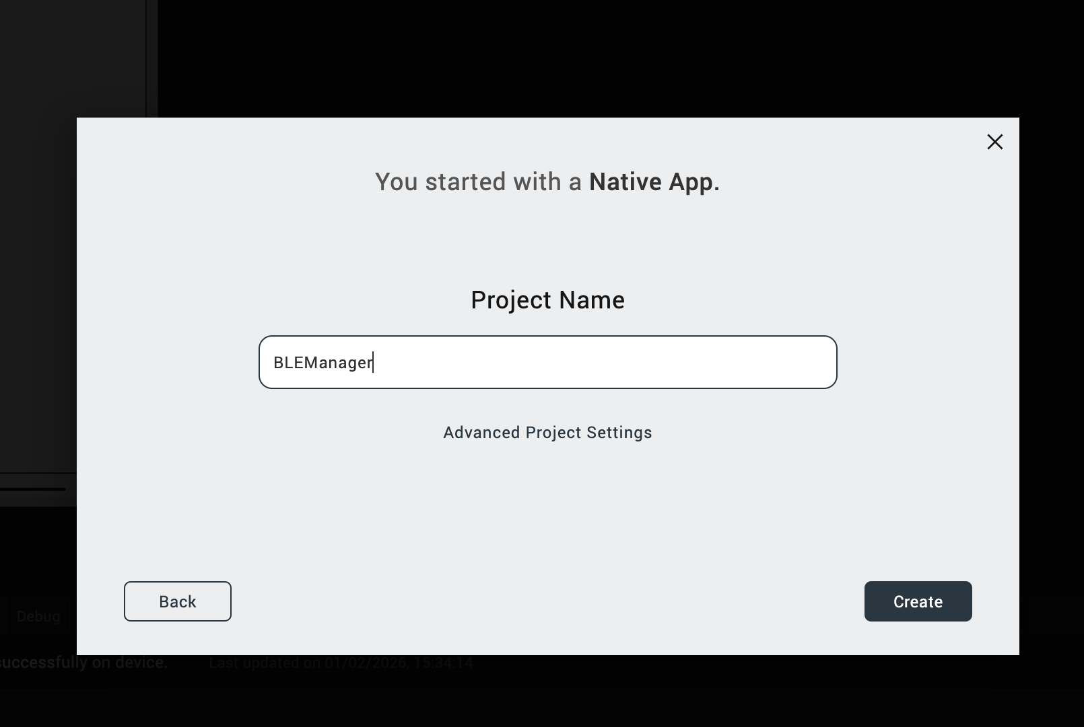

- Create forms in Mobile. example: frmHome
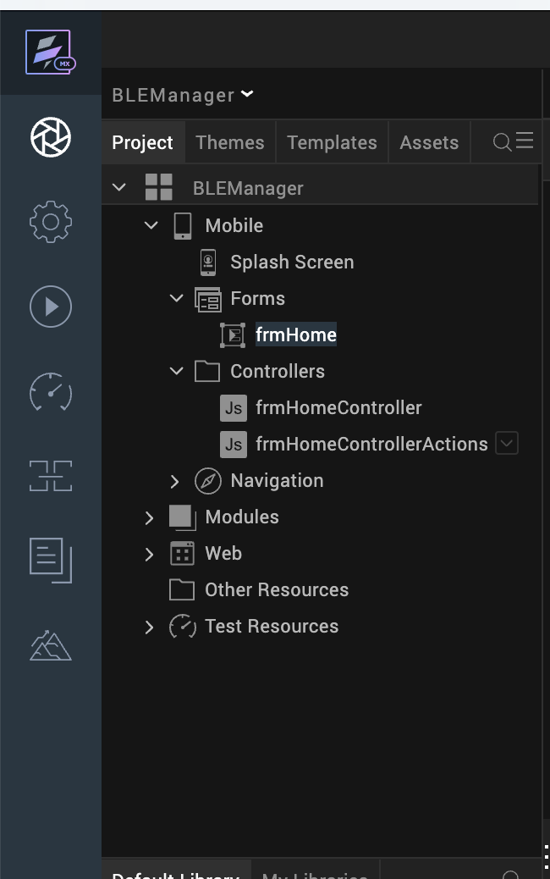

- Go to templates, components, Import Component.
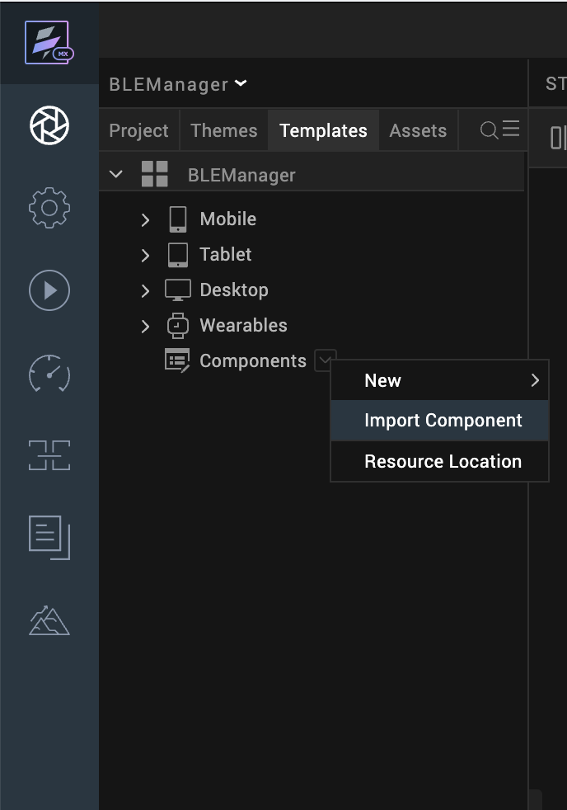

- Browse, select the component and Import.
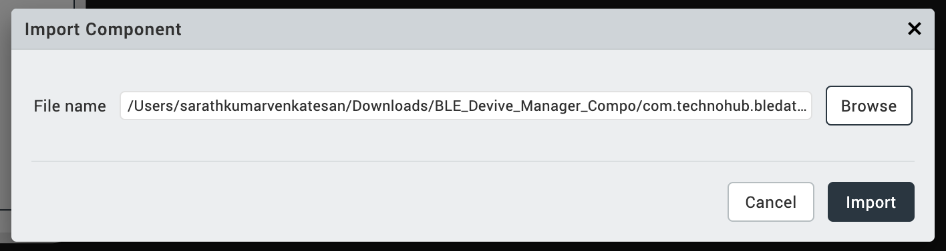

- In the components section, bledevicemanager will be available and ready to use.
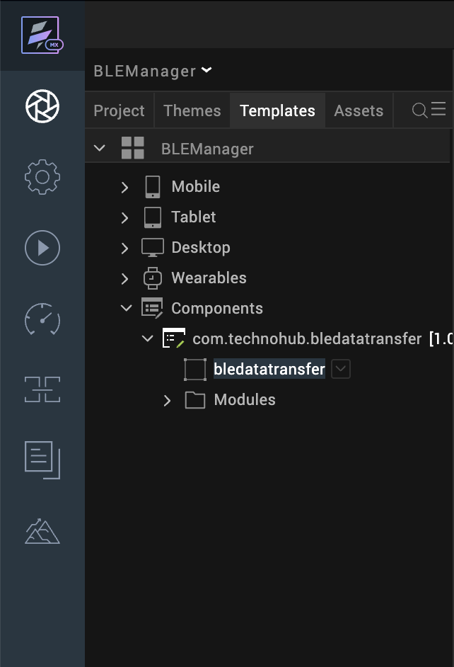

- Insert the component in to Mobile form respectively. For more information, refer to Add a Component to a Form

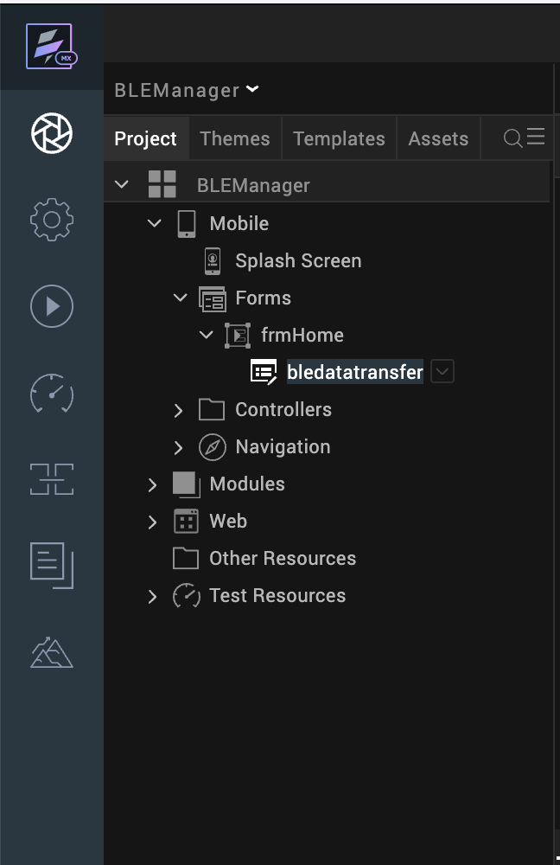

- Add the below Tags in the project settings for Android.
Paste the below in the following location
<uses-permission android:name="android.permission.BLUETOOTH_SCAN"/>
<uses-permission android:name="android.permission.BLUETOOTH_CONNECT"/>
Open project settings -> Native -> Android Mobile/Tablet -> Scroll to the bottom -> Tags -> Child Tag Entries Under Manifest
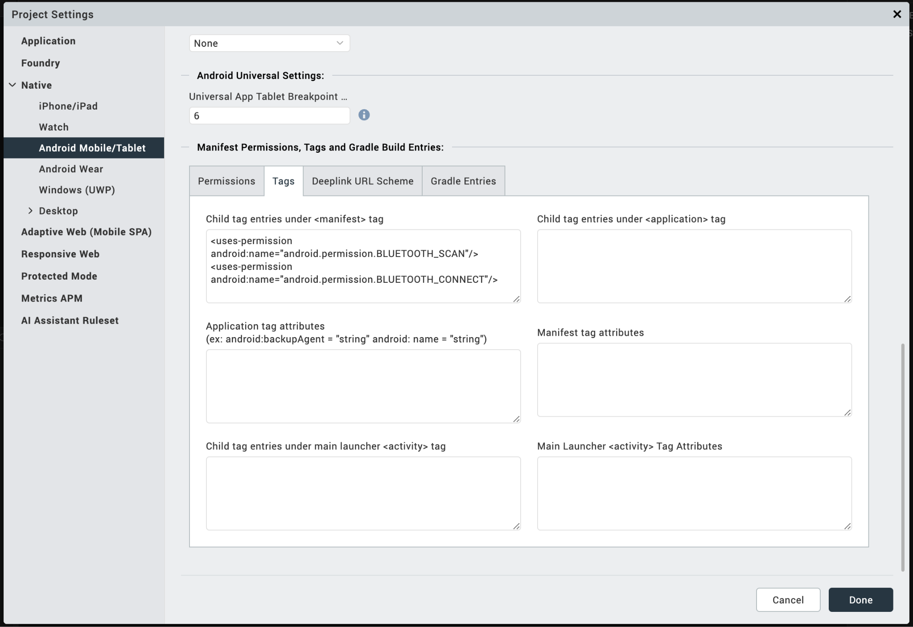

- Add the below Permissions in the project settings for Android.
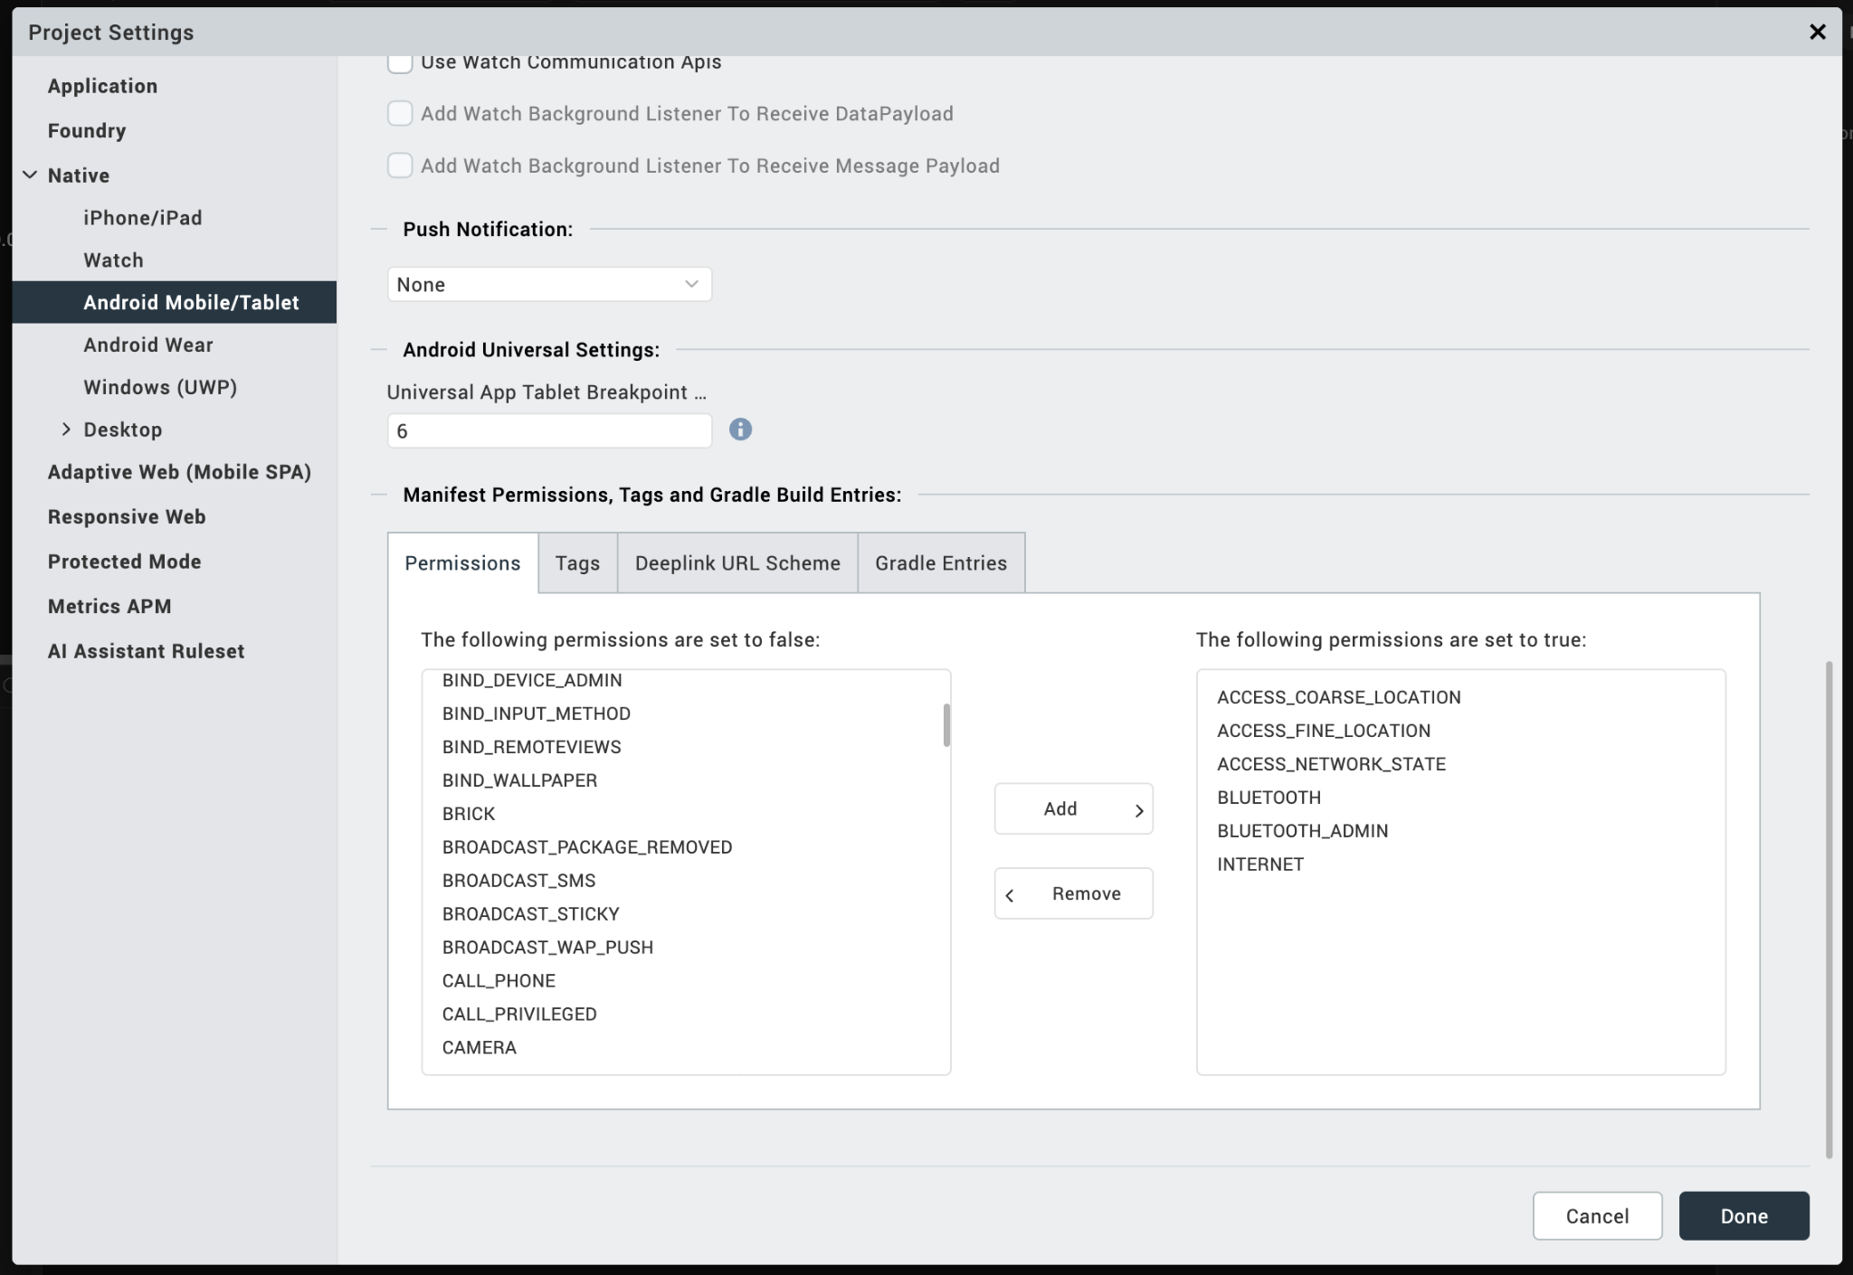
- After successful import of the component, check for the iOS NFI
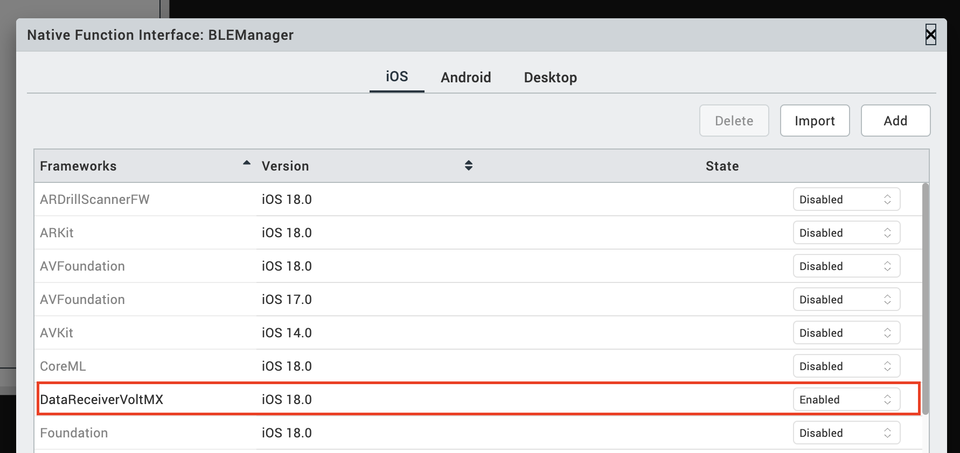
If not, please add them manually from the component zip folder

- After successful import of the component, check for the Android NFI on below path.
Android Library Path: BLEManager/resources/customlibs/lib/android/blescanner-debug.aar
If not, please add them manually from the component zip folder

- Add the below iOS permission in the infoplist_configuration.json file in the path below path
BLEDataTransfer/resources/common/infoplist_configuration.json
{
"NSBluetoothAlwaysUsageDescription": "This is a dummy description"
}
- Events.
- permissionCallBack Triggered when Bluetooth permission status is evaluated on the device.
  - Purpose:
    - Notify the application whether Bluetooth permission is granted or denied
  - Usage:
    - this.view.bledevicemanager.permissionCallback = function(){};

- Methods.
- initDependencies – Initialises Bluetooth dependencies and prepares the BLE manager for operation.
Example usage:
var callbacks = {
onStatusUpdate: this.updateStatusLabel,
onDevicesUpdate: this.populateDeviceList,
onDataReceived: this.displayReceivedData
};
this.view.bledevicemanager.initDependencies(callbacks);

- getConnectedDeviceAddress – Returns the unique identifier (UUID) of the currently connected BLE device.

Example Usage:
let getConnectedDevice = this.view.bledevicemanager.getConnectedDeviceAddress();

- startScan – Starts scanning for nearby BLE IoT devices.

Example Usage:
this.view.bledevicemanager.startScan();
- stopScan – Stops the ongoing BLE device scan.

Example Usage:
this.view.bledevicemanager.stopScan();

- connectToDevice – Connects to a BLE device selected from the scanned device list.

Example Usage:
this.view.bledevicemanager.connectToDevice(index);

- disconnect – Disconnects from the currently connected BLE device.

Example Usage:
this.view.bledevicemanager.disconnect();

- cleanup – Cleans up all BLE resources, stops scanning, disconnects devices, and clears cached data.

Example Usage:
this.view.bledevicemanager.cleanup();

- checkPermission – Checks whether Bluetooth permissions are granted and triggers the permission callback.

Example Usage:
this.view.bledevicemanager.checkPermission();

- Building and previewing the app.
After performing all the above steps, you can build your app and run it on your device. For more information, you can refer to the Building and Viewing an Application section of the Volt MX User Guide.

- SAMPLE IOT APPLICATION (DEVELOPER REFERENCE)
A sample IoT application attached below helps developers quickly understand the usage pattern.
Android:
Mac App:
- Application Flow.
Mobile Device
- Launch the application
- Grant Bluetooth permission when prompted
- Start scanning for nearby IoT devices
- Select a device from the list
- Connect and receive data
- Disconnect or clean up when done
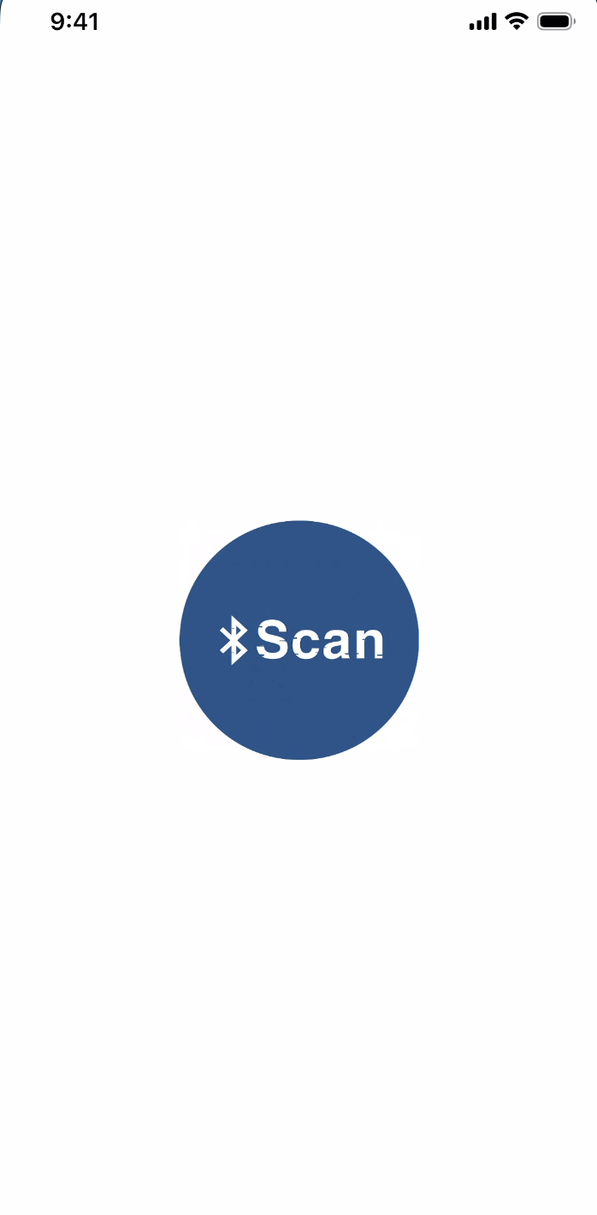
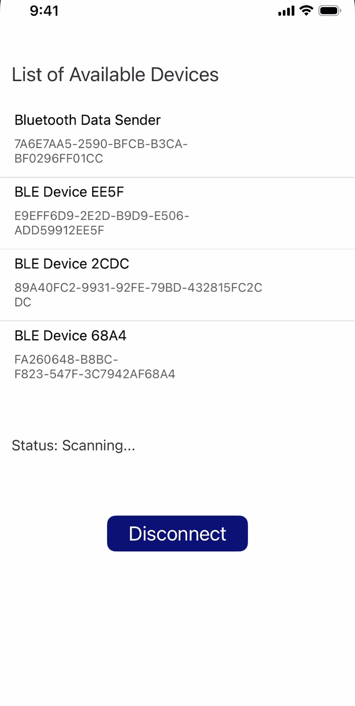

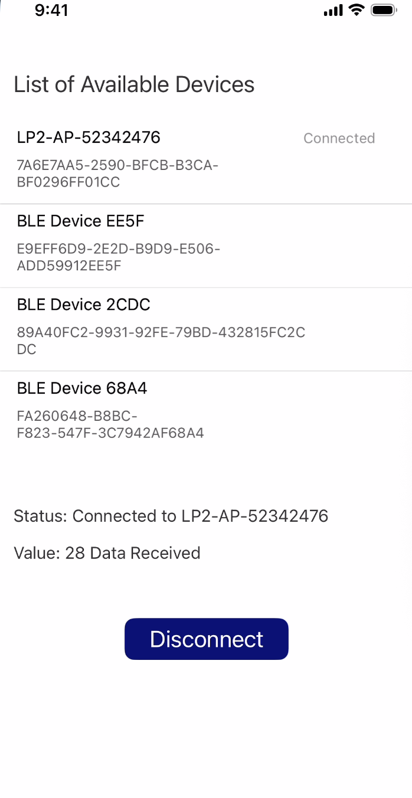

3. REVISION HISTORY

A. Limitations:
- Supports BLE IoT devices only
- Classic Bluetooth audio devices are not supported
B. Known issues:
None

