Date :  14-March-24

Bing News Search

version: 1.0.1

# **Overview**

This Bing News Search data adapter enables seamless integration of Bing's News Search functionality within your application.

The Bing News Search Adapter helps user turn his/ her app into a news search resource with various news grouped and filtered by area, topic, and metadata.

After you create the necessary operations, you can integrate your mobile app with the integration service that you created with Bing News Search data adapter.

## **Features:**

* Send a search query to Bing and get back a list of relevant news articles with details like provider info, date added, article URL/ image, related news and categories
* Search news by topics like Politics, Sports etc.
* Get trending news topics by region and category

## **Percentage of re-use:**

70% (Data can be customizable and customer need to implement UI by themselves).

# **Getting Started**

## **Prerequisites**

Before you start using the **Bing News Search** data adapter, ensure you have the following:

* [HCL Foundry](https://manage.hclvoltmx.com/)
* Volt MX Iris
* [Microsoft account](https://portal.azure.com/)
* Ocp-Apim-Subscription-Key to use the APIs issued by Microsoft

## **Importing the Bing News Search Data adapter**

To import the **Bing News Search** Data Adapter to Volt MX Foundry, do the following:

1. Sign in to the  [HCL Foundry](https://manage.hclvoltmx.com/)
2. In the left pane, click the **API Management** menu. The **APIs** tab opens by default.
3. In **API Management**, select **Custom Data Adapters**.

1. Click **IMPORT** to import a custom data adapter.

1. On the Import Data Adapter dialog box, click browser to import.

1. Drag the data adapter zip file into the **Drag a Data Adapter** box.

Or

Click **browse**. The **Open** dialog appears.

Navigate to the location where you downloaded the data adapter (zip file) on your computer, select the data adapter, and click **Open**. The **Import Data Adapter** dialog shows the selected data adapter.

**Note:**Click **Remove** if the selected data adapter is not the one that you want to import.

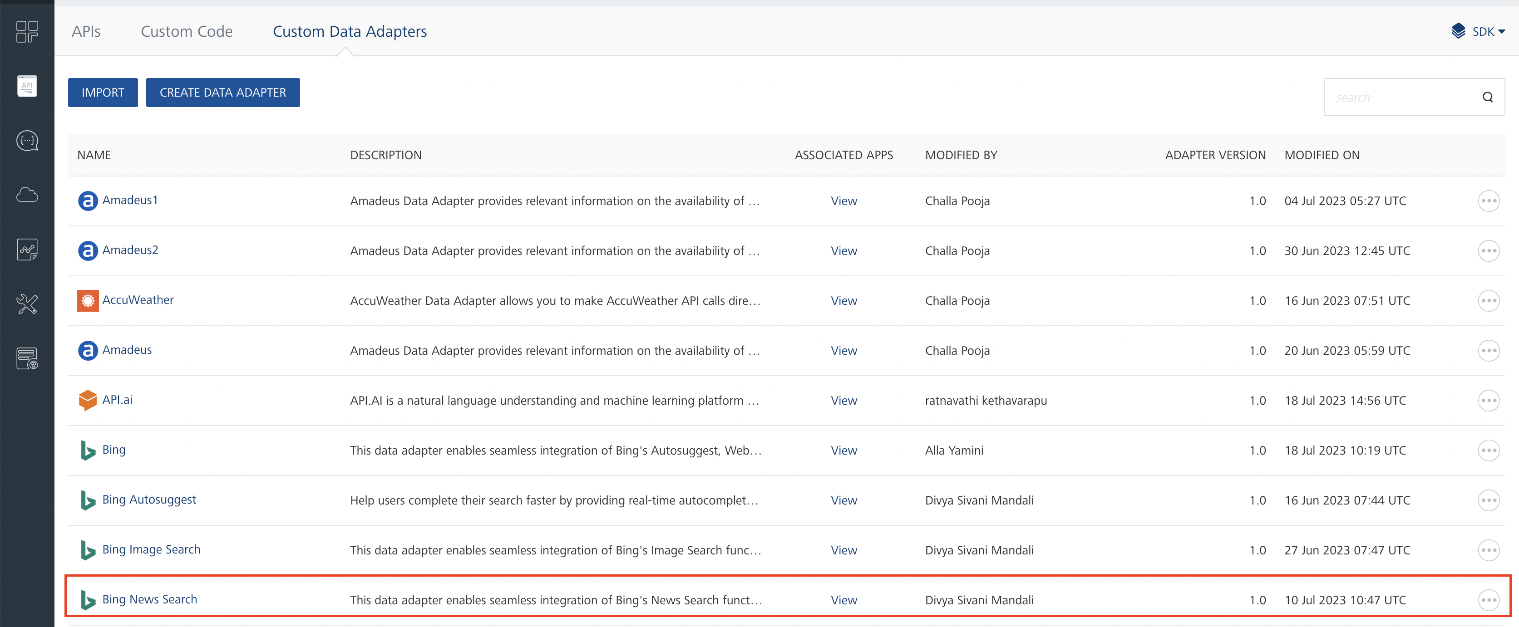

**OR**

**To import the data adapter zip file, do the following:**

1. Perform steps 1 through 4 in the above procedure
2. Click **IMPORT FROM HCL FORGE**. The **Import Data Adapter** from **HCL Forge** dialog appears with a list of available data adapters.
3. Click **Import**. The **Bing News Search**data adapter is listed on the **Custom Data Adapters** page.



After you import the data adapter, you can view it on the Custom Data Adapters page and use it to create services on Volt MX Foundry.

After you add the data adapter to your Volt Foundry app, you need to get your Ocp-Apim-Subscription-Key. You can refer to [Bing developer site](https://www.bing.com/partners/developers).

## **Creating an Integration Service with Bing News Search**

After you import **Bing News Search**Data Adapter into Volt MX Foundry, you must create an integration service with service type as **BingNewsSearch**to connect with your [Bing developer site](https://www.bing.com/partners/developers).

**To create an integration service with Bing News Search, do the following:**

1. Log on to your [HCL Foundry](https://manage.hclvoltmx.com/) The **Dashboard** page appears by default.
2. In the left pane, click the **API Management** menu. The **APIs** tab opens by default.
3. Click the **Integration** tab. The **Integration** tab opens with a list of existing integration services.
4. Click **CONFIGURE NEW**. The **Service Definition** tab opens.
5. In the **Name** box, type a unique name for your service.
6. From the **Service Type** list, select **Bing News Search**.

**Note:**The **Bing News Search**is listed only after you import the Bing News Search Data Adapter into Volt MX Foundry.

1. Under **Authentication** select **Use Existing Identity provider**. From the drop-down list select **Bing News Search**.

1. Click **Save**.

If the details provided are valid, the Volt MX Foundry service connects to your Bing developer site and allows you to make the API calls.

Refer to [Integration Services](https://opensource.hcltechsw.com/volt-mx-docs/docs/documentation/Foundry/vmf_integrationservice_admin_console_userguide/Content/Integration_Services.html) for more information on creating and using integration services.

## **Creating an Operation**

To make any API call in the Volt MX Foundry console, you must create an operation for the respective API and then execute the operation. Executing an operation involves making the API call and displaying the response. For more information, see Executing an Operation.

This section provides steps to create an operation for the **Search** API.

**Steps to create an operation for the Search** **API:**

1. Log on to your [HCL Foundry](https://manage.hclvoltmx.com/). The **Dashboard** page appears by default.
2. In the left pane, click the **API Management** menu. The **APIs** tab opens by default.
3. Click the **Integration** tab. The **Integration** page appears with a list of existing integration services.
4. From the list of integration services, select the integration service that you have created with service type as **BingNewsSearch**. The **Service Definition** tab of the selected integration service opens by default.
5. Click the **Operations List** tab. The **Operations List** tab opens.
6. Click the context menu arrow to expand the **Please Select** list. The **News Search API V7**services is displayed.
7. Click the plus icon to expand the **News Search API V7**list.
8. Click the plus icon to expand the **Services** list and select **Search**.

1. Click **ADD OPERATION**. The **Search** operation is listed in the **Configured Operations** section.  
     
   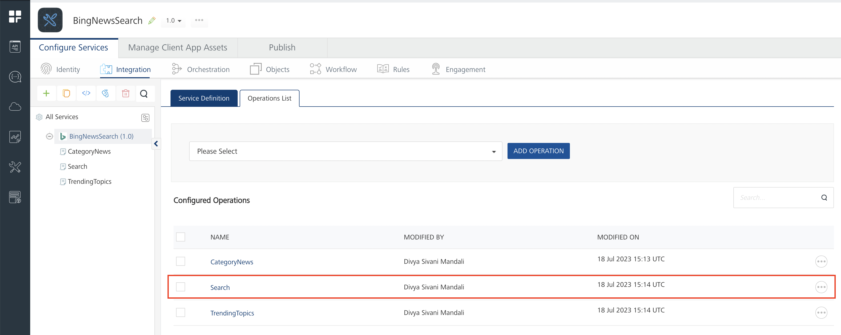

**Note:**You can follow the same steps to create operations for other methods, but ensure that you select the required API.

You can create multiple operations with required APIs and save them in the **Configured Operations** section. You can then execute the operations whenever required.

## **Executing an Operation**

Executing an operation involves making the API call by setting the necessary parameters and displaying the response. The procedure to execute any operation is same, but the request parameters of the APIs vary. For more information on request parameters of each API, refer [Bing News API Catalog](https://www.microsoft.com/en-us/bing/apis/bing-news-search-api).

This section provides steps to execute the **Search** operation (explained in Creating an Operation).

**Steps to execute the Search operation:**

1. Log on to your [HCL Foundry](https://manage.hclvoltmx.com/). The **Dashboard** page appears by default.
2. In the left pane, click the **API Management** menu. The **APIs** tab opens by default.
3. Click the **Integration** tab. The **Integration** tab opens with a list of existing integration services.
4. From the list of integration services, select the integration service that you have created with service type as **BingNewsSearch**. The **Service Definition** tab of the selected integration service opens by default.
5. Click the **Operations List** tab.
6. Under the **Configured Operations** section, click the **Search** operation. The **Search** tab opens with the **Request Input** sub-tab opened by default.

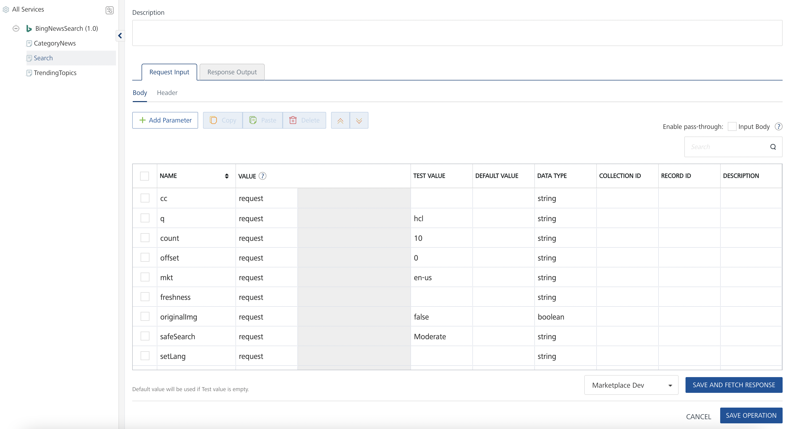

1. In the **Name** box, the name of the operation is displayed by default. If you want, you can change the name.
2. On the **Request Input** tab, in the **Body** section, for the following parameters, specify the values in the respective boxes under the **Test Value** column.

**Mandatory Parameters**

* + **q:** It takes string values.

1. Click **Header** sub-tab. The **Header** section opens.
2. Click **Add Parameter**. A new row adds to provide parameter values.
3. In the box under the **NAME** column, type **Ocp-Apim-Subscription-Key**.
4. In the boxes under the **TEST VALUE** and **DEFAULT VALUE** columns, type the **API Key** generated from Microsoft Azure.
5. Click **SAVE OPERATION**.
6. Click **SAVE AND FETCH RESPONSE**. The **Output Result** dialog appears with the response. Otherwise, the **Output Result** shows an error.

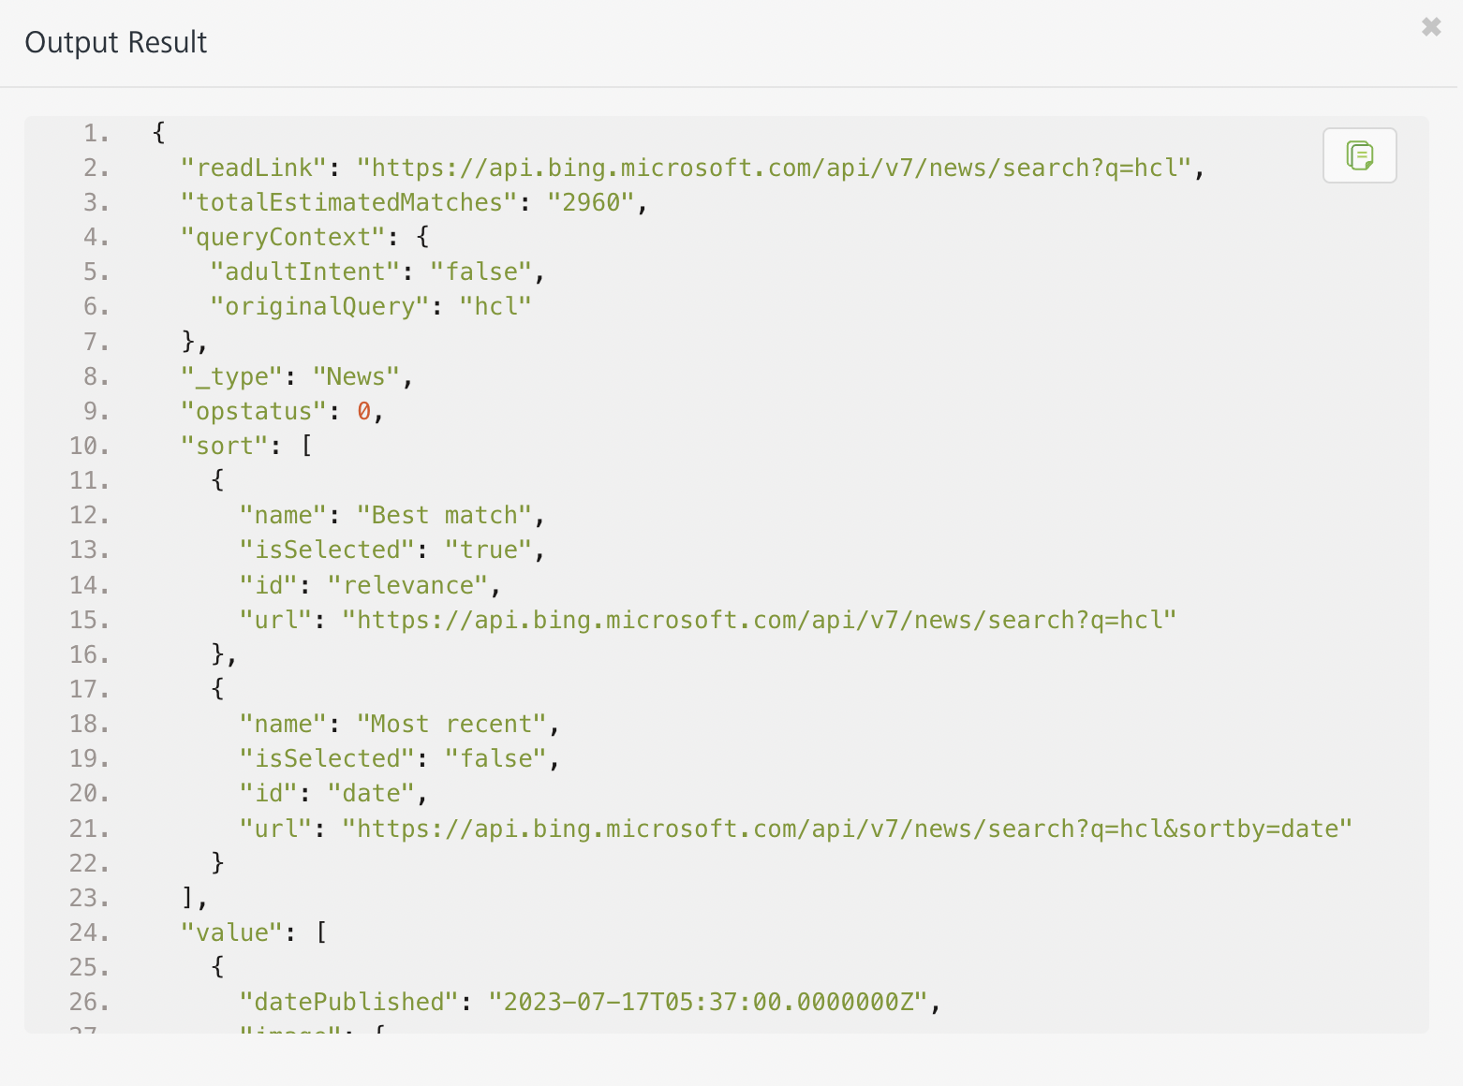

## 

## **Publishing the App to Volt MX Foundry**

After adding the Bing News Search Data Adapter to your app and configuring the necessary configurations, you must publish the app to Volt MX Foundry. For more information, refer to [Publish a Project to Volt MX Foundry.](https://opensource.hcltechsw.com/volt-mx-docs/docs/documentation/Iris/iris_user_guide/Content/PublishVoltMXFoundryServicesApp.html)  
  
If you want to use the services in client applications, you need to publish the app to a run-time environment.

You can also link the Volt Foundry app to a client application.

# **References**

## **Properties**

* + - None of the properties are exposed.

## **Events**

* + - None of the events are exposed.

## **API’s**

* + - None of the APIs are exposed.

# **Revision History**

App version 1.0.1:

## **Known Issues**

None

## **Limitations**

None