15 Feb 2022

Legacy Barcode/QR Code Scanner (2.0.0)

Overview
The Legacy Barcode/QR Code Scanner component can scan and decode barcodes. Under the hood, the component contains NFIs that use the Google Mobile Vision: Barcode API. The component also supports continuous scanning and automatic rendering. It works with NFI 3.0 and Temenos Quantum 9.x.

Use case
1. An event organizer app, where a user needs to continuously scan barcodes on passes and allow entry to the attendees.
2. A calendar app that adds events to a user's calendar using the QR Code of the event

Percentage of re-use: 90%

Features
- The component utilizes Google Mobile Vision's Barcode API for decoding barcodes and QR codes
- It automatically parses QR Codes, Data Matrix, PDF-417 and Aztec values for following supported formats:
  - URL
  - Contact information (VCARD etc.)
  - Calendar event
  - Email
  - Phone
  - SMS
  - ISBN
  - WIFI
  - Geo-location (latitude and longitude)
  - AAMVA driver license/ID
- Updated to NFI 3.0

Getting Started

Prerequisites
Before you start using the Barcode/QR Code Scanner component, ensure the following:

• Temenos Fabric

• Quantum Visualizer

Platforms Supported

Mobile

iOS

Android

Tablets

Importing the app

You can import the Forge components only into the apps that are of the Reference Architecture type.

To import the Barcode/QR code Scanner component, do the following:

Open your app project in Quantum Visualizer.
2. In the Project Explorer, click the Templates tab.
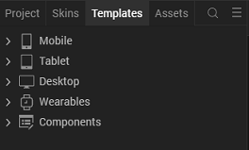
3.Right-click Components, and then select Import Component. The Import Component dialog box appears.
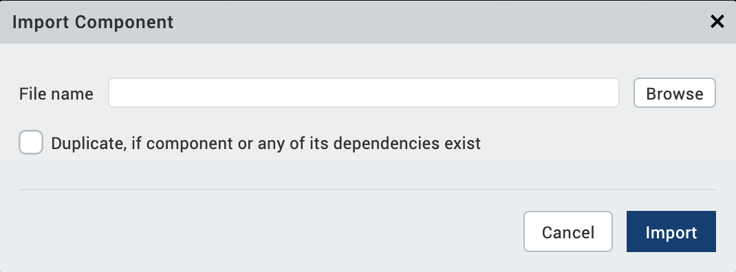
4.Click Browse to navigate to the location of the component, select the component, and then click Import. The component and its associated widgets and modules are added to your project.

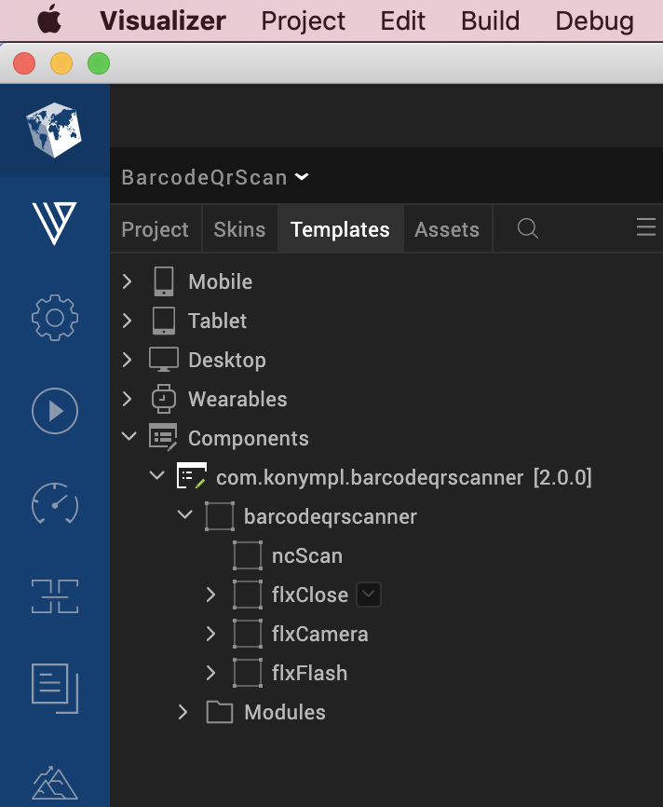
Once you have imported a component to your project, you can easily add the component to a form.

Building and previewing the app
After performing all the above steps, you can build your app and run it on your device. For more information, you can refer to the Build and Run your app section of the Quantum Visualizer User Guide.
You can then run your app to see the Barcode/QR Code Scanner work in real time.

References

Dynamic Usage
You can also add Barcode/QR Code Scanner component dynamically. To do so,

1. In the Project Explorer, on the Projects tab, click Controllers section to access the respective Form Controller. Create a method and implement the code snippet similar to the sample code mentioned below.

/* Creating Barcode/QR Code Scanner component instance */

var barcodeqrscanner = new com.konympl.barcodeqrscanner(
{
id: "barcodeqrscanner",
isVisible: true,
height: "45%"
top: "0dp",
left: "0dp",
width: "100%",
layoutType: kony.flex.FREE_FORM,
autogrowMode: kony.flex.AUTOGROW_NONE,
skin: "slFbox",
clipBounds:true,
zIndex:1
}, {}, {});

/*Adding the Barcode/QR Code Scanner component to a Form*/

this.view.add(barcodeqrscanner);

/* Displaying result after scanning barcode/qrcode */

this.view.barcodeqrscanner.afterScanCallback = () =>{
alert(this.view.barcodeqrscanner.getScanResult());
};

In the code snippet, you can edit the properties of the component as per your requirement.
2. Save the file

Configuring Native Settings (IOS)
To configure the native settings for iOS, follow these steps:
- From the Project explorer, go to Assets and expand Media.
- Right-click Common, and then select Resource Location. Quantum Visualizer opens the common resources folder in a file explorer.
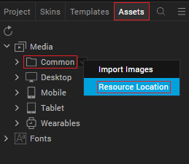
- Open the infoplist_configuration.json file with a text or code editor.
- At the end of the file, type the following code. You can change the description based on your preference.
"NSCameraUsageDescription" : "Your Description"

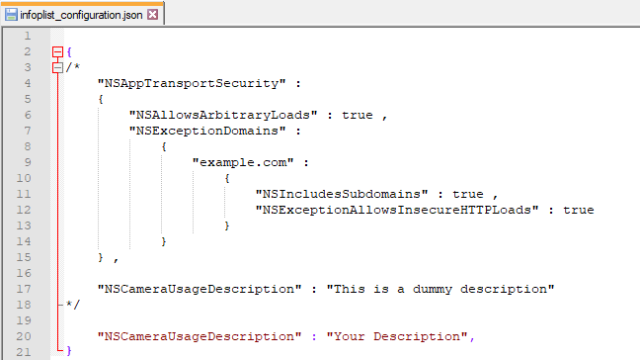

5. Save the file.

Configuring Native Settings (Android)

To configure the native settings for Android, follow these steps:
1. From the left navigation menu, click Project Settings.
2. In the Project Settings window, go to Native → Android Mobile/Tablet.
3. Set the CAMERA permission to true.
To set a permission to true, select the permission from the left panel, and then click Add >.
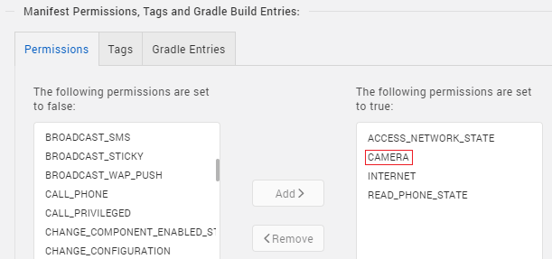
4. Switch to the Gradle Entries tab.
5. In the build.gradle entries to Suffix box, type the given code based on the version of the component.
dependencies{
implementation 'com.tbruyelle.rxpermissions2:rxpermissions:0.9.4@aar'
implementation 'io.reactivex.rxjava2:rxjava:2.1.5'
implementation 'com.google.android.gms:play-services-base:11.6.0'
implementation 'com.google.android.gms:play-services-basement:11.6.0'
implementation 'com.google.android.gms:play-services-tasks:11.6.0'
implementation 'com.google.android.gms:play-services-vision:11.6.0'
}

NOTE : 1. If you do not add the gradle entries to your project , the app crashes.
2. you can update the Play Services version in the later builds of your app.

To add NFI 3.0 in android follow the steps:

- Copy the aar/jar from the NFI zip, Delete existing Android NFI zip.
- Paste that jar/aar that has been separated in step 1, at <project>/resources/customlibs/Android folder.
NOTE: If customlibs folder is not present then create it.

General Properties

1. Camera Facing (cameraFacing)

Description: | Specifies the camera that the component should use to scan codes.
Syntax: | cameraFacing
Type: | List Selector, String
Read/Write: | Read + Write
Example: | this. view. barcodeqrscanner. cameraFacing = "Back";
Remarks: | The default value for the property is “Back”.

2. Render Automatic(renderAutomatic)

Description: | Specifies whether you want to render the scanner by default.
Syntax: | renderAutomatic
Type: | Boolean
Read/Write: | Read + Write
Example: | this. view. barcodeqrscanner. renderAutomatic = true;
Remarks: | The default value for the property is “true”.

3. Enable Continuous Scanning (enableContinuousScanning)

Description: | Specifies whether the camera should remain open after scanning a code.
Syntax: | enableContinuousScanning
Type: | Boolean
Read/Write: | Read + Write
Example: | this. view. barcodeqrscanner. enableContinuousScanning = true;
Remarks: | - If you want the camera to scan codes continuously, set the Enable Continuous Scanning property to true, and then use the afterScanCallback event to call the resumeScan API.  - If the Enable Continuous Scanning property is false, then the component closes the camera after scanning a code.  - The default value for the property is “true”.

4. Close Button Visibility (closeButtonVisibility)

Description: | Toggles the visibility of the close button of the scanner.
Syntax: | closeButtonVisibility
Type: | Boolean
Read/Write: | Read + Write
Example: | this. view. barcodeqrscanner. closeButtonVisibility = true;
Remarks: | The default value for the property is true.

5. Close Button Image (closeButtonImage)

Description: | Specifies the image that you want to use for the close button of the scanner.
Syntax: | closeButtonImage
Type: | Image, String
Read/Write: | Read + Write
Example: | this. view. barcodeqrscanner. closeButtonImage = “close.png”;
Remarks: | - If you want to use a local file, make sure that the file exists in the workspace\resources\common directory.  - The default value for the property is “close.png”.

6. Flash Button Visibility (flashButtonVisibility)

Description: | Toggles the visibility of the flash button of the scanner.
Syntax: | flashButtonVisibility
Type: | Boolean
Read/Write: | Read + Write
Example: | this. view. barcodeqrscanner. flashButtonVisibility = true;
Remarks: | The default value for the property is true.

7. Flash Button Image (flashButtonImage)

Description: | Specifies the image that you want to use for the flash button of the scanner.
Syntax: | flashButtonImage
Type: | Image, String
Read/Write: | Read + Write
Example: | this. view. barcodeqrscanner. flashButtonImage = “flash.png”;
Remarks: | - If you want to use a local file, make sure that the file exists in the workspace\resources\common directory.  - The default value for the property is “flash.png”

8. Camera Toggle Visibility(cameraToggleVisibility)

Description: | Toggles the visibility of the camera toggle button of the scanner.
Syntax: | cameraToggleVisibility
Type: | Image, String
Read/Write: | Read + Write
Example: | this. view. barcodeqrscanner. cameraToggleVisibility= true;
Remarks: | The default value for the property is true.

9. Camera Toggle Image (flashButtonImage)

Description: | Specifies the image that you want to use for the camera toggle button of the scanner.
Syntax: | cameraToggleImage
Type: | Image, String
Read/Write: | Read + Write
Example: | this. view. barcodeqrscanner. cameraToggleImage = “switch_cam.png”;
Remarks: | - If you want to use a local file, make sure that the file exists in the workspace\resources\common directory.  - The default value for the property is “switch_cam.png”

B. API

i.renderScan

Description: | Renders the barcode scanner on the device.
Syntax: | renderScan ()
Parameters: | None
Return Value: | None
Remarks: | Use the API to manually render the scanner when the Render Automatic property is false.
Example: | this. view. barcodeqrscanner . renderScan ();

ii.resumeScan

Description: | Resumes the scanning process of the component.
Syntax: | resumeScan ()
Parameters: | None
Return Value: | None
Remarks: | If you want the camera to scan codes continuously, set the Enable Continuous Scanning property to true, and then use the afterScanCallback event to call the resumeScan API.
Example: | this. view. barcodeqrscanner . resumeScan ();

iii.stopScan

Description: | Stops the scanning process of the component.
Syntax: | stopScan ()
Parameters: | None
Return Value: | None
Example: | this. view. barcodeqrscanner . stopScan ();

iv.flashControl

Description: | Toggles the flashlight of the camera during the scanning process.
Syntax: | flashControl ()
Parameters: | None
Return Value: | None
Example: | this. view. barcodeqrscanner . flashControl ();

v.getScanResult

Description: | Used to get the value of the scanned barcode/Qr code.
Syntax: | getScanResult()
Parameters: | None
Return Value: | String or Object
Example: | this. view. barcodeqrscanner . getScanResult();

C. Events

1. afterScanCallback

Description: | Invoked after the component scans and decodes a barcode or a QR code.
Syntax: | afterScanCallback
Parameters: | None
Remarks: | If you want the camera to scan codes continuously, set the Enable Continuous Scanning property to true, and then use the afterScanCallback event to call the resumeScan API.
Example: | this.view.barcodeqrscanner.afterScanCallback = function(){  alert("Result : " + this.view.barcodeqrscanner.getScanResult());  };

2. onClickClose

Description: | Invoked when the user taps the close button of the scanner.
Syntax: | onClickClose
Parameters: | None
Example: | this.view.barcodeqrscanner.onClickClose= function () {  alert(“Closing the scanner”);  };

3. errorCallback

Description: | Invoked when an error occurs in the component.
Syntax: | errorCallback
Parameters: | error [JSON] :  Information about the error, such as the error code and error message.
Example: | this.view.barcodeqrscanner. errorCallback = function (error) {  alert(“Error”+ error);  };

Revision History
Asset Version | Modifications
Version 2.0.0 | - Updated the component with NFI 3.0 and included NFI code for checking flashlight in android and IOS.  - Works for Temenos Quantum 9.x
Version 1.0 | - Initial release of asset and documentation.  - Works for NFI 3.0 in Temenos Visualizer 8.x

App version 2.0.0:

Limitations

1. Landscape mode is not supported.

