2nd May 2023

AVBarcode Scanner (1.0.o)

Overview
The AV Barcode/QR Code Scanner component can scan and decode barcodes. Under the hood, the component contains NFIs that use the AV Barcode API.

Use case
1. An event organizer app, where a user needs to continuously scan barcodes on passes and allow entry to the attendees.
2. A calendar app that adds events to a user's calendar using the QR Code of the event

B .Percentage of re-use:
Approximate 90% of reuse. It sets an expectation of how much can be used out of the box, and how much needs to be customized for a specific app.

C. Features

- The component utilizes AV Barcode SDK for decoding barcodes and QR codes.
- It supports the following Barcode types
iOS:( https://developer.apple.com/documentation/avfoundation/avmetadatamachinereadablecodeobject/machine-readable_object_types )
- Uses NFI 3.0

2. Getting Started

A. Prerequisites
Before you start using the AVBarcode /QR code Scanner component, ensure the following:
• HCL Foundry
• Volt MX Iris

Platforms Supported

Mobile

iOS

Tablets

Importing the app

You can import the Forge components only into the apps that are of the Reference Architecture type.

To import the Appple AV Barcode/QR code Scanner component, do the following:

Open your app project in Volt MX Iris.
2. In the Project Explorer, click the Templates tab.
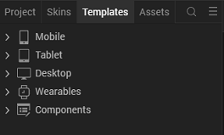
3.Right-click Components, and then select Import Component. The Import Component dialog box appears.
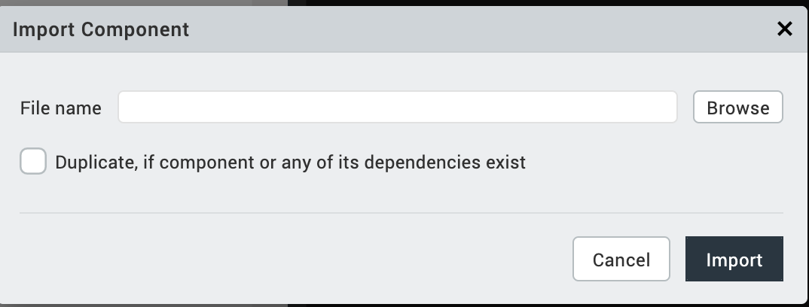
4.Click Browse to navigate to the location of the component, select the component, and then click Import. The component and its associated widgets and modules are added to your project.

Once you have imported a component to your project, you can easily add the component to a form. For more information, refer Add a Component to a Form

Building and previewing the app
After performing all the above steps, you can build your app and run it on your device. For more information, you can refer to the Building and Viewing an Application section of the Volt MX User Guide.
You can then run your app to see the Barcode/QR code Scanner work in real time.

References

Dynamic Usage
You can also add AV Barcode/QR code Scanner component dynamically. To do so,

1. In the Project Explorer, on the Projects tab, click Controllers section to access the respective Form Controller. Create a method and implement the code snippet similar to the sample code mentioned below.

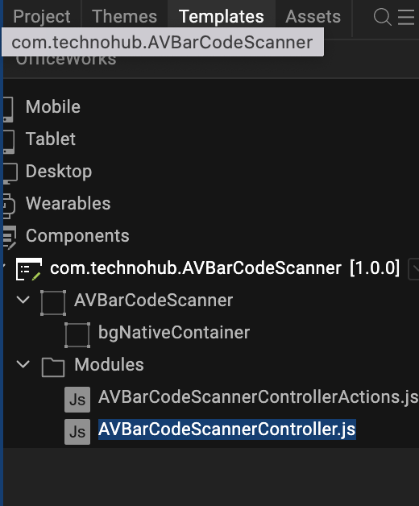

/* Creating AV Barcode/QR code Scanner component instance */

var AVBCScanner = new com.technohub.AVBarCodeScanner({
"height": "50%",
"id": “AVBCScanner",
"isVisible": true,
"left": "0dp",
"masterType": constants.MASTER_TYPE_USERWIDGET,
"isModalContainer": false,
"skin": "slFbox",
"top": "0dp",
"width": "100%",
"zIndex": 1,
"overrides": {
"AVBCScanner": {
"right": "viz.val_cleared",
"bottom": "viz.val_cleared",
"minWidth": "viz.val_cleared",
"minHeight": "viz.val_cleared",
"maxWidth": "viz.val_cleared",
"maxHeight": "viz.val_cleared",
"centerX": "viz.val_cleared",
"centerY": "viz.val_cleared"
}
}
}, {
"overrides": {}
}, {
"overrides": {}
});

/*Adding the AV Barcode/QR code Scanner component to a Form*/

this.view.add(AVBCScanner);
In the code snippet, you can edit the properties of the component as per your requirement. For more information, see Setting Properties.
2. Save the file

Configuring Native Settings (iOS)
To configure the native settings for iOS, follow these steps:
- From the Project explorer, go to Assets and expand Media.
- Right-click Common, and then select Resource Location. Volt MX Iris opens the common resources folder in a file explorer.
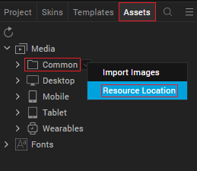
- Open the infoplist_configuration.json file with a text or code editor.
- At the end of the file, type the following code. You can change the description based on your preference.
"NSCameraUsageDescription" : "Your Description"

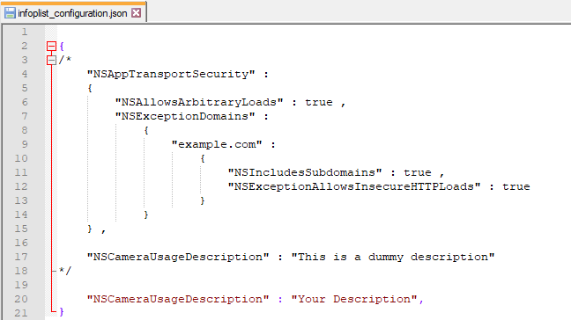

5. Save the file.

Configuring Deployment Target
- From the left navigation menu, click Project Settings.
- In the Project Settings window, go to Native → iPhone/iPad.
- Under Target Versions, from the iOS Version list, select 10.0 or higher.
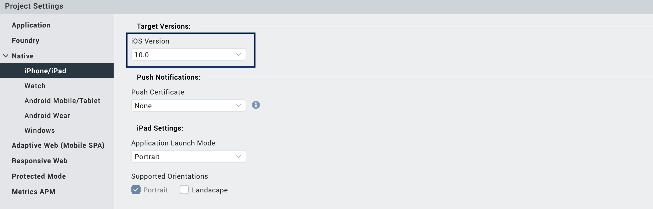

General Properties

API

i.startSession

Description: | Starts the scanning.
Syntax: | startSession ()
Parameters: | None
Return Value: | None
Remarks: | Call this API to start the scanning.
Example: | this.view.AVBarCodeScanner.startSession();

ii.stopSession

Description: | Stops the scanning.
Syntax: | stopSession ()
Parameters: | None
Return Value: | None
Remarks: | Call this API after successful scan to avoid the continues scan.  And call this API when app moves to background.
Example: | this.view.AVBarCodeScanner.stopSession();

iii. restartSession

Description: | Restarts the stopped scanning.
Syntax: | restartSession ()
Parameters: | None
Return Value: | None
Remarks: | Call this API restart the scan after the stopSession() invocation.  And In case session stopped on the background. call this API when app moves to foreground to resume the scanning.
Example: | this.view.AVBarCodeScanner.restartSession ();

iv.enableFlash

Description: Turn on/off the flash light | Turns on/off the device Flash light.
Syntax: enableFlash(true/false) | enableFlash ()
Parameters: Boolean, send true or false | None
Return Value: None | None
Remarks: Call this API restart the turn on/off the flash light. | Call this API to turn on the flashlight
Example: this.view.AVBarCodeScanner.enableFlash(true); | this.view.MLKitBCScanner.enableFlash(true/false);

v. zoomIn

Description: | Increase zoom by 1 step.
Syntax: | zoomIn()
Parameters: | None
Return Value: | None
Remarks: | Call this API to Zoom In
Example: | this.view. AVBarCodeScanner.zoomIn();

vi. zoomOut

Description: | decrease zoom by 1 step.
Syntax: | zoomOut()
Parameters: | None
Return Value: | None
Remarks: | Call this API to Zoom Out
Example: | this.view. AVBarCodeScanner.zoomOut();

vii. isFlashSupports

Description: | Returns status about the Flash light support in the device.
Syntax: | isFlashSupports()
Parameters: | None
Return Value: | Boolean: True/False
Remarks: | Call this API to get the Flash light support status
Example: | this.view. AVBarCodeScanner.isFlashSuuports();

viii. setupRectOfInterest

Description: | Adds the Rectangle/Square image on top of the Camera Screen.
Syntax: | setupCustomRectOfInterest ()
Parameters: | None
Return Value: | None
Remarks: | Call this API to add Rectangle/Square image on top of the Camera. And it should be  Called every time when session restarts.
Example: | this.view. AVBarCodeScanner. setupRectOfInterest ();

C. Events

1. retrieveData

Description: | Invoked after the component scans and decodes a barcode or a QR code.
Syntax: | retrieveData
Parameters: | data[JSON] : The data that is decoded from the barcode or QR code.
Remarks: | If you want the camera to scan codes continuously, do not call the stopSession() in retrieveData.
Example: | onNavigate: function(context) {  this.view. AVBarCodeScanner. retrieveData (this.callback);  },  callback: function(data) {  alert(JSON.stringify(data));  }  this.view. AVBarCodeScanner.stopSession();  },

App version 1.0.0:

Limitations

B. Known Issue

