Date : 27-02-2024

Auto Sugest queries

version: 1.0.0

Overview
This is a Query Suggest API which provides suggestions for search queries based on a given keyword.
Auto Suggest Query API provides intelligent suggestions for search queries based on a given keyword. Simply input a keyword, and the API will return a list of relevant and related queries to help guide and refine your search.

Getting Started

A. Prerequisites

Volt Foundry
- Account and api key from https://rapidapi.com/
- Sign up in https://rapidapi.com/ and login into the account and get the api key.
- Auto Suggest Queries API Documentation (devXprite) | RapidAPI

B. Importing the adapter:
To import the Data Adapter to Volt Foundry, do the following:
- Sign in to the HCL Foundry.
- From the left navigation menu, select API Management.
- In API Management, select Custom Data Adapters.
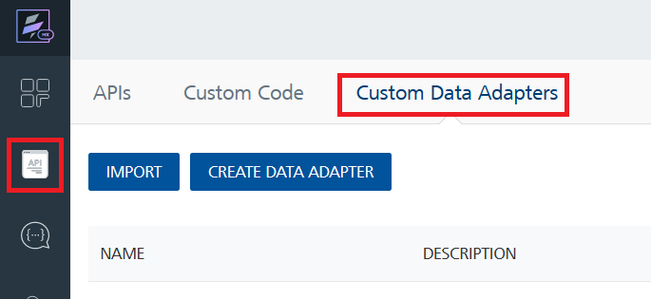
- Click IMPORT to import a custom data adapter.
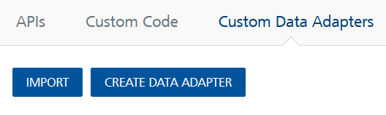
- On the Import Data Adapter dialog box, click browser to import.
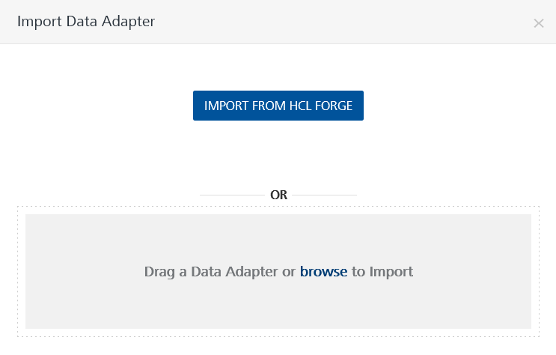
- Select Auto Suggest Queries zip file and click IMPORT.
After you import the data adapter, Volt Foundry opens a window that shows the metadata of the data adapter.
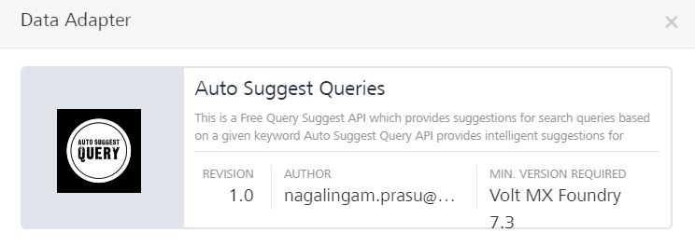

After you import the data adapter, you can view it on the Custom Data Adapters page and use it to create services on Volt Foundry.
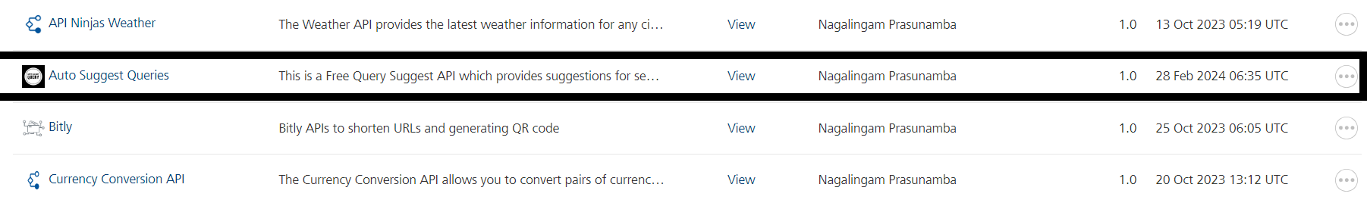

C. Creating an Integration service
After you import the data adapter into Volt Foundry, you can use it to create an Integration Service.
Follow the given steps to create an Integration service using the Auto Suggest Queries Adapter.
- Sign in to the HCL Foundry.
- From the left navigation menu, select API Management.
- In API Management, select Integration.
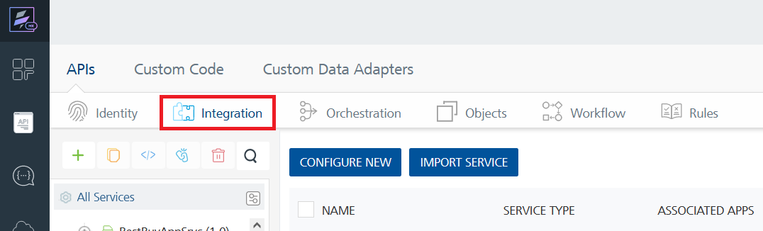
- To create a new service, click the + button or the CONFIGURE NEW button.
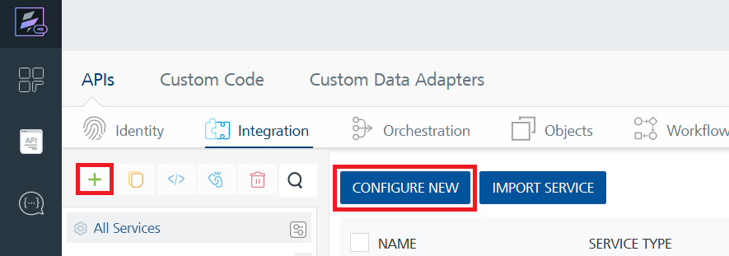
- On the Service Definition tab, select the service type as Auto Suggest Queries, and click SAVE.
- 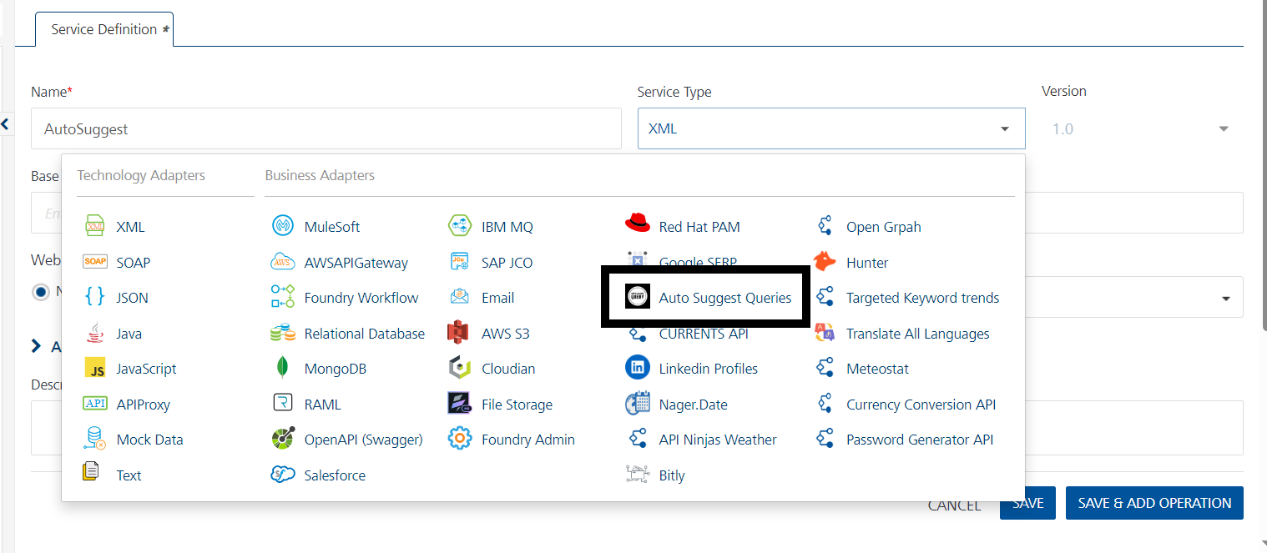
Alternatively, you can also create a Foundry app and create an Integration service inside it.
D. Creating and Executing operations:
After you create an integration service, you can create and execute operations using the service.

Creating an operation
- In API Management/Foundry app you created, in the Integration section, select the service that you created.
- After you select the service, navigate to the Operation List tab.
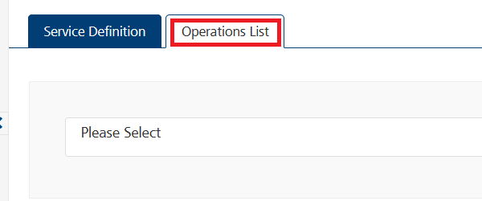
- From the drop-down list, select an operation that you want to execute, and click ADD OPERATION.
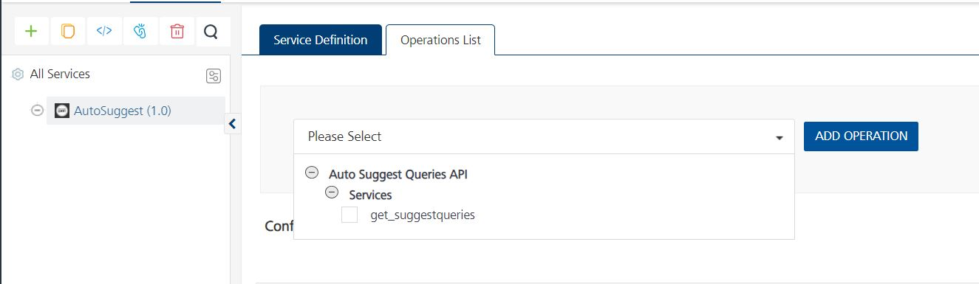

Executing an operation
- From the Operations List tab, in the Configured Operations section, select the operation you want to execute.
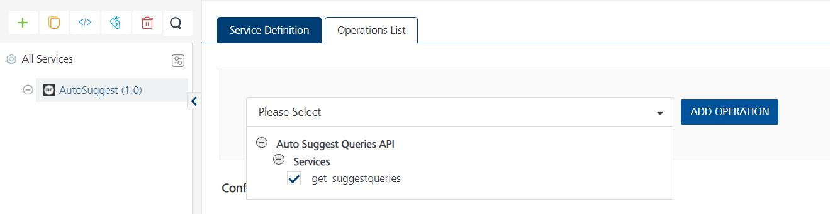
- On the Operation Page, in the Request Input tab, enter a TEST VALUE for all the fields.
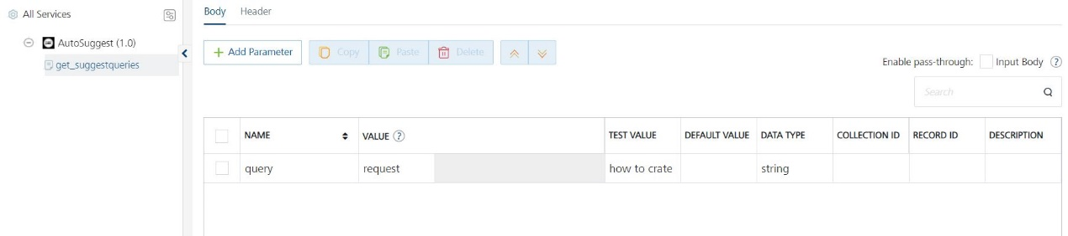
Request Header:
Authorization: X-RapidAPI-Key, X-RapidAPI-Host [in header]: API Key associated with your RapidAPI account, required for authentication. To get keys – Login in to Rapid API Account -> You can view your keys.
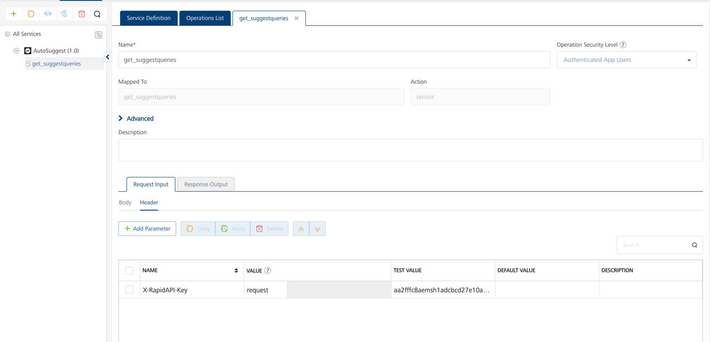
- Select a run-time environment and click Save and Fetch Response to get a response based on your inputs.
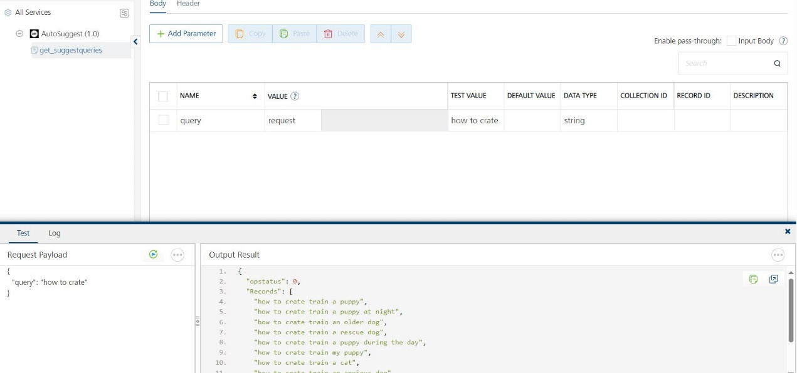

E. Publishing your application:
If you want to use the services in client applications, you need to publish an app to a run-time environment. You can create the service (as described above) in an application or import the service into an application and publish the application.

3. References

Endpoint Documentation

/suggestqueries

GET
https://auto-suggest-queries.p.rapidapi.com/suggestqueries

Header Parameters:

Header Parameter | Value
X-RapidAPI-Key | [Your API Key]

Query Parameters:
Query Parameter | Value
queryaut | [Your Keyword]

Reference Document: Refer this document for more information.
Auto Suggest Queries API Documentation (devXprite) | RapidAPI

4. Revision History
Adapter version 1.0.0

Known Issues
-

Limitations
-

