Date : 21-Mar -24

AUDIO COMPONENT

VERSION : 2.1.0

- OVERVIEW
Audio is a component that can record and play audio on the device. The component can also share the recorded file from the device. Under the hood, the Audio component uses the Social Share Component and Native Function APIs.

Use case
- You can change the icon, add custom actions, and use the APIs to control the functionality of the component.
- You can use the component in scenarios where you want to provide a feature to record and play audio in your app.

B. Percentage of re-use:
80-90% (Audio icon and actions can be customizable and skins are not customized but can be changed manually)

GETTING STARTED

Prerequisites
Before you start using the Audio component, ensure you have the following:
- HCL Foundry
- Volt MX Iris

Platforms Supported

Mobile

iOS

Android

Tablets

PWA

Importing the Component

You can import the Forge components only into the apps that are of the Reference Architecture type.

To import the Audio component, do the following:

Open your app project in Volt MX Iris.
- In the Project Explorer, click the Templates tab.

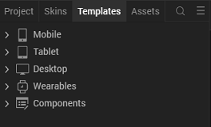

3.Right-click Components, and then select Import Component. The Import Component dialog box appears.
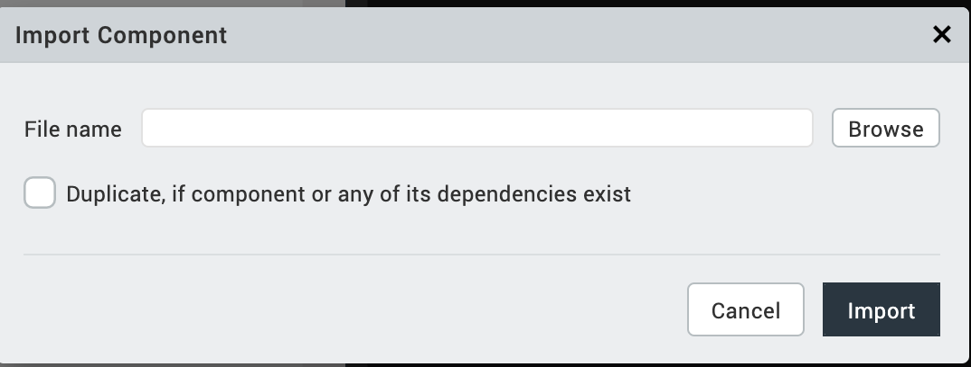
4.Click Browse to navigate to the location of the component, select the component, and then click Import. The component and its associated widgets and modules are added to your project.
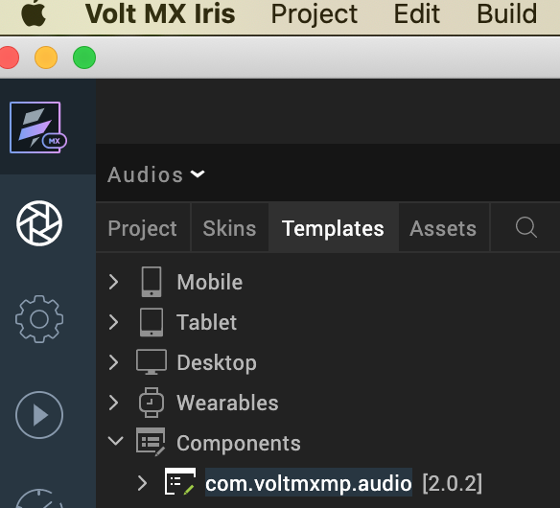
Once you have imported a component to your project, you can easily add the component to a form. For more information, refer Add a Component to a Form.
- Configuring Native Settings (Android)
- Configuring the Manifest file (Application Tag)

To access files that you add to your project from the device, you need to create an XML file that specifies the directories that you want to share. For more information, refer to Specifying the Sharable Directories in the XML file.

After you create the XML file, copy the file into the following folder of your project workspace: resources/mobile/native/android/xml. If the xml folder does not exist, you can create the folder.

After you copy the file to the Android folder, you need to configure the Manifest properties of the project.

Follow the given steps to configure the application tag.
- Open your Project Settings from Volt MX Iris.
- Go to the Native – Android Mobile/Tablet
- Under Android, go to tab Tags.
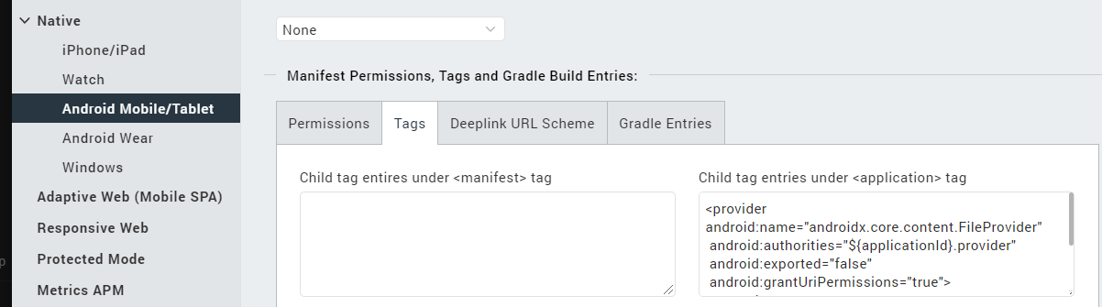
- Enter the given code snippet in Child tag entries under <application> tag.

<provider android:name="androidx.core.content.FileProvider"
android:authorities="${applicationId}.provider"
android:exported="false"
android:grantUriPermissions="true">
<meta-data android:name="android.support.FILE_PROVIDER_PATHS"
android:resource="@xml/filepaths" />
</provider>

- Run-time Permissions
On the Android platform, the Audio component requires the WRITE_EXTERNAL_STORAGE and RCORD_AUDIO permissions.
To enable the permissions, follow these steps:
- From the left navigation bar, select Project Settings.
- From the Project Settings window, go to Native → Android Mobile/Tablet.
- Scroll down to Manifest Permissions, Tags and Gradle Build Entries.
- Set the WRITE_EXTERNAL_STORAGE and RCORD_AUDIO permissions to true.
To set a permission to true, select the permission from the left panel and click Add >.
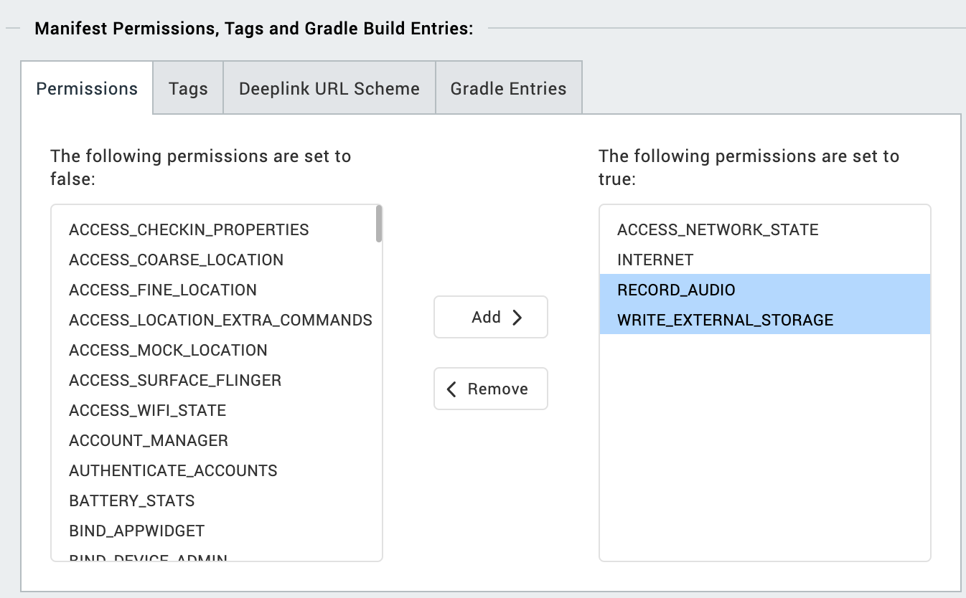

iii. Note: Need to enable "Use Google Pay Location Services" for android in the project settings. From Project Settings window, go to Native → Android Mobile/Tablet and enable Use Google Pay Location Services.
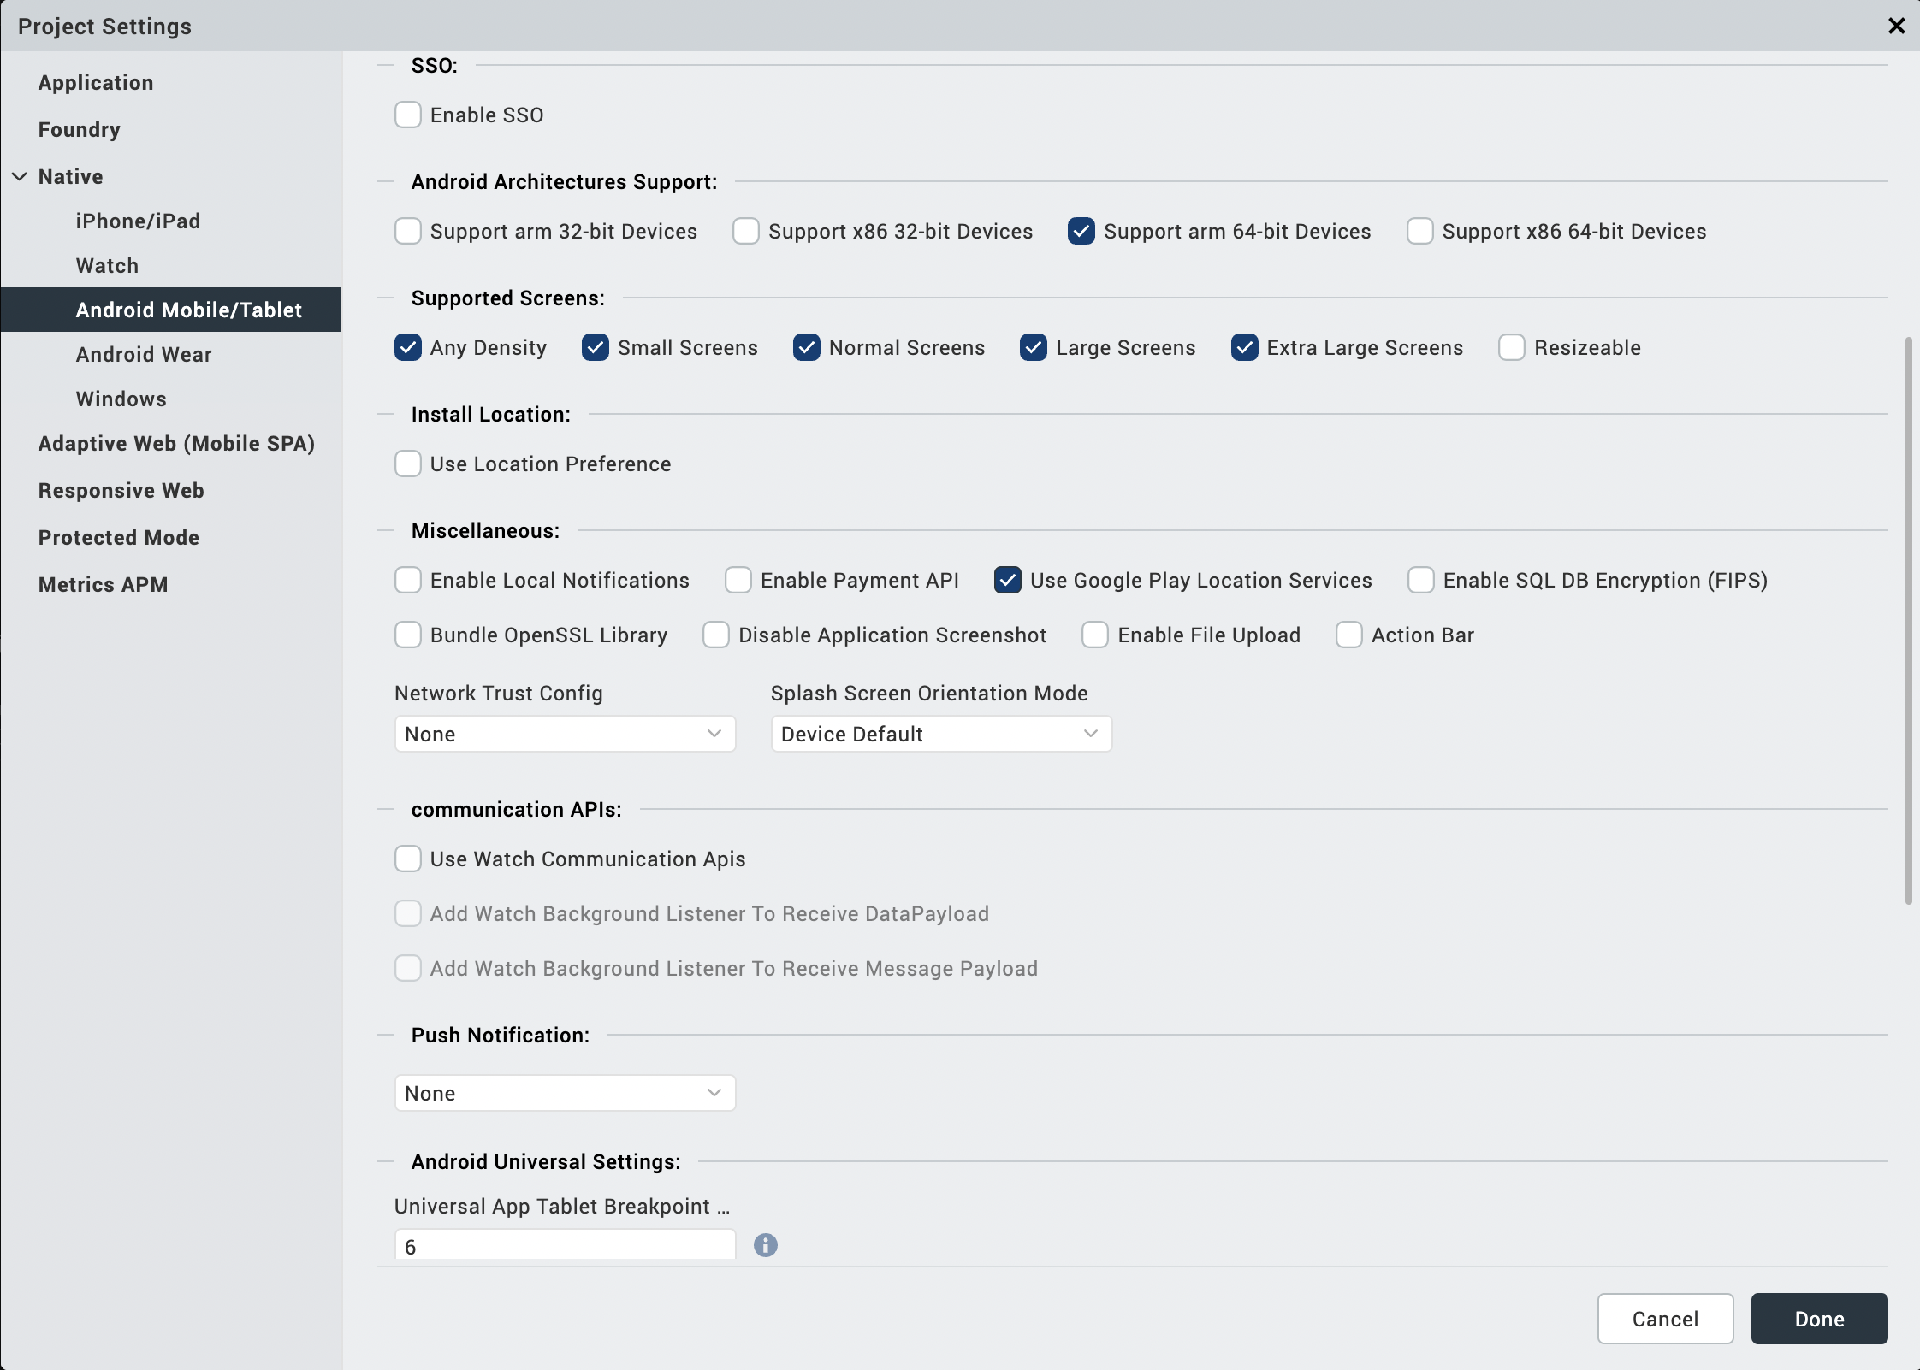

- Configuring Native Settings (iOS)

Follow the given steps to enable the permissions.

- From the Project explorer, navigate to the Assets tab.
- Right click Media and select Resource Location to open the project resources folder.
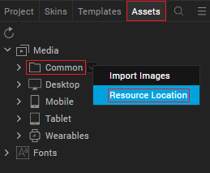
- In the browser window that opens, navigate to the common folder.
- Open the infoplist_configuration.json file with a text or code editor.
- Add "NSMicrophoneUsageDescription" : "This is a dummy description"
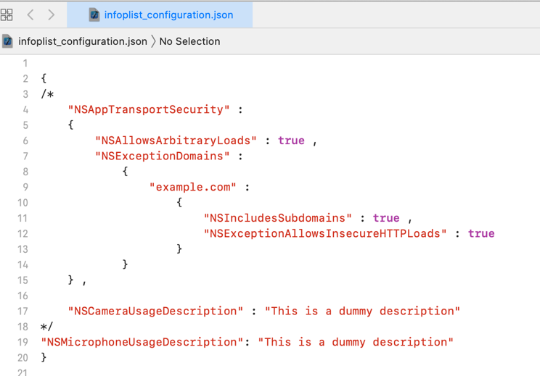
- Save the file.

3.REFERENCES

A. Dynamic Usage
You can also add an Audio component dynamically. To do so:
- In the Project Explorer, on the Projects tab, click Controllers section to access the respective Form Controller. Create a method and implement the code snippet similar to the sample code mentioned below.
In the code snippet, you can edit the properties of the component as per your requirement. For more information, see Setting Properties.
/* Creating the component's object */
var audio = new com.voltmxmp.audio(
{
"clipBounds": true,
"height": "66%",
"id": "audio",
"isVisible": true,
"left": "0dp",
"top": "0dp",
"width": "100%",
"zIndex": 1
}, {}, {});

/* Setting the component's properties */
audio.iconImage = "wave_graphic_active.png";

/* Defining the component's events */
audio.recordSuccessCallback = function()
{
alert("Recording completed.");
};
audio.recordErrorCallback = function()
{
alert("Recording could not be completed.");
};

/* Adding the component to a Form */
this.view.add(audio);

- Save the file.

B. Properties
The properties provided on the Component tab allow you to customize the UI elements in the Audio component. You can set the properties directly on the Component tab or by writing a JavaScript.
1. Icon Image
Category: | Pass Through
Description: | Specifies the source of the image that you want to use as the component icon.
Syntax: | iconImage
Type: | - Image  - String
Read/Write: | Read + Write
Default Value: | "wave_graphic_active.png"
Remarks: | Make sure that the image exists in the resources\common folder of your workspace.
Example:
this.view.componentID.iconImage = "audioIcon.png";
  - Events
The component invokes events when its corresponding action is performed. You can configure any logic you want the component to perform whenever an event occurs.
1. recordSuccessCallback
 | Category: | Custom
 | Description: | Invoked when the component successfully records the audio.
 | Syntax: | recordSuccessCallback
 | Parameters: | None
 | Example: | this.view.componentID.recordSuccessCallback = function()  {  alert("Recording completed.");  }.bind(this);
2. recordErrorCallback
Category: | Custom
Description: | Invoked when an error occurs while the component records the audio.
Syntax: | recordErrorCallback
Parameters: | None
Example: | this.view.componentID.recordErrorCallback = function()  {  alert("Recording could not be completed.");  }.bind(this);

D. APIs
The following APIs pertain to the Audio component:
1. startRecord
Category: | Custom
Description: | Starts recording the audio.
Syntax: | startRecord()
Parameters: | None
Return Value: | None
Example:
this.view.componentID.startRecord();
2. stopRecord
Category: | Custom
Description: | Stops recording the audio.
Syntax: | stopRecord()
Parameters: | None
Return Value: | None
Example:
this.view.componentID.stopRecord();
3. togglePlayPause
Category: | Custom
Description: | Plays or pauses the audio playback.
Syntax: | togglePlayPause()
Parameters: | None
Return Value: | None
Remarks: | The component does not play the audio in the following scenarios:  - The component is recording the audio.  - There is no recording available.
Example:
this.view.componentID.togglePlayPause();

4. isrecordedFileExist
 | Category: | Custom
 | Description: | Checks whether a recorded file exists in the storage.
 | Syntax: | isrecordedFileExist()
 | Parameters: | None
 | Return Value: | doesFileExist [Boolean]  The value is true if a recorded file exists.  The value is false if a recorded file does not exist.
 | Example: | var doesFileExist = this.view.componentID.isrecordedFileExist();  if(doesFileExist == true)  {  this.view.componentID.togglePlayPause();  }
5. shareRecordFile
Category: | Custom
Description: | Shares the recorded file using the name and base64 value.
Syntax: | shareRecordFile()
Parameters: | None
Return Value: | None
Remarks: | To share the recorded file, the API uses the Social Share component from Forge.
Example:
this.view.componentID.shareRecordFile();

4. REVISION HISTORY

App version 2.1.0

- Known Issues
No known issues

- Limitations
No limitations

