06 June 2024

AUGMENTED REALITY(NATIVE) version:1.0.2

1. **OVERVIEW:**

Augmented Reality is changing the way real world information is augmented with virtual 3D content that enables delivering rich and amazing experiences to the users. AR also simultaneously provides a great degree of information. This enables rendering of real-world information and presenting it in an interactive way, where virtual elements can become part of the real world, extending the real world into virtual world.

With capabilities ranging from Real-time Image Recognition and Tracking, SLAM (Simultaneous localization and Mapping) and virtual 3D Models in AR scenes that enables you in creating powerful interfaces and rich feedback loops in products customization. This revolutionizes the way rich content can be delivered.

This application is based on AR Renderer widget. The widget is added dynamically to the form and is used for scanning surfaces and adding objects.

1. **Requirements:**

* Volt MX Iris
* [Volt MX Foundry](https://manage.hclvoltmx.com/)

1. **Devices:**

* Mobile

1. **Platforms:**

* Android -using AR Renderer widget.
* IOS

1. **GETTING STARTED**
2. **Prerequisites**

Before you start previewing the AR Sample app on your Mobile device, ensure that you have the following:

1. Voltmx Account

2. Voltmx Iris

**B. Import the App**

To import the AR sample into your workspace, follow these steps:

1. Open Voltmx Iris.
2. Click on project ->New Project

1. Select Sample apps and click on next.

1. Select Augmented Reality and click on choose button.
2. From the **Project** explorer, go to **Mobile**, expand **Forms**, and then verify whether the **frmDashboard, frmCameraScreen** is successfully imported to the existing application.

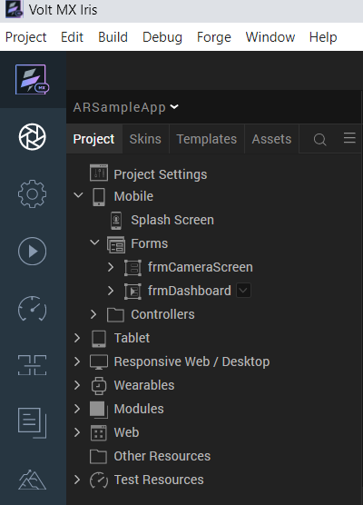

1. Go to **Templates**, expand **Components** and then verify whether the components are successfully imported to the existing application.

## 

**C. Configure Native Settings**

**Android:**

## We need to give permissions for Android Mobile to open Camera.

## We need to give dependencies in the build.gradle tag.

android {

defaultConfig {

renderscriptSupportModeEnabled false

}

}

dependencies {

api "com.google.ar.sceneform:core:1.17.1"

api "com.google.ar.sceneform.ux:sceneform-ux:1.17.1"

api "com.google.ar:core:1.22.0"

}

* 1. The minimum SDK version for Android is 7(24) because AR features for Android was supported from Android version7.

**IPHONE:**

We need to give permissions for iPhone to open Camera in infoplist_configuration file.

Location: \WorkspaceName\ProjectName\resources\common\ infoplist_configuration

{

"NSCameraUsageDescription" : " This app uses Camera ",

}

1. **Building the app**

From menu bar, go to **Build** and then select **Build Native Local**.

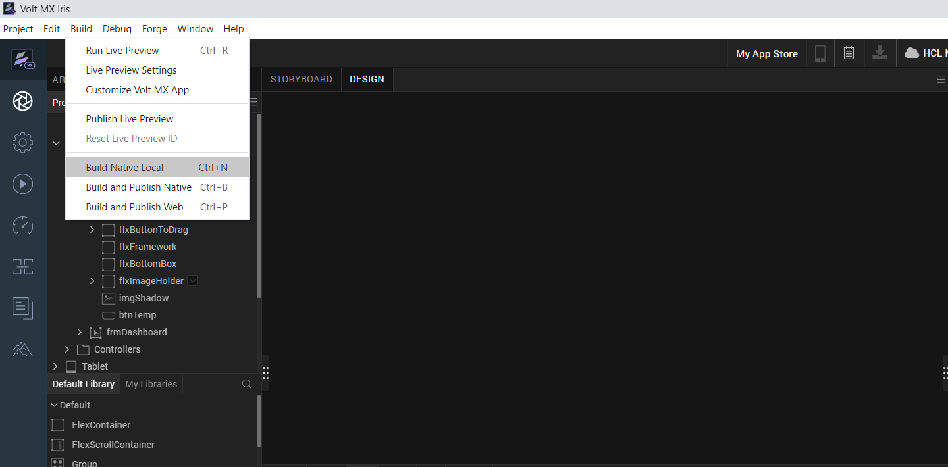

For **Mobile**, select **Android** and **iOS**. Click **Build**.

After the build is successful, run the app on your mobile device.

1. **Application Flow**

The landing page for the app is as follows:

Click on Scan and so The AR Renderer will ask the camera permissions as shown in below.

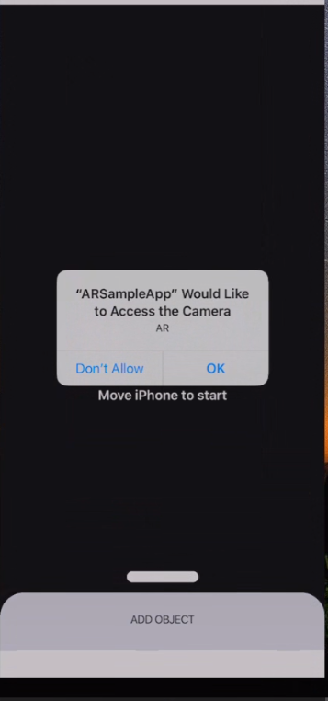

Once click on OK then it will starts searching for a plane surface.

**FOR ANDROID:**

It will redirect to play store to install the Google play services for AR app to support AR features in Android.

Then add an object and you will see the selected object as show in the following screen shots.

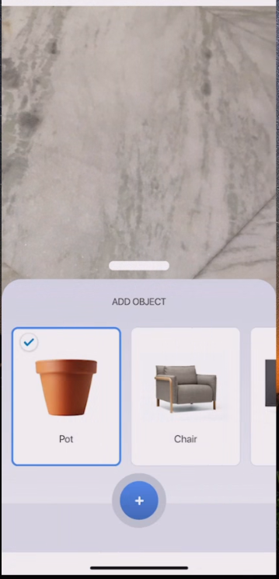

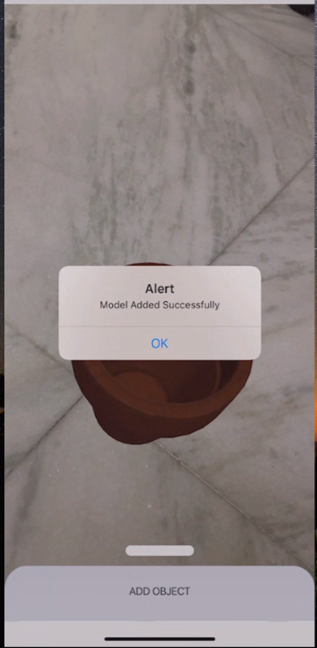

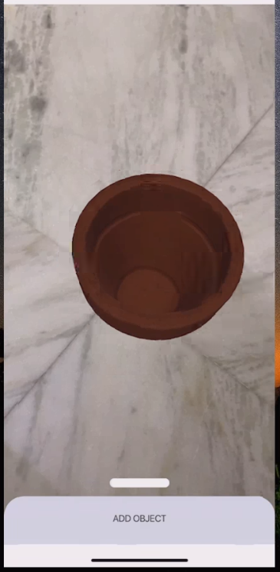

Select another object from list of objects and can see 3d view as shown in below images.

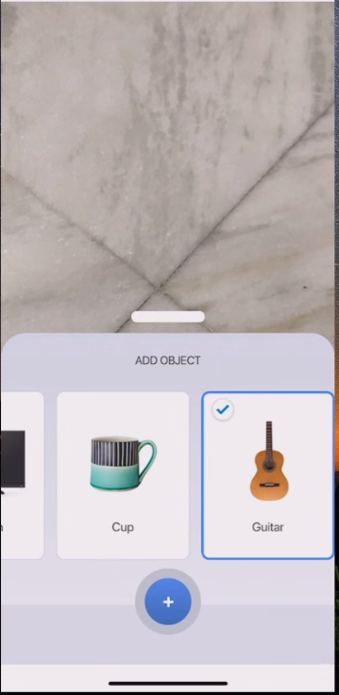

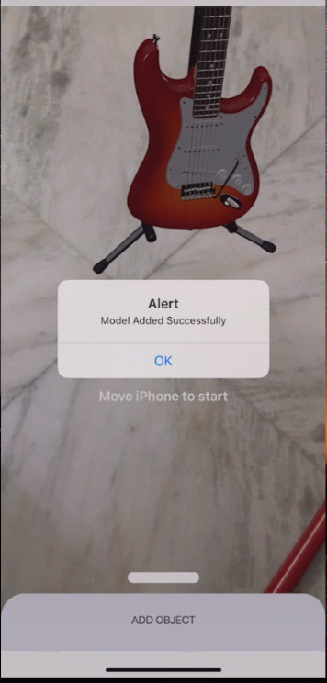

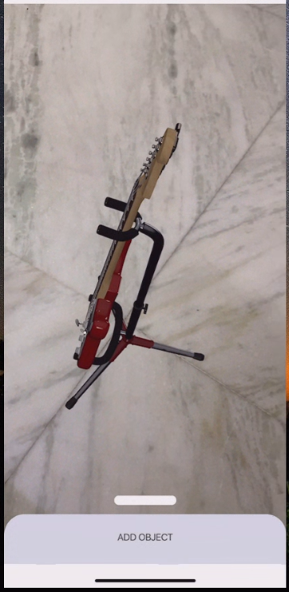

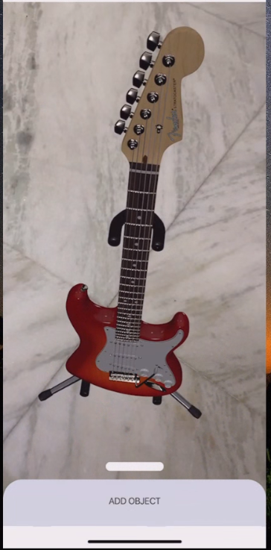

**3. REVISION HISTORY**

App version 1.0.2

**A. Limitations:**

**Note:** For Android, the image is displaying very small and when moving the camera closely then the image is displaying in big size.

**B. Known issues:**

No issues