Date :  13th Oct 2023

Appstore DATA ADAPTER (1.0.0)

# Overview

App Store data adapter is one of the best and fastest performing APIs for iTunes/Mac app store data. This is an unofficial App Store API offering a solution for developers who crave for a gateway for their App Store API calls.

It does not cache nor store any information in their servers, instead it scraps the app store in real-time when requested.

If the developer wants to fetch its iTunes/Mac app apps details in the app, this adapter is very helpful in fetching the iPhone/iPad/Mac apps data.

# Getting Started

## Prerequisites

* Volt Foundry
* ApiLayer license key - <https://apilayer.com/marketplace/app_store-api#documentation-tab>

## Importing the adapter

**To import the Data Adapter to Volt Foundry, do the following:**

1. Sign in to the  [HCL Foundry](https://manage.hclvoltmx.com/).
2. From the left navigation menu, select **API Management**.
3. In **API Management**, select **Custom Data Adapters**.  
   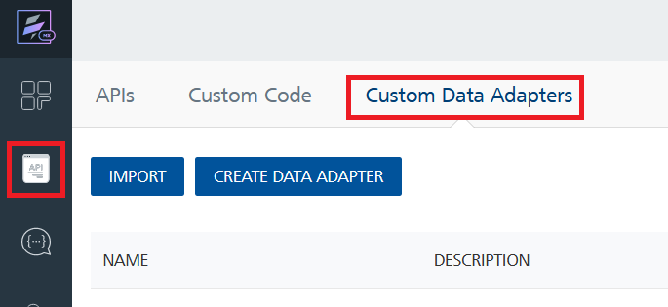
4. Click **IMPORT** to import a custom data adapter.  
   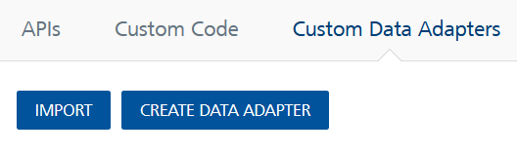
5. On the Import Data Adapter dialog box, click browser to import.  
   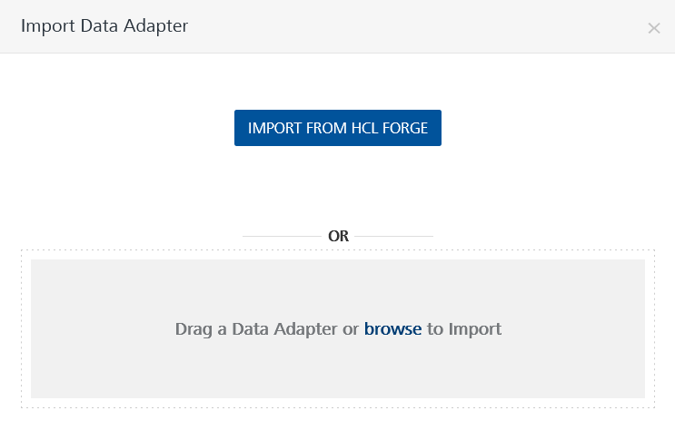
6. Select **AppStoreAPI** zip file and click **IMPORT**.

After you import the data adapter, Volt Foundry opens a window that shows the metadata of the data adapter.

After you import the data adapter, you can view it on the Custom Data Adapters page and use it to create services on Volt Foundry.



## [Creating an Integration service](javascript:void(0);)

After you import the data adapter into Volt Foundry, you can use it to create an Integration Service.

Follow the given steps to create an Integration service using the **AppStoreAPI** Adapter.

1. Sign in to the [HCL Foundry](https://manage.hclvoltmx.com/).
2. From the left navigation menu, select **API Management**.
3. In **API Management**, select **Integration**.  
   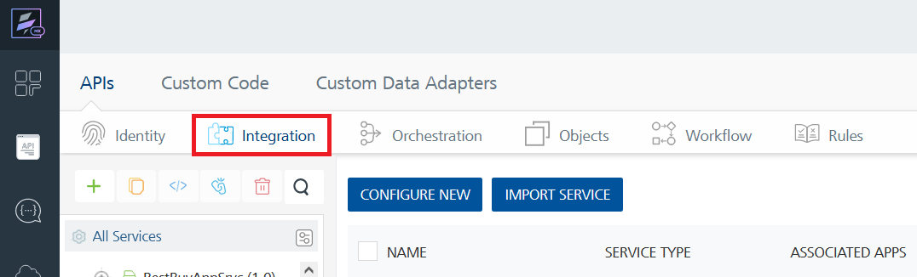
4. To create a new service, click the **+** button or the **CONFIGURE NEW** button.  
   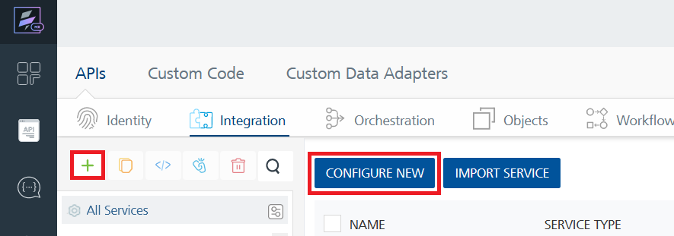
5. On the Service Definition tab, select the service type as **AppStoreAPI**, and click **SAVE**.  
   A screenshot of a computer

   Description automatically generated

Alternatively, you can also create a Foundry app and create an Integration service inside it.

E. [Creating and Executing operations](javascript:void(0);)



After you create an integration service, you can create and execute operations using the service.

#### Creating an Operation

* In **API Management/Foundry app you created**, in the **Integration** section, select the service that you created.
* After you select the service, navigate to the **Operation List** tab.  
  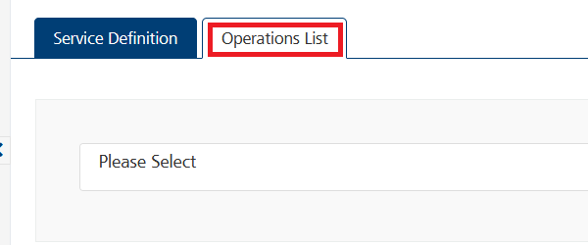
* From the drop down list, select an operation that you want to execute, and click **ADD OPERATION**.  
  A screenshot of a computer

  Description automatically generated

#### Executing an Operation

* From the **Operations List** tab, in the **Configured Operations** section, select the operation you want to execute.
* A screenshot of a computer

  Description automatically generatedOn the Operation Page, in the Request Input tab, enter a TEST VALUE for all the fields.  
  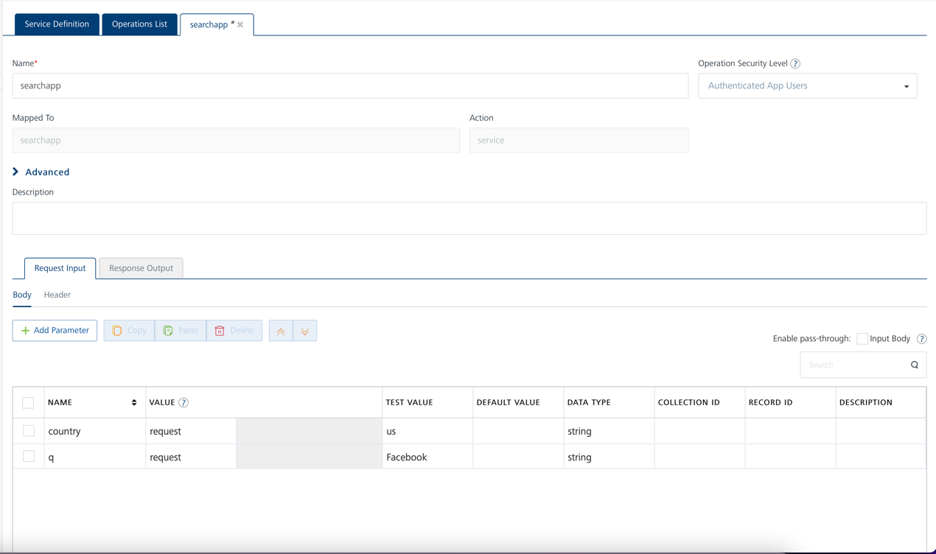

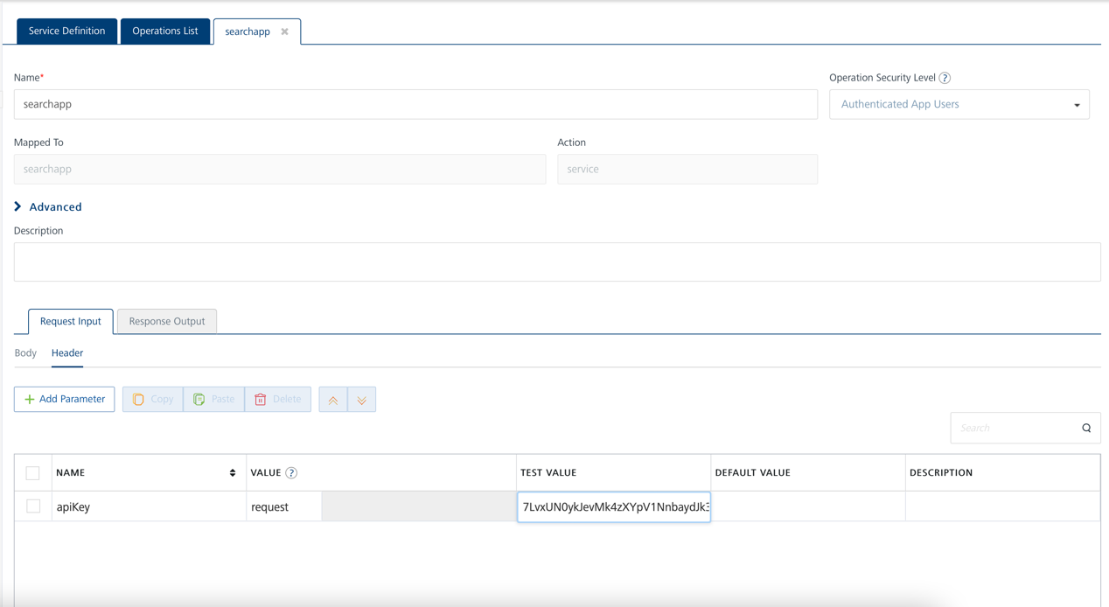

* Select a run-time environment and click **Save and Fetch Response** to get a response based on your inputs.  
    
  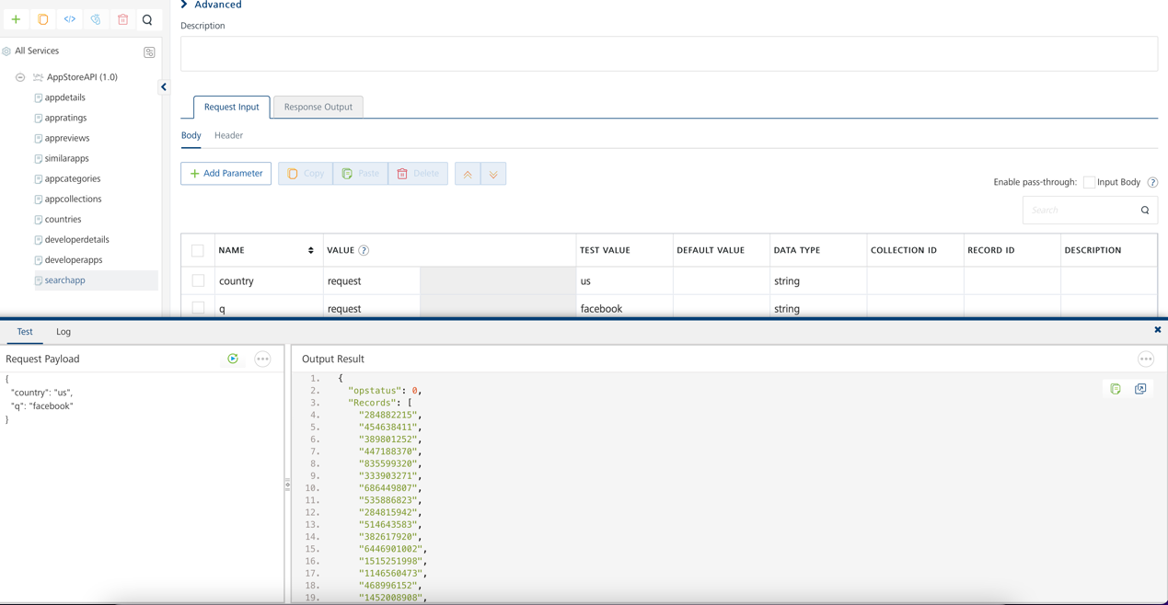

## [Publishing your application](javascript:void(0);)

If you want to use the services in client applications, you need to publish an app to a run-time environment. You can create the service (as described above) in an application or import the service into an application and publish the application.

# References

## Endpoint Documentation

### Operations:

### i. appDetails

|  |  |
| --- | --- |
| **Description:** | Fetches information of any app using app id. |
| **Parameters:** | **Request Params:** i. country(required) - String - Two-character country parameter. To get a full list of supported countries check /countries endpoint.  ii. id(required) - String - The id of the app. **Header Params:**i. apiKey(required) - String - license key must be passed in the service header param |
| **Restrictions:** | NA |

### ii. appRatings

|  |  |
| --- | --- |
| **Description:** | Retrieves the ratings information of an application |
| **Parameters:** | **Request Params:** i. country(required) - String - Two-character country parameter. To get a full list of supported countries check /countries endpoint.  ii. id(required) - String - The id of the app. **Header Params:**i. apiKey(required) - String - license key must be passed in the service header param |
| **Restrictions:** | NA |

### iii. appReviews

|  |  |
| --- | --- |
| **Description:** | Retrieves the reviews of an application |
| **Parameters:** | **Request Params:** i. country(required) - String - Two-character country parameter. To get a full list of supported countries check /countries endpoint.  ii. id(required) - String - The id of the app. **Header Params:**i. apiKey(required) - String - license key must be passed in the service header param |
| **Restrictions:** | NA |

### iv. similarApps

|  |  |
| --- | --- |
| **Description:** | Returns the list of 'customers also bought apps' shown in the app's detail page |
| **Parameters:** | **Request Params:**  i. id(required) - String - The id of the app. **Header Params:**i. apiKey(required) - String - license key must be passed in the service header param |
| **Restrictions:** | NA |

### v. appCategories

|  |  |
| --- | --- |
| **Description:** | Gets the full list of categories to use for in the /list endpoint. |
| **Parameters:** | **Request Params:** NA **Header Params:**i. apiKey(required) - String - license key must be passed in the service header param |
| **Restrictions:** | NA |

### vi. appCollections

|  |  |
| --- | --- |
| **Description:** | Gets the full list of collections to use for in the /list endpoint. |
| **Parameters:** | **Request Params:** NA **Header Params:**i. apiKey(required) - String - license key must be passed in the service header param |
| **Restrictions:** | NA |

### vii. countries

|  |  |
| --- | --- |
| **Description:** | Gets the full list of countries |
| **Parameters:** | **Request Params:** NA**Header Params:**i. apiKey(required) - String - license key must be passed in the service header param |
| **Restrictions:** | NA |

### viii. developerDetails

|  |  |
| --- | --- |
| **Description:** | Retrieves the details of a developer |
| **Parameters:** | **Request Params:** i. country(required) - String - Two-character country parameter. To get a full list of supported countries check /countries endpoint.  ii. developer id(required) - String - The id of the developer. **Header Params:**i. apiKey(required) - String - license key must be passed in the service header param |
| **Restrictions:** | NA |

### ix. developerApps

|  |  |
| --- | --- |
| **Description:** | Retrieves the list of apps published by a developer |
| **Parameters:** | **Request Params:** i. country(required) - String - Two-character country parameter. To get a full list of supported countries check /countries endpoint.  ii. developer id(required) - String - The id of the developer. **Header Params:**i. apiKey(required) - String - license key must be passed in the service header param |
| **Restrictions:** | NA |

### x. searchApp

|  |  |
| --- | --- |
| **Description:** | Search for an app using the search term q. |
| **Parameters:** | **Request Params:** i. country(required) - String - Two-character country parameter. To get a full list of supported countries check /countries endpoint.  ii. q(required) - String - The term to search. **Header Params:**i. apiKey(required) - String - license key must be passed in the service header param |
| **Restrictions:** | NA |

# Revision History

Adapter version 1.0.0:

## Known Issues

## Limitations

Note: that API is not affiliated in any way by Apple Inc. or its affiliates.