Date :  20-10-2023

Api2pdf (1.0.0)

# Overview

[Api2Pdf](https://www.api2pdf.com/) is a powerful PDF generation API with no rate limits or file size constraints. Api2Pdf runs on AWS Lambda, a serverless architecture powered by Amazon to scale to millions of requests while being up to 90% cheaper than alternatives. Supports wkhtmltopdf, Headless Chrome, LibreOffice, and PDF Merge.

Generate PDFs from HTML, URLs, images, and office documents. Merge PDFs. Api2Pdf runs on AWS Lambda making it extremely reliable and the most affordable PDF service around.

# Getting Started

## Prerequisites

* Volt Foundry
* [Api2Pdf API Key](https://www.api2pdf.com/)
* API Key to authenticate requests

## Importing the adapter

**To import the Data Adapter to Volt Foundry, do the following:**

1. Sign in to the  [HCL Foundry](https://manage.hclvoltmx.com/).
2. From the left navigation menu, select **API Management**.
3. In **API Management**, select **Custom Data Adapters**.  
   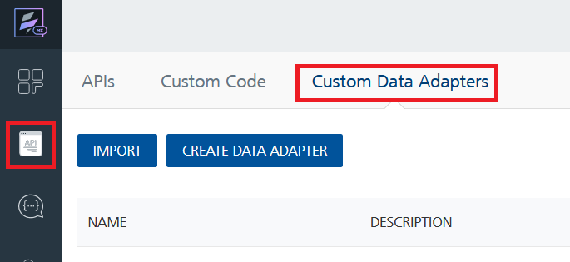
4. Click **IMPORT** to import a custom data adapter.  
   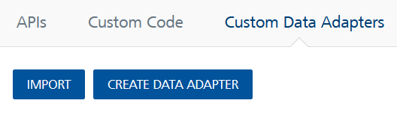
5. On the Import Data Adapter dialog box, click browser to import.  
   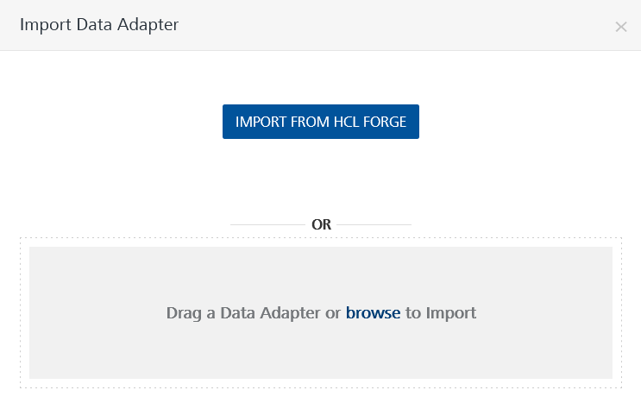
6. Select **Api2Pdf** zip file and click **IMPORT**.

After you import the data adapter, Volt Foundry opens a window that shows the metadata of the data adapter.

After you import the data adapter, you can view it on the Custom Data Adapters page and use it to create services on Volt Foundry.

## [Creating an Integration service](javascript:void(0);)

After you import the data adapter into Volt Foundry, you can use it to create an Integration Service.

Follow the given steps to create an Integration service using the **Api2Pdf** Adapter.

1. Sign in to the [HCL Foundry](https://manage.hclvoltmx.com/).
2. From the left navigation menu, select **API Management**.
3. In **API Management**, select **Integration**.  
   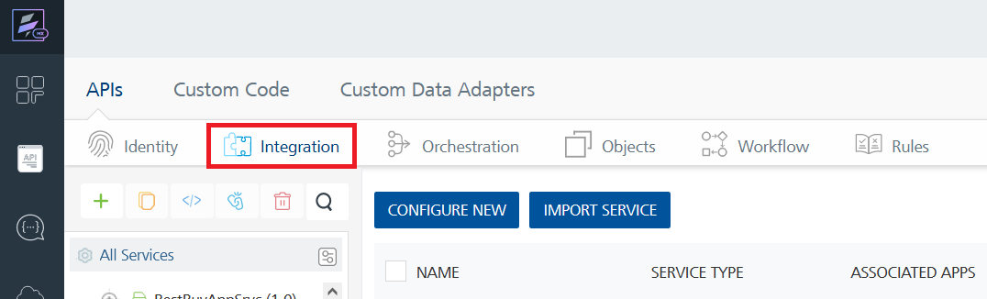
4. To create a new service, click the **+** button or the **CONFIGURE NEW** button.  
   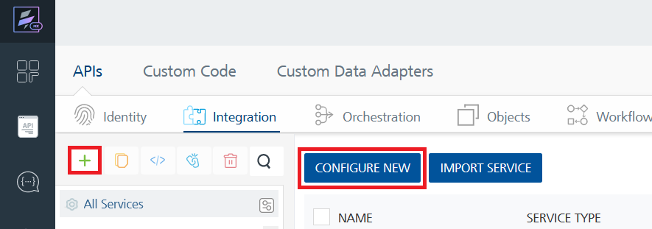
5. On the Service Definition tab, select the service type as **Api2Pdf,** and click **SAVE**.  
   A screenshot of a computer

   Description automatically generated

Alternatively, you can also create a Foundry app and create an Integration service inside it.

## Creating and Executing operations

After you create an integration service, you can create and execute operations using the service.

#### Creating an Operation

* In **API Management/Foundry app you created**, in the **Integration** section, select the service that you created.
* After you select the service, navigate to the **Operation List** tab.  
  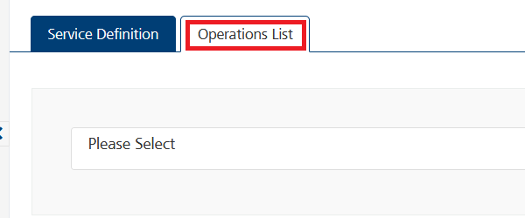
* From the drop down list, select an operation that you want to execute, and click **ADD OPERATION**.  
  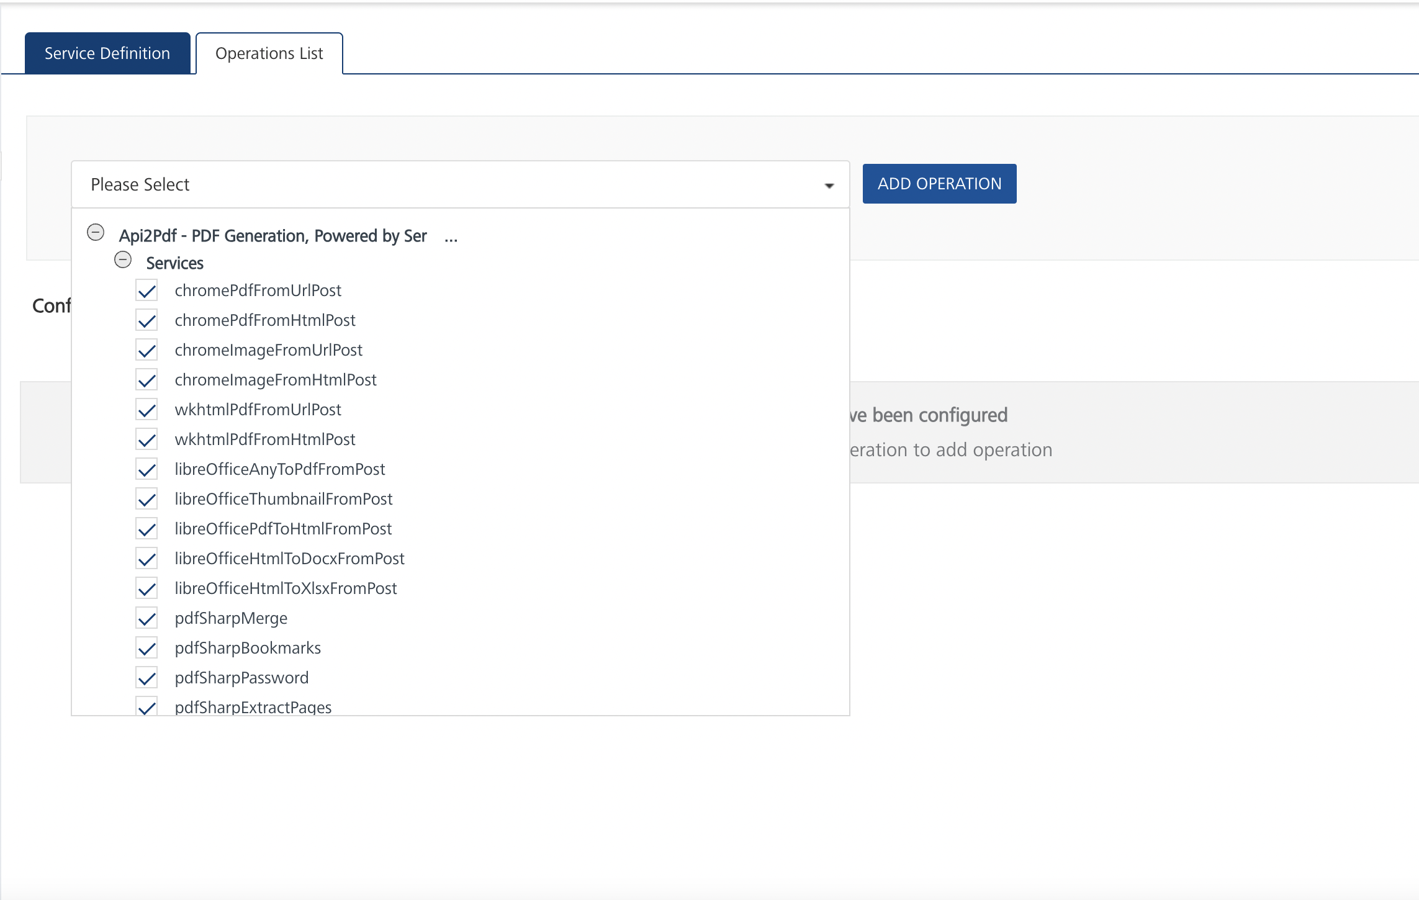

#### Executing an Operation

* From the **Operations List** tab, in the **Configured Operations** section, select the operation you want to execute.

* On the Operation Page, in the Request Input tab, enter a TEST VALUE for all the fields.  
  A screenshot of a computer

  Description automatically generated

* Select a run-time environment and click **Save and Fetch Response** to get a response based on your inputs.

## Publishing your application

If you want to use the services in client applications, you need to publish an app to a run-time environment. You can create the service (as described above) in an application or import the service into an application and publish the application.

# References

## Endpoint Documentation

### **Requests Input Parameters for chromePdfFromUrlPost operation**

| **Parameter Name** | **Location** | **Type** | **Required** | **Description** |
| --- | --- | --- | --- | --- |
| Authorization | Header | String | Required | Your API Key for authorization from [Api2Pdf API Key](https://www.api2pdf.com/) |
| url | Request Body | String (URL, required) | Required | The URL of the web page to convert to PDF. |
| inline | Request Body | Boolean | Optional | Open the PDF in a browser window. Defaults to **false** if not specified. |
| fileName | Request Body | String | Optional | Specify a file name for the output PDF. A random name will be used if not specified. |
| options | Request Body | Object | Optional | Advanced Headless Chrome options for margins, headers, and footers. See the full list of advanced options in [**ChromeAdvancedOptions**](https://www.api2pdf.com/documentation/advanced-options-headless-chrome/). **Sample Payload:** "options": {  "landscape": "",  "printBackground": "false"  } |

### **Response Output Parameters for chromePdfFromUrlPost operation**

| **Status Code** | **Description** | **Response Schema** |
| --- | --- | --- |
| 200 | Successful response | application/json |
|  |  |  |
|  | **Response Body:** |  |
|  | - **cost** (number): | Cost of the operation (mbIn + mbOut) * $.001 |
|  | - **mbIn** (number): | The amount of megabytes of bandwidth used to process the PDF |
|  | - **mbOut** (number): | The amount of megabytes of bandwidth generated from the resulting PDF |
|  | - **pdf** (string): | A URL to the PDF that will exist only for 24 hours |
|  | - **success** (boolean): | Will be true if the operation succeeded |
|  |  |  |
| 401 | Failed to generate PDF | application/json |
|  |  |  |
|  | **Response Body:** |  |
|  | - **reason** (string): | The reason for the PDF generation failure |
|  | - **success** (boolean): | Will be false if the operation failed |

## **Reference Document:** Refer this document[**Api2Pdf Documentation**](https://redocly.github.io/redoc/?url=https://api.apis.guru/v2/specs/api2pdf.com/1.0.0/openapi.json)

## to know the request input, request header and response output parameters for the other operations.

# Revision History

Adapter version 1.0.0:

## Known Issues

* For APIs to send html content as request input. Foundry supports html content in the payload with html tags as- i,b,ol,ul, h tags ( h1,h2,h3,h4,h5,h6).

## Limitations

* Some endpoints form this [Api2Pdf](https://www.api2pdf.com/) API is not working in the Foundry.
* ZXING (Zebra Crossing) Bar Codes andPOST[/zip](https://app.swaggerhub.com/apis-docs/api2pdf/api2pdf/2.0.0#/Utility%20Commands/filesZip) Create a.zip file endpoint response output format is not supporting by Foundry.

##### **GET/chrome/image/url -** convert URL to Image**, GET/wkhtmltopdf/url -** Convert URL to PDF and **GET/chrome/url** Convert URL to PDF endpoints are not working in foundry.