Date : 21-Nov-25

AMAZON BEDROCK RUNTIME APPLICATION

VERSION: 1.0.0

OVERVIEW
Amazon Bedrock Runtime is a fully managed service provided by AWS to help developers build and scale generative AI applications. It allows you to easily use foundation models from leading AI companies such as AI21 Labs, Anthropic, Stability AI, and more. Amazon Bedrock Runtime provides APIs that enable access to various pre-trained models capable of performing tasks like text generation, summarization, image generation, and natural language processing (NLP).

Use case:
- Chatbots & Virtual Assistants
- Text Summarization
- Code Generation
- Sentiment/Intent Detection
- RAG using Private Documents
- Text-to-Image Generation
- Multimodal AI Tasks

Features:
- Multi-model access: One API supports various FMs, including Claude, Llama, Stable Diffusion, Titan.
- Customization & RAG support: Fine-tune models privately and connect them to your data using Retrieval Augmented Generation (RAG). Knowledge Bases streamline ingesting data (docs, images, video) and feeding it to models
- Data automation: Automatically extract insights (like video summaries or document understanding) from unstructured content

Percentage of re-use:
80% (Data can be customizable and customers need to implement UI by themselves).

GETTING STARTED

Prerequisites
Before you start using the Amazon Bedrock Runtime , ensure you have the following:
- An account with AWS ,IAM Role.
- Volt MX Iris
- HCL Foundry

Devices
- Mobile

Platforms
- Android
- IOS

Importing the App
To import the Amazon Bedrock Runtime App to Volt MX Iris, do the following:

To import the Amazon Bedrock Runtime App, do the following:
- Launch Volt MX Iris.
- Click project, and then select Import. The Import dialog box appears.
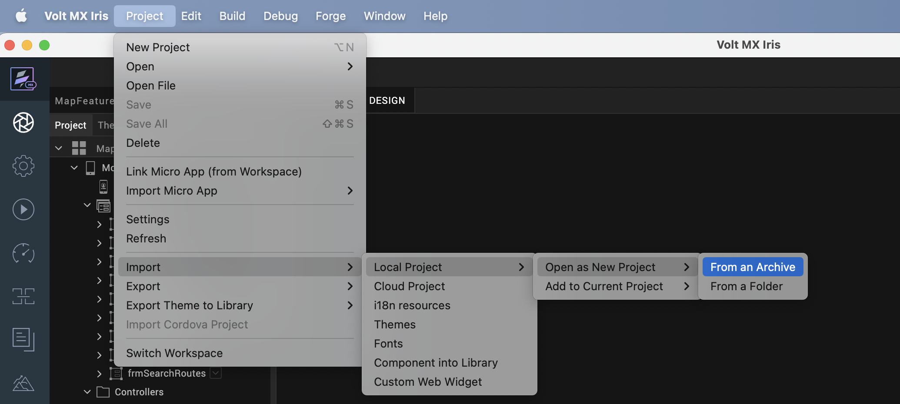

- Click From an Archive to navigate to the location of the project, select the files, and then click Import.
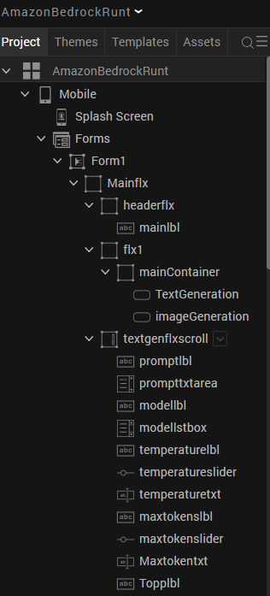
After you import the application, you can view the associated Foundry app connected at the in Data & Services section.
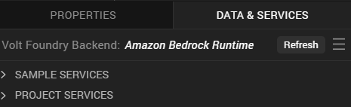

Amazon Bedrock Runtime Volt MX Foundry Services:
The Amazon Bedrock Runtime app contains an Integration Service:
Amazon Bedrock Runtime : Amazon Bedrock Runtime is a fully managed service that lets you generate text and images, summarize content using foundation models via API. It enables building AI-powered apps without managing infrastructure or training models.
Operations :
amazonbedrockruntime_amazonBedrockRuntime- is an operation that invokes foundation models in Amazon Bedrock Runtime to generate text, images, summaries, or extract text from images.
It takes input like prompt,temperature ,models,TopP, Number of Images,size in px ,maxtokens to perform the desired AI task using the selected model.

Configure Native Settings
1. While building the app for Android in Debug and Release mode, in order to open the camera and gallery. You need to add CAMERA and WRITE_EXTERNAL_STORAGE permissions in project settings.
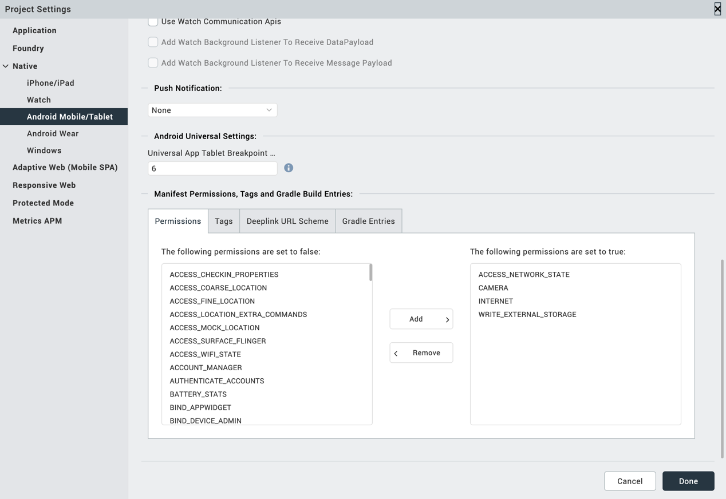

Enter the given snippet in Child tag entries under <manifest > tag
For Android below permissions are required in IRIS project setting > Native> Android Mobile/Tablet -> Tags (Child tag entries under tag) depending on the target version.
If target version is 33 and above below media permission must be added.
- <uses-permission android:name="android.permission.READ_MEDIA_IMAGES"/>
If target version is 34 and above below permission must be added along with other media permissions.
- <uses-permission android:name="android.permission.READ_MEDIA_VISUAL_USER_SELECTED"/>

2.Configuring Native Settings (iOS)
Follow the given steps to enable the permissions.
1. From the Project explorer, navigate to the Assets tab.
2. Right click Media and select Resource Location to open the project resources folder.
3. In the browser window that opens, navigate to the common folder.
4. Open the infoplist_configuration.json file with a text or code editor.
5. Add the given code at the end of the file. You can replace the values with your own descriptions.
{
"NSCameraUsageDescription" : " This app uses Camera ",
"NSPhotoLibraryUsageDescription" : "This app uses photo library"
}

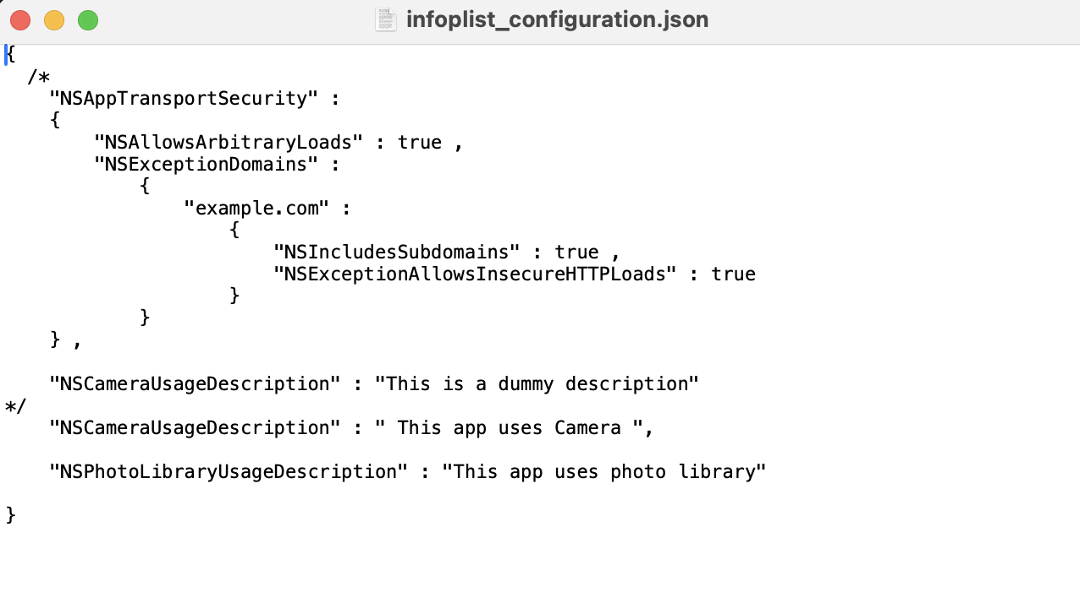
3.Save the file.

Building the app
From the menu bar, go to Build and then select Build Native Local.
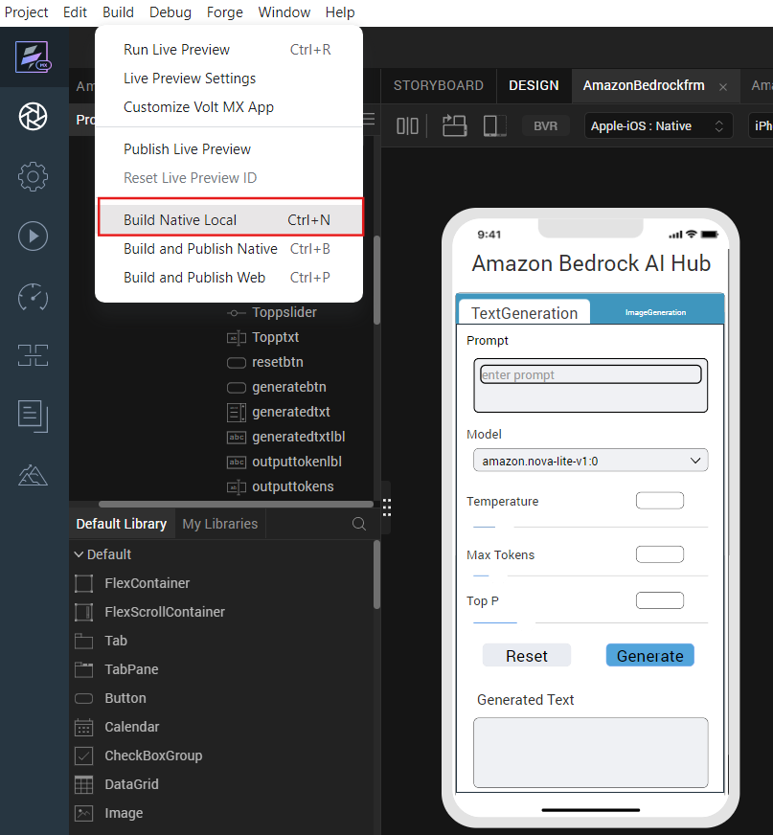
For Mobile, select Android and iOS. Click Build.
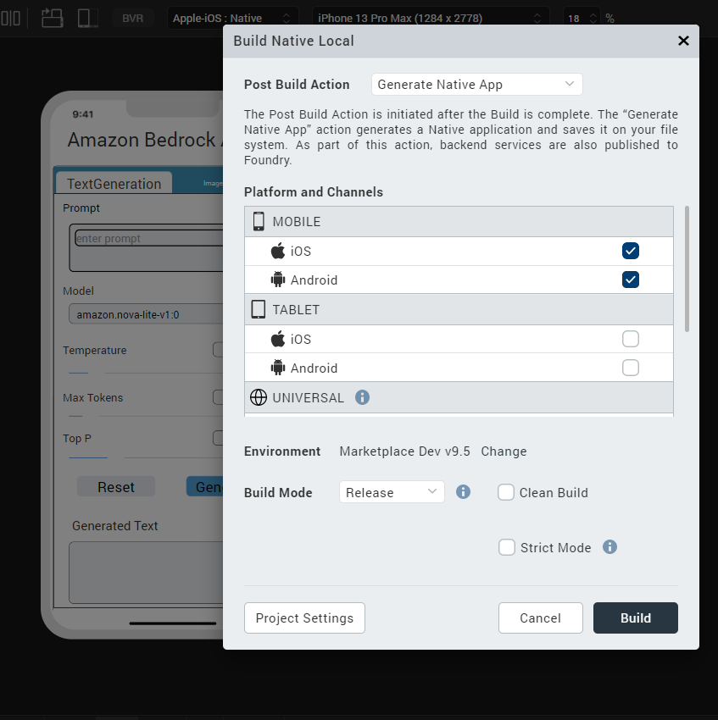

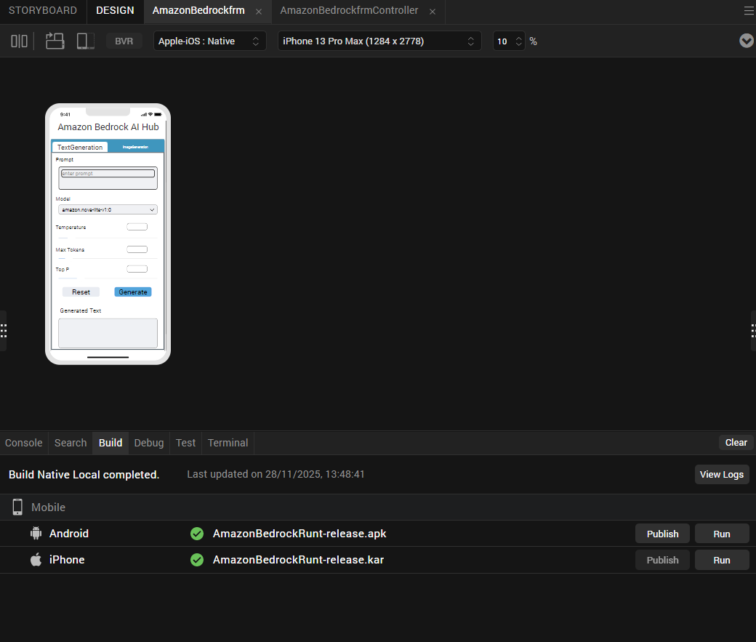

After the build is successful, run the app on your mobile device.

Application Flow
The landing page for the app is as follows:
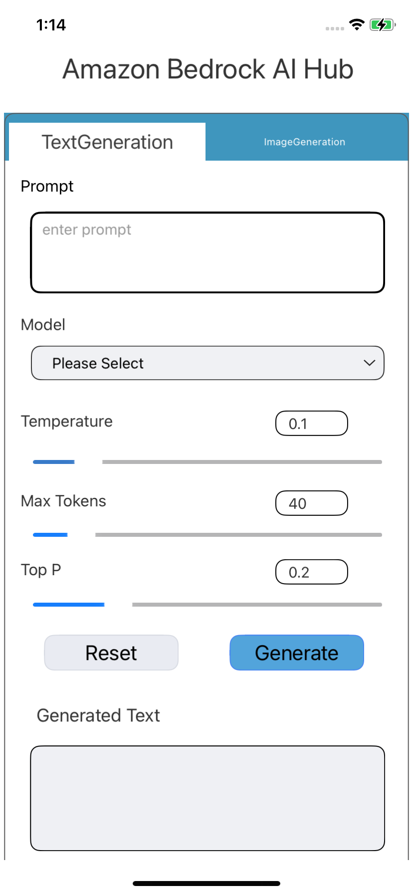

Enter a prompt, select a model, and specify the Temperature, Max Tokens, and Top-P values.
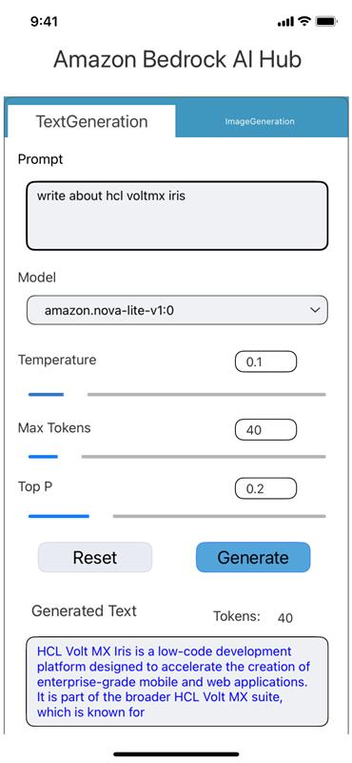

Enter a prompt, and the system will generate an image response based on it.

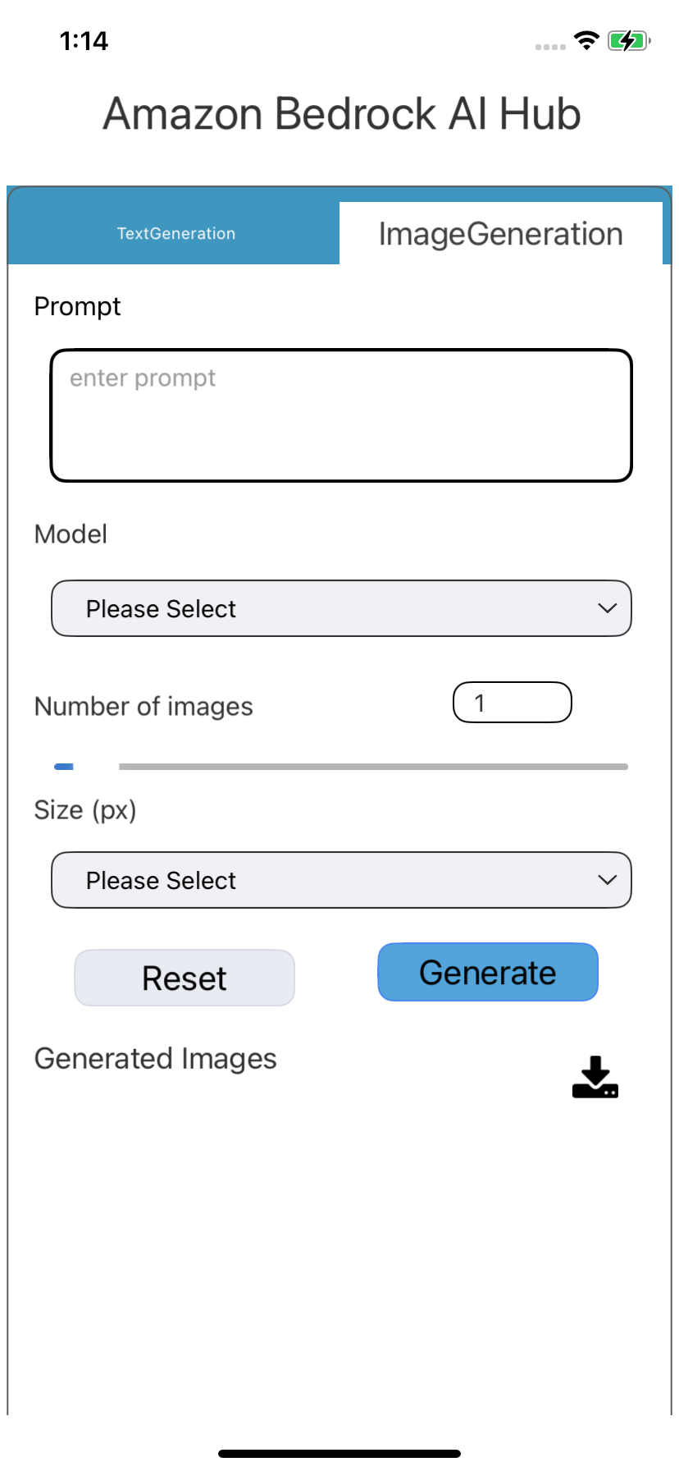

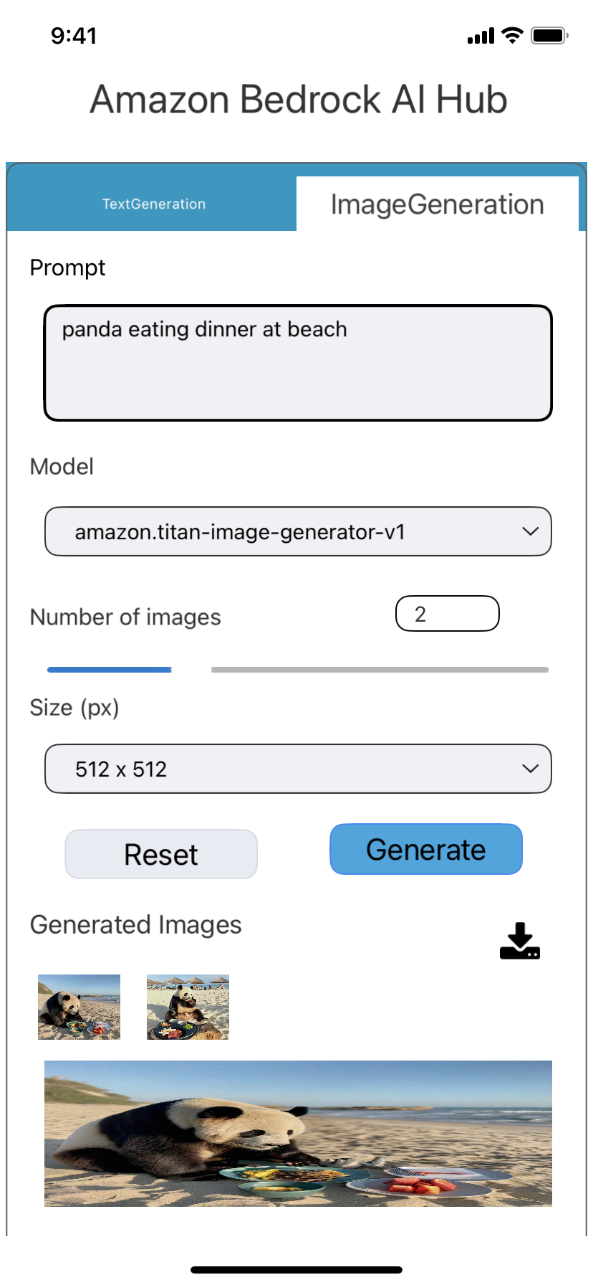

REVISION HISTORY
App version 1.0.0:

A. Limitations
1. Do not have support for Landscape mode.

B. Known Issue
- NA

