Date : 21-Nov-25

AMAZON BEDROCK RUNTIME

VERSION: 1.0.0

OVERVIEW
Amazon Bedrock Runtime is a fully managed AWS service that provides fast and scalable access to foundation models.It allows developers to run generative AI tasks like text, chat, embeddings, and image generation through simple APIs.The service supports leading models from Amazon, Anthropic, AI21 Labs, Stability AI, and more.It offers synchronous, streaming, conversational, and asynchronous inference options.Bedrock Runtime removes infrastructure complexity so teams can easily integrate AI into applications.

Use case:
- Chatbots & Virtual Assistants
- Text Summarization
- Code Generation
- Sentiment/Intent Detection
- RAG using Private Documents
- Text-to-Image Generation
- Multimodal AI Tasks

Features:
- Multi-model access: One API supports various FMs, including Claude, Llama, Stable Diffusion, Titan.
- Customization & RAG support: Fine-tune models privately and connect them to your data using Retrieval Augmented Generation (RAG). Knowledge Bases streamline ingesting data (docs, images, video) and feeding it to models
- Data automation: Automatically extract insights (like video summaries or document understanding) from unstructured content

Percentage of re-use:
90% (Data can be customizable and customers need to implement UI by themselves).

GETTING STARTED

Prerequisites
Before you start using the Amazon Bedrock Runtime data adapter, ensure you have the following:

- HCL Foundry
- An AWS Account,IAM Role.
Reference document: https://us-east-1.console.aws.amazon.com/bedrock/home?region=us-east-1#/

Creating an Integration Service with Amazon Bedrock Runtime
To create an integration service with Amazon Bedrock Runtime, do the following:
- Log on to your HCL Foundry The Dashboard page appears by default.
- In the left pane, click the API Management menu. The APIs tab opens by default.
- In the Foundry Apps, click "Add New" to create an Amazon Bedrock Runtime Adapter.
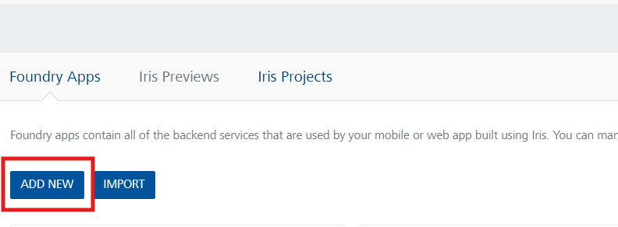
- Click the Integration tab. The Integration tab opens with a list of existing integration services.
- Click CONFIGURE NEW. The Service Definition tab opens.
- In the Name box, type a unique name for your service.
- From the Service Type list, Select JavaScript.
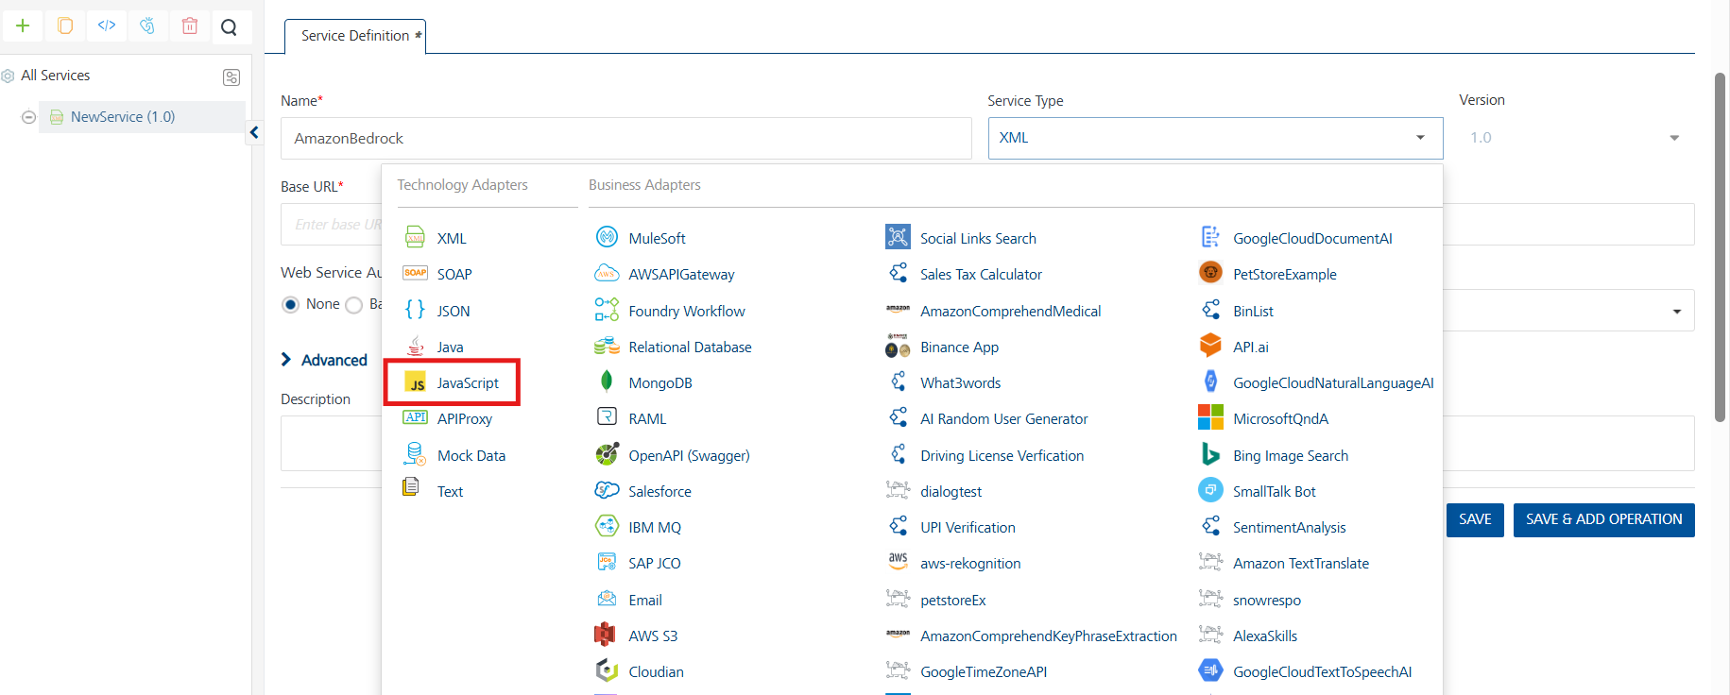
- After selecting the service type, upload a JavaScript file or select an existing one.
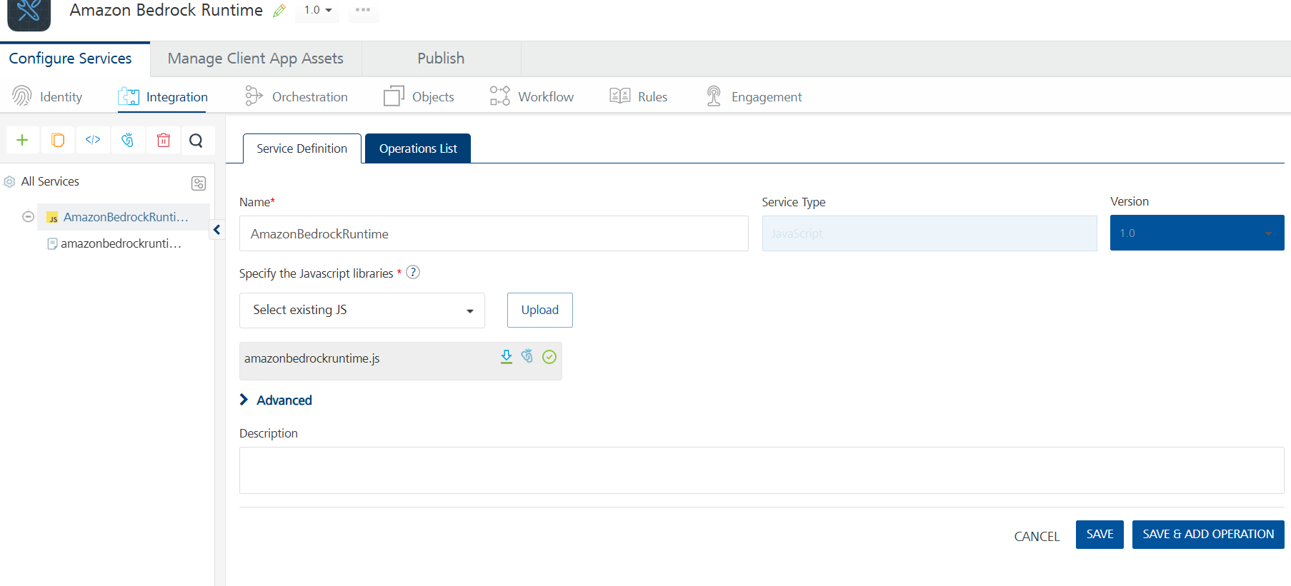
- Click Save and Add Operation
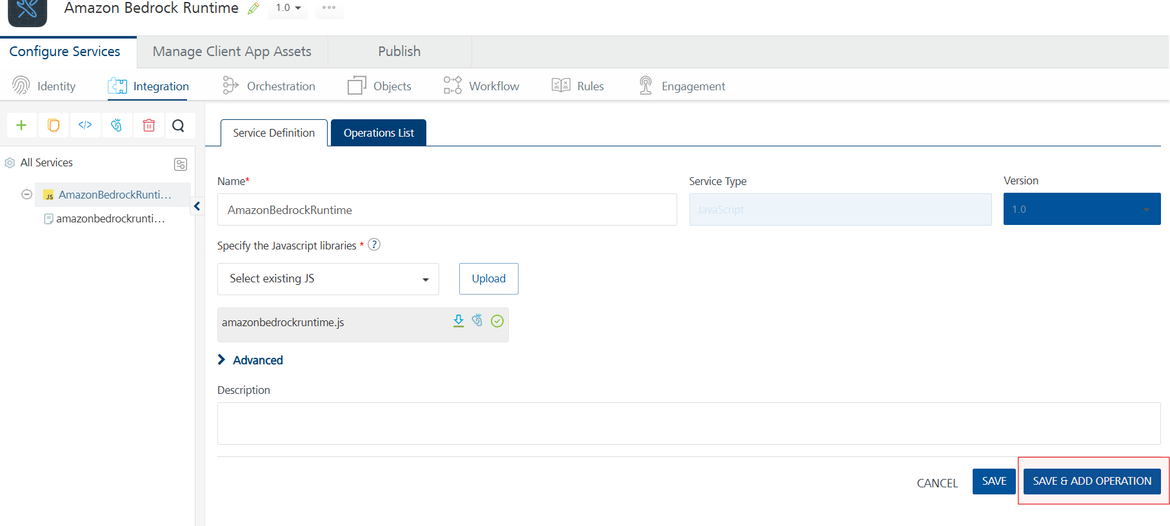

Creating an Operation
To make any API call in the Volt MX Foundry console, you must create an operation for the respective API and then execute the operation. Executing an operation involves making the API call and displaying the response. For more information, see Executing an Operation.
This section provides steps to create an operation for the Amazon Bedrock Runtime
Steps to create an operation for the Amazon Bedrock Runtime:
- Log on to your HCL Foundry. The Dashboard page appears by default.
- In the left pane, click the API Management menu. The APIs tab opens by default.
- Click the Integration tab. The Integration page appears with a list of existing integration services.
- From the list of integration services, select the integration service that you have created with the service type as JavaScript. The Service Definition tab of the selected integration service opens by default.
- Click the Operations List tab. The Operations List tab opens.
- Select the JavaScript library and choose the required operations and click Add Operation
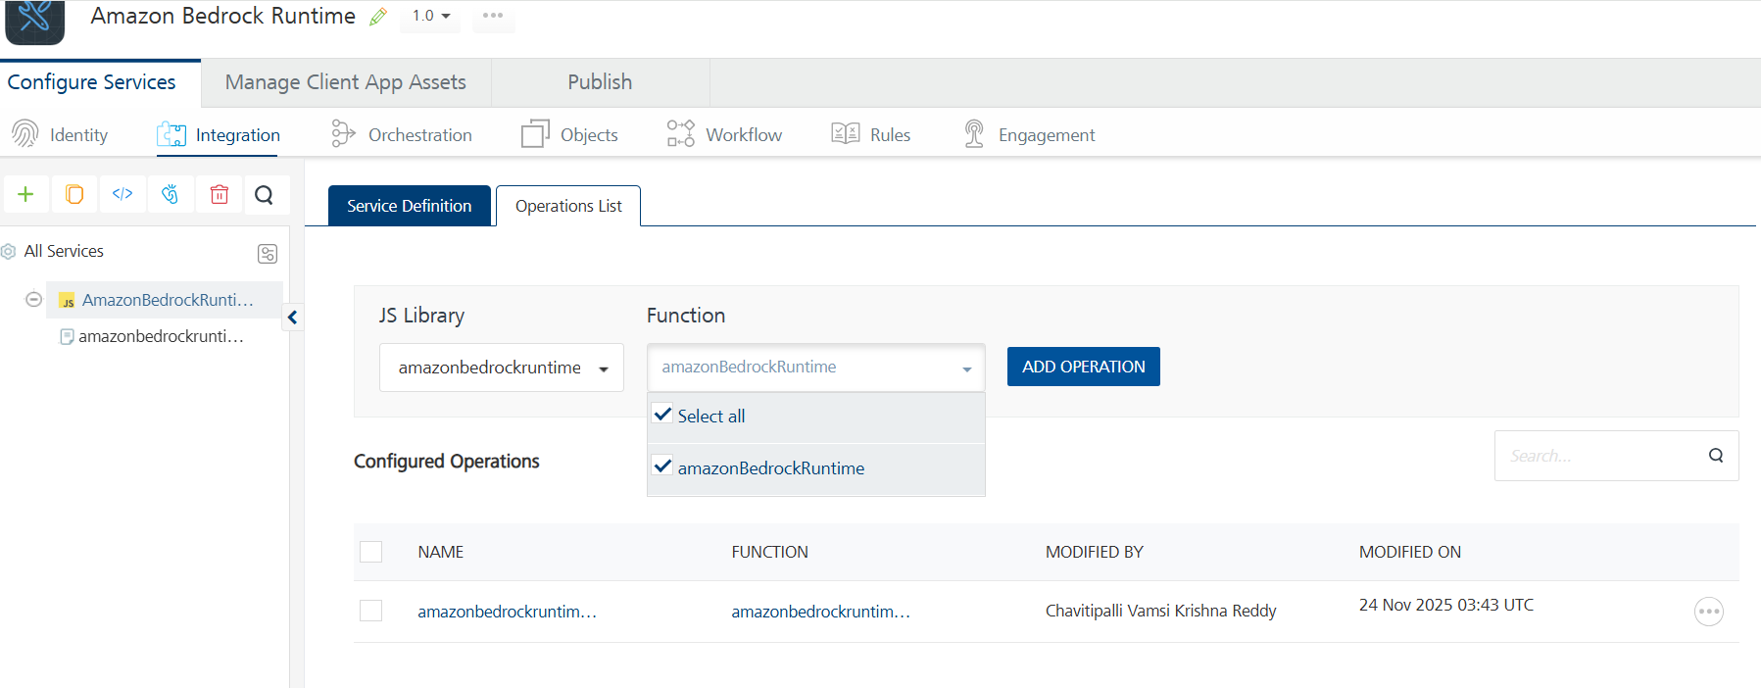
- The amazonbedrockruntime_amazonBedrockRuntime operation is listed in the Configured Operations section.
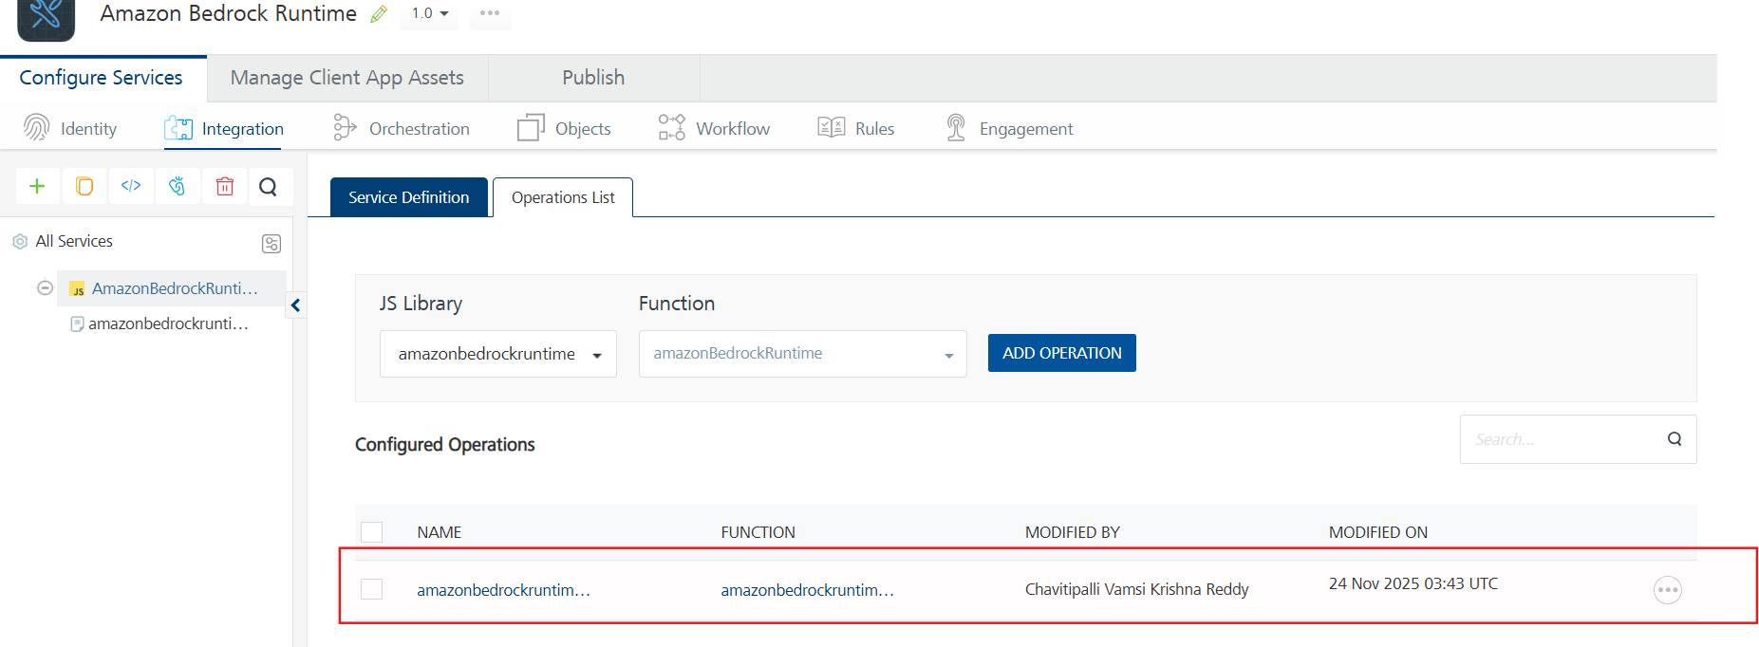
Note: You can follow the same steps to create operations for other methods, but ensure that you select the required JS Library.
You can create multiple operations with required JS Library and save them in the Configured Operations section. You can then execute the operations whenever required.

Executing an Operation
Executing an operation involves making the API call by setting the necessary parameters and displaying the response. The procedure to execute any operation is the same, but the request parameters of the APIs vary. For more information on request parameters of API, refer https://us-east-1.console.aws.amazon.com/bedrock/home?region=us-east-1#/providers
This section provides steps to execute the amazonbedrockruntime_amazonBedrockRuntime operation (explained in Creating an Operation).
Steps to execute the amazonbedrockruntime_amazonBedrockRuntime:
- Log on to your HCL Foundry. The Dashboard page appears by default.
- In the left pane, click the API Management menu. The APIs tab opens by default.
- Click the Integration tab. The Integration tab opens with a list of existing integration services. Open AmazonBedrockRuntime service .
- Click the Operations List tab.
- Under the Configured Operations section, click the amazonbedrockruntime_amazonBedrockRuntime operation. The amazonbedrockruntime_amazonBedrockRuntime tab opens with the Request Input sub-tab opened by default.
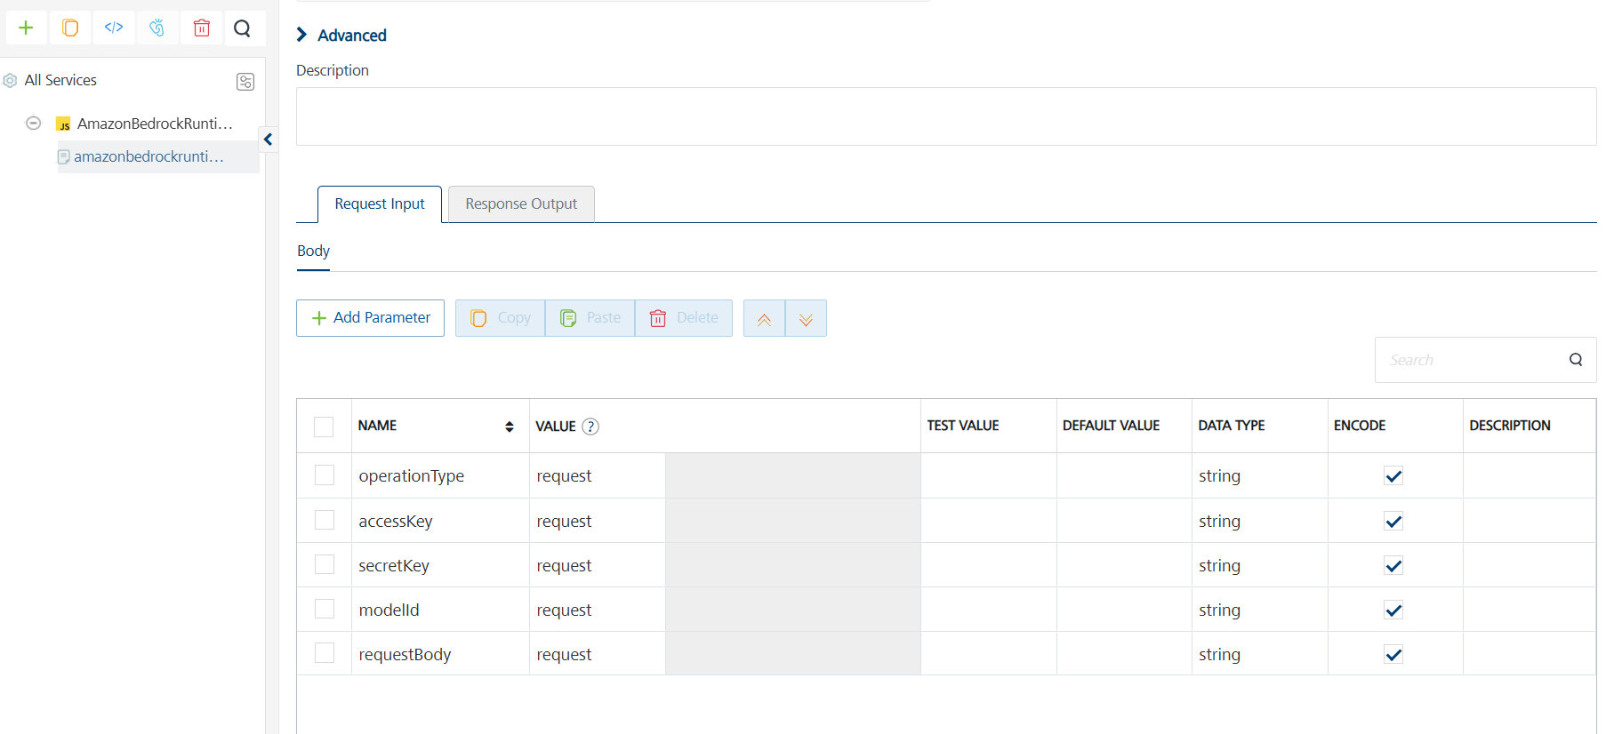
- In the Name box, the name of the operation is displayed by default. If you want, you can change the name.
- On the Request Input tab, in the Body section, for the following parameters, specify the values in the respective boxes under the Test Value column.

Mandatory Parameters
- For invoke,converse,countTokens operations
- ModelId: The ID of the model you want to use (e.g., amazon.nova-lite-v1:0).
- Region: The AWS region where the Bedrock service is deployed (e.g., us-east-1).
- accessKey: Your AWS access key used for authentication.
- secretKey: Your AWS secret key used for authentication.
- requestBody: The input text or message you want the model to process.
- operationType: The type of operation you want to perform(invoke, converse etc)

- Guardrail operation
- Region: The AWS region where the Bedrock service is deployed (e.g., us-east-1).
- accessKey: Your AWS access key used for authentication.
- secretKey: Your AWS secret key used for authentication.
- requestBody: The input text or message you want the model to process.
- operationType: The type of operation you want to perform(invoke, converse etc)
- guardrailVersion:
- guardrailIdentifier:

- Click SAVE OPERATION.
- Click SAVE AND FETCH RESPONSE. The Output Result dialog appears with the response. Otherwise, the Output Result shows an error.
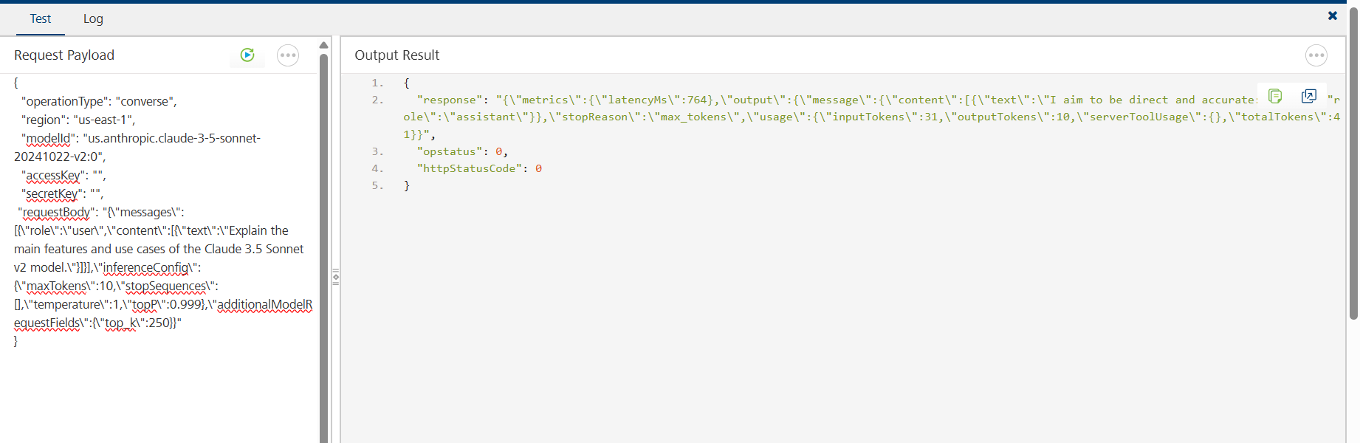

E. Create an IAM User
- Navigate to IAM in AWS Console:
  - Go to the IAM service.

2. Navigate to IAM Users
- On the left sidebar, click "Users"
- Click “Create User”

3. Configure User Details
- User name: Enter a unique user name
- Click Next.

4. Set Permissions
Choose “Attach policies directly”
Attach these policies (search and check each one):
- AmazonBedrockFullAccess
- Create Inline Policy and Add these lines
{
"Version": "2012-10-17",
"Statement": [
{
"Effect": "Allow",
"Action": [
"bedrock:InvokeModel"
],
"Resource": [ "arn:aws:bedrock:*::foundation-model/amazon.nova-lite-v1:0", "arn:aws:bedrock:*::foundation-model/amazon.titan-text-express-v1"
]
}
]
}
- Click Next.

6. Review and Create
- Review the configuration
- Click Create user
- Once the user is created, the Access Key ID and Secret Access Key will be displayed.

3. Publishing the App to Volt MX Foundry
After adding Amazon Bedrock Runtime to your app and configuring the necessary configurations, you must publish the app to Volt MX Foundry. For more information, refer to Publish a Project to Volt MX Foundry.
If you want to use the services in client applications, you need to publish the app to a run-time environment.
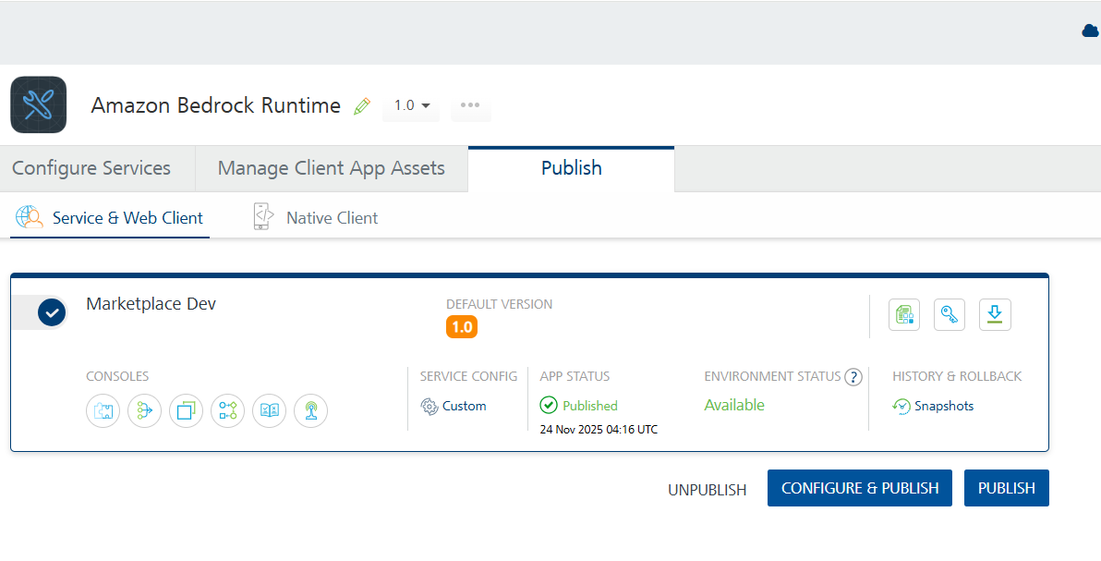
You can also link the Volt Foundry app to a client application.

4. Reference Document:
https://us-east-1.console.aws.amazon.com/bedrock/home?region=us-east-1#/

5. REVISION HISTORY
App version 1.0.0:

Known Issues
None

