Date : 23 Jan 2025

AMADEUS DATA ADAPTER

VERSION: 1.0.1

# **OVERVIEW**

Amadeus Data Adapter is a useful adapter that helps you rapidly build innovative travel apps. Amadeus Data Adapter connects to the Amadeus Travel Innovation sandbox and retrieves relevant information on the availability of flights, hotels, and rental cars. The adapter supports searching through geo-location, nearby airport, or airport code. The adapter also provides information on SNCF train routes.

Amadeus Data Adapter allows you to make Amadeus API calls directly from HCL Volt MX Foundry. You can import the Data Adapter into HCL Volt MX Foundry. After you import the Data Adapter, you can use the HCL Volt MX Foundry console to make Amadeus API calls and view the responses by creating and executing required operations.

Here is a use case that describes the use of Amadeus Data Adapter.

## **Use Case**

Consider a case of a customer who wants to develop an app with the following services using the Amadeus Travel Innovation Sandbox APIs:

* Search for available flights to travel from one place to another
* Search for hotels near the airport or within a specific range
* Search for a car or taxi.

In the above use case, you can develop the user interface and functionality of the mobile app using Volt MX Iris. To fetch the search results from Amadeus, you can use HCL Volt MX Foundry with Amadeus Data Adapter. In the HCL Volt MX Foundry console, you can create an integration service with the Amadeus Data Adapter and create operations with the following Amadeus APIs:

1. **Flight Affiliate Search:** Displays a list of available flights for the specified source, destination, and day.
2. **Hotel Airport Search:** Displays a list of hotels available near the specified airport along with prices, images, and so on.
3. **Car Rental Airport Search:** Provides the availability of rental cars near the specified airport along with details, such as price, type of car, and so on.

After you create the necessary operations, you can integrate your mobile app with the integration service that you created with Amadeus Data Adapter.

The following sections help you use the Amadeus Data Adapter:

## **Percentage of re-use:**

70% (Data can be customizable and customers need to implement UI by themselves).

# **GETTING STARTED**

## **Prerequisites**

Before you start using the Amadeus Data Adapter, ensure you have the following:

* An [Amadeus for Developers](https://developers.amadeus.com/) account
* An app created in your Amadeus account
* Access key issued by Amadeus when you created your app
* A [HCL Foundry](https://manage.hclvoltmx.com/)
* Volt MX Iris

## **Importing the Amadeus Data Adapter**

1. **Log on** to your [HCL Foundry](https://manage.hclvoltmx.com/). The Dashboard page appears by default.
2. From the left navigation bar, navigate to **API Management** and open the **Custom Data Adapters** tab.A screenshot of a computer

   Description automatically generated with low confidence
3. Click **IMPORT** to import a custom data adapter..

1. On the Import Data Adapter dialog box, click **IMPORT FROM HCL MARKETPLACE.** A screenshot of a computer

   Description automatically generated with low confidence
2. Search for the Amadeus data adapter and click **IMPORT**.

You can also download the data **adapter onto your** system as a **zip file** from [HCL Forge](https://marketplace.hclvoltmx.com/). You can then import the zip file into VoltMX Foundry.

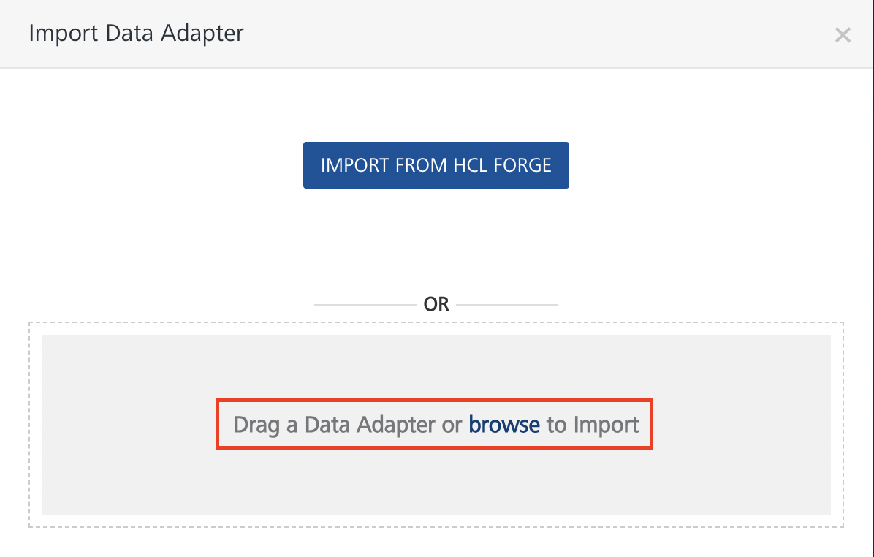

After you upload the data adapter, Foundry opens a window that shows the metadata of the data adapter.

After you import the data adapter, you can view it on the **Custom Data Adapters** page.

You need to create an application on Amadeus before you create services using the data adapter.

# **CREATING AN APPLICATION ON AMADEUS**

## Open the list of apps in your [Amadeus account](https://developers.amadeus.com/my-apps).

## Select **Create New Application**.

## Enter the details for the app, such as the**App name.**

## After you enter all the details, click **Create**.

## From the **Application Info** screen, make a note of the **API Key and API Secret**.

## 

## You need to enter the API key and API Secret when you create an Identity Service on VoltMX Foundry. You can refer to the Creating an Identity Service section for more information.

# **CREATING AN IDENTITY SERVICE**

After you create an app on Amadeus, you need to create an Identity Service on VoltMX Foundry. This service adds an authentication layer for the data adapter.

Follow the given steps to create an Identity Service.

1. Sign in to the [HCL Foundry](https://manage.hclvoltmx.com/) Console, the **Dashboard** page appears by default.
2. From the left navigation bar, navigate to **API Management**, the **Identity** tab is open by default.  
   A screenshot of a computer

   Description automatically generated
3. Click the **CONFIGURE NEW** button to create a new Identity Service.  
   A screenshot of a computer

   Description automatically generated
4. Select the **Type of Identity** as **OAuth 2.0**.  
   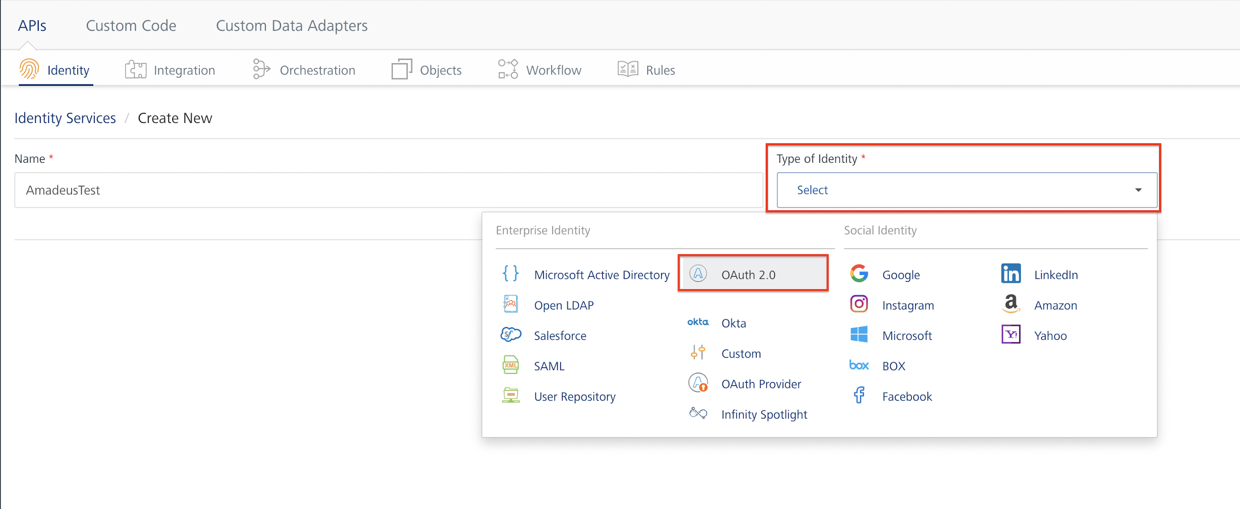
5. Under **Provider Details**, enter the OAuth Information that you got from Amadeus.  
   You can refer to the given table to match the fields on VoltMX Foundry with the OAuth Information on Amadeus.  
   A screenshot of a computer

   Description automatically generated

# **CREATING AN INTEGRATION SERVICE**

After you import the Data Adapter into VoltMX Foundry and create an Identity Service, you can create an Integration Service using the data adapter.

**Follow the given steps to create an Integration service using the Amadeus Data Adapter.**

1. Sign in to the [HCL Foundry](https://manage.hclvoltmx.com/). The **Dashboard** **page** appears by default.
2. From the left navigation bar, navigate to **API Management** and open the **Integration** tab.

1. Click the **+** button or the **CONFIGURE NEW** button to create a new Integration service.  
     
   A screenshot of a computer

   Description automatically generated
2. In the **Service Definition** tab, select the **Service Type** as Amadeus.  
     
   A screenshot of a computer

   Description automatically generated

**Note:**The **Amadeus** is listed only after you import the Amadeus Data Adapter into HCL Foundry.

1. Under **Authentication**, select the Identity Service that you created for Amadeus.  
     
   A screenshot of a computer

   Description automatically generated
2. Click **Save**.

**Note:**You can use the Integration Service in your VoltMX Foundry applications. For more information, you can refer to the [How to Use and Existing Integration Service](https://opensource.hcltechsw.com/volt-mx-docs/docs/documentation/Foundry/vmf_integrationservice_admin_console_userguide/Content/Integration_Services.html)  section in the VoltMX Foundry User Guide.

# **CREATING AN EXECUTING OPERATIONS**

After you create an integration service, you can create and execute operations using the service.

#### **Creating an Operation**

To make any API call in the HCL Volt MX Foundry console, you must create an operation for the respective API and then execute the operation. Executing an operation involves making the API call and displaying the response. For more information, see [Executing an Operation](https://docs.kony.com/marketplace/V8Marketplace/Content/Marketplace/amadeus.htm#Performi).

This section provides steps to create an operation for the **Airport & City Search API**.

1. From **API Management**, select the Integration Servicethat you created, and navigate to the **Operation List** tab.
2. From the drop down list, select the operations that you want to add, and click **ADD OPERATION**.  
     
   A screenshot of a computer

   Description automatically generated

**Note:**For information on the Amadeus APIs, you can refer to [Amadeus Developer Documentation](https://developers.amadeus.com/self-service/apis-docs).

**Note:**You can follow the same steps to create operations for other methods, but ensure that you select the required API.

You can create multiple operations with required APIs and save them in the **Configured Operations** section. You can then execute the operations whenever required.

#### **Executing an Operation**

Executing an operation involves making the API call by setting the necessary parameters and displaying the response. The procedure to execute any operation is same, but the request parameters of the APIs vary. For more information on request parameters of each API, refer [Self-Service travel API catalog | Amadeus for Developers](https://developers.amadeus.com/self-service).

This section provides steps to execute the **getAirportCitySearch** operation (explained in Creating an Operation).

1. From the **Operations List** tab, select the operation that you want to execute.  
     
   A screenshot of a computer

   Description automatically generated
2. Under the **Request Input** tab, enter a TEST VALUE or a DEFAULT VALUE for the fields.  
     
   A screenshot of a computer

   Description automatically generated
3. Select a run-time environment and click **Save and Fetch Response** to get a response from Amadeus based on your inputs.  
     
   A screenshot of a computer

   Description automatically generated

.

**Note:**

For information on the Amadeus APIs, you can refer to [Self-Service travel API catalog | Amadeus for Developers](https://developers.amadeus.com/self-service)

For more information on how to use the Integration Service in your applications, you can refer to the [How to Use and Existing Integration Service](https://opensource.hcltechsw.com/volt-mx-docs/docs/documentation/Foundry/vmf_integrationservice_admin_console_userguide/Content/Integration_Services.html) section in the VoltMX Foundry User Guide

# **PUBLISHING THE APP IN VOLTMX FOUNDRY**

After you add the Integration Service to a VoltMX Foundry app, you can publish the app to a run-time environment. For more information, refer to [Publish a Project to VoltMX Foundry.](https://opensource.hcltechsw.com/volt-mx-docs/docs/documentation/Iris/iris_user_guide/Content/PublishVoltMXFoundryServicesApp.html)  
  
You can then link the VoltMX Foundry app to a client application. For more information, you can refer to the following documents:

* [SDKs Section](https://opensource.hcltechsw.com/volt-mx-docs/docs/documentation/Foundry/voltmx_foundry_user_guide/Content/Foundry_SDKs.html) in VoltMX Foundry User Guide
* [Connect to Services section](https://opensource.hcltechsw.com/volt-mx-docs/docs/documentation/Iris/iris_user_guide/Content/Connecting_to_Services.html) in the VoltMX Iris User Guide

# **REVISION HISTORY**

App version 1.0.1:

## **Known Issues**

## N/A

## **Limitations**

## N/A