CTO LAB

KONY  7380 W SANDLAKE RD, ORLANDO

KONY FABRIC – OAUTH –ALEXA INTEGRATION Steps

# Steps below explain, how to integrate an OAuth based connection with Amazon Alexa and Kony Fabric by adding an Alexa skill into your AWS console that is authenticated using a Kony companion app and Kony Fabric as the OAuth endpoint.

## Step 1:

## Download the “accountant” app from Kony marketplace. Login to Kony Fabric, click on apps, click on import and choose the downloaded “accountant” app. App will appear in your account.

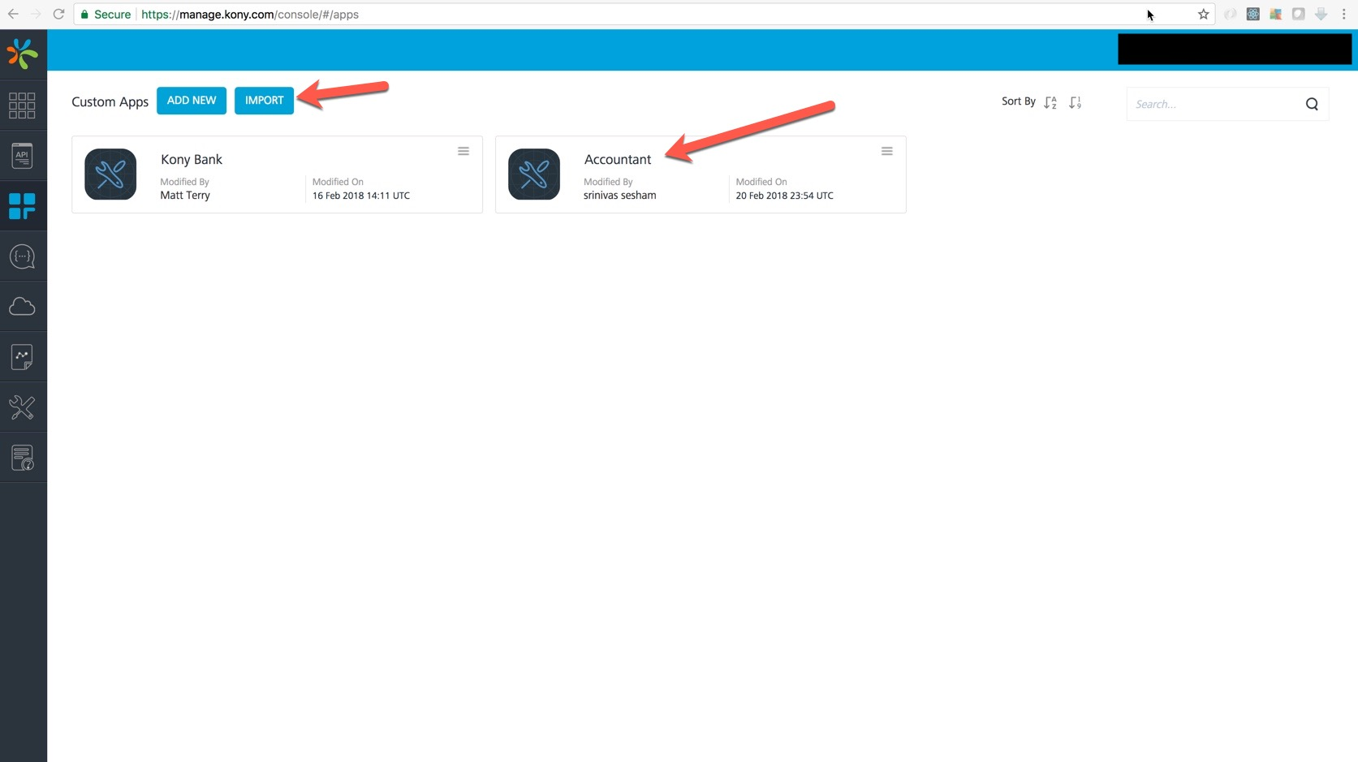

## Step2: Click on the app and go to “Identity” tab, you should see 2 entries like below. Click on Kony User Repository

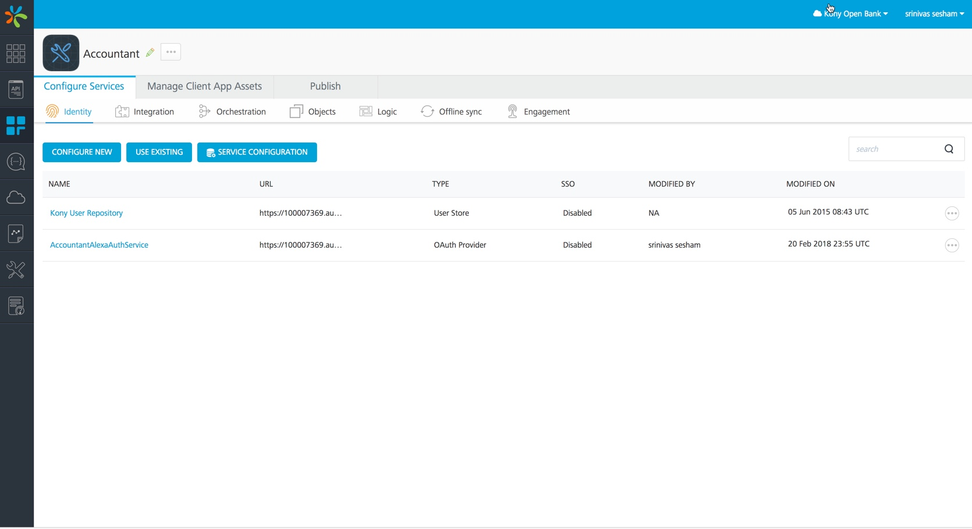

## Step3: Click on Add user to create a user for OAuth, make a note of the credentials, you will be using these credentials during account linking of the Alexa Skill

## Step4: Under Identity click “AccountantAlexaAuthService” and note down the “token endpoint”, “Authorization Endpoint”. You will need these details when you create the Alexa Skill.

## Step5: Click on Integration tab and make use the identity service for backend token is AccountantAlexaAuthService

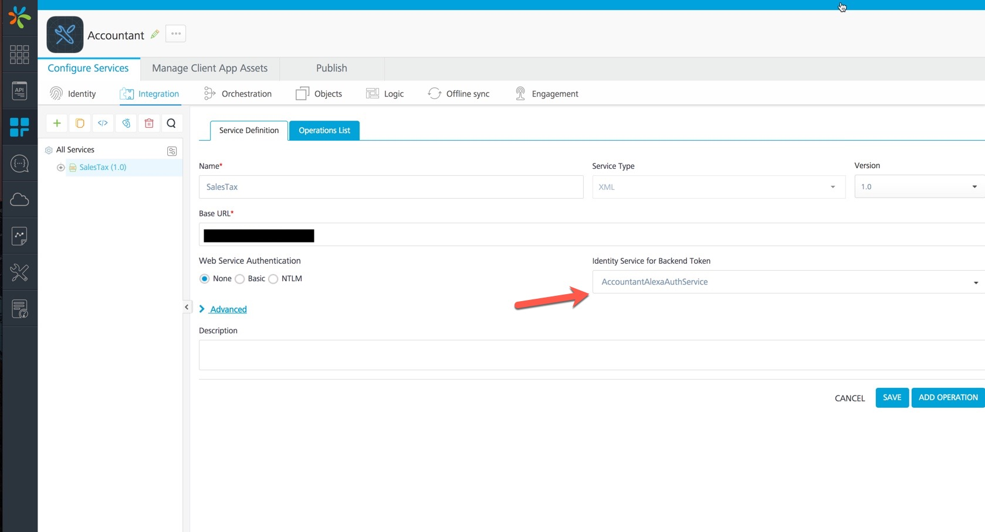

## Step 6: Click on “publish tab”, select the environment you want the application to be published to. Click “Publish button”.

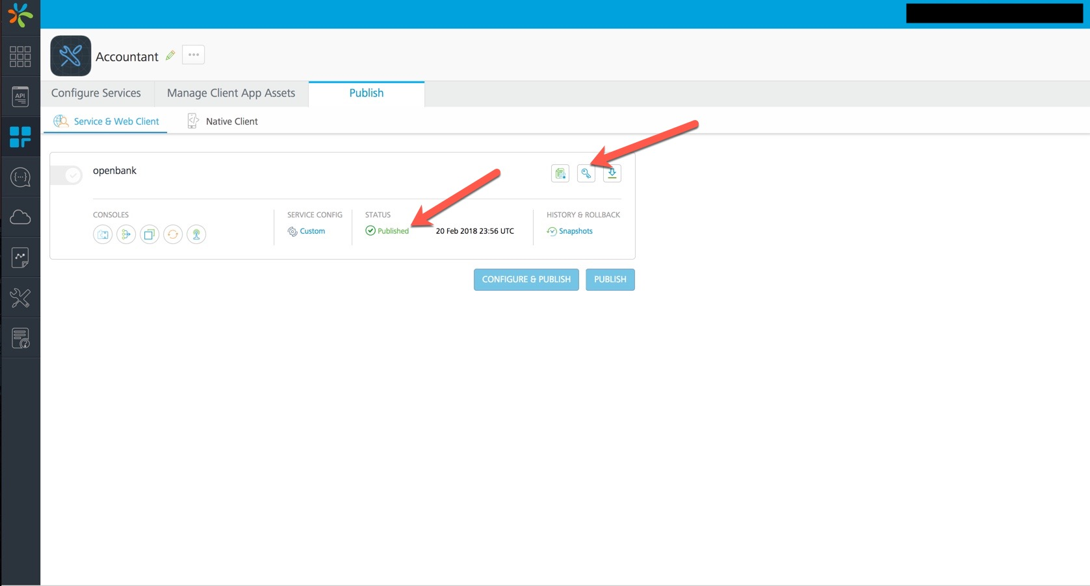

## Step 7: You should see the app key, secret popup on successfully publishing the app. You can always click on the key icon to retrieve these details. Make a note of the app key /secret, you would need these while creating the Alexa skill.

## 

## Step 8: Login to your account on AWS console portal and click on Lambda. Create a function ex: salesTaxSkill

## 

## Step9: Your function configuration should like below. Make a note of the ARN on the top right corner, you will need while creating the Alexa Skill. Download lambda.zip from marketplace and upload it here by clicking upload a zip file under “Function code”. Save the function.

## 

## Step 10: Login to Alexa console portal. Create a skill Ex: Kony Accountant. Enter your lambda ARN (Noted in Step10) in Default text box. Enter Authorization URL and client Id (app key) from step 8.

## 

## Step11: Enter Access Token URI, Client Secret from Step 8

## 

## Step12: Go through the rest of the steps and click publish to get your skill certified.

## 

## High level architecture

Description: The below diagram shows the design time tools used and also explains high level sequence of the steps a user goes through to add the Alexa skill, it also shows the responsibility of each of the components.

## Design Time:

Kony Fabric Console: Is used to create the accountant application which will have the OAuth service.

AWS Lambda Console: Is used to create the Lambda Function which will be used from your Alexa Skill.

Alexa Skill Console: Is used to create the Alexa Skill. This is where you configure the skill to use Kony Fabric hosted OAuth provider.

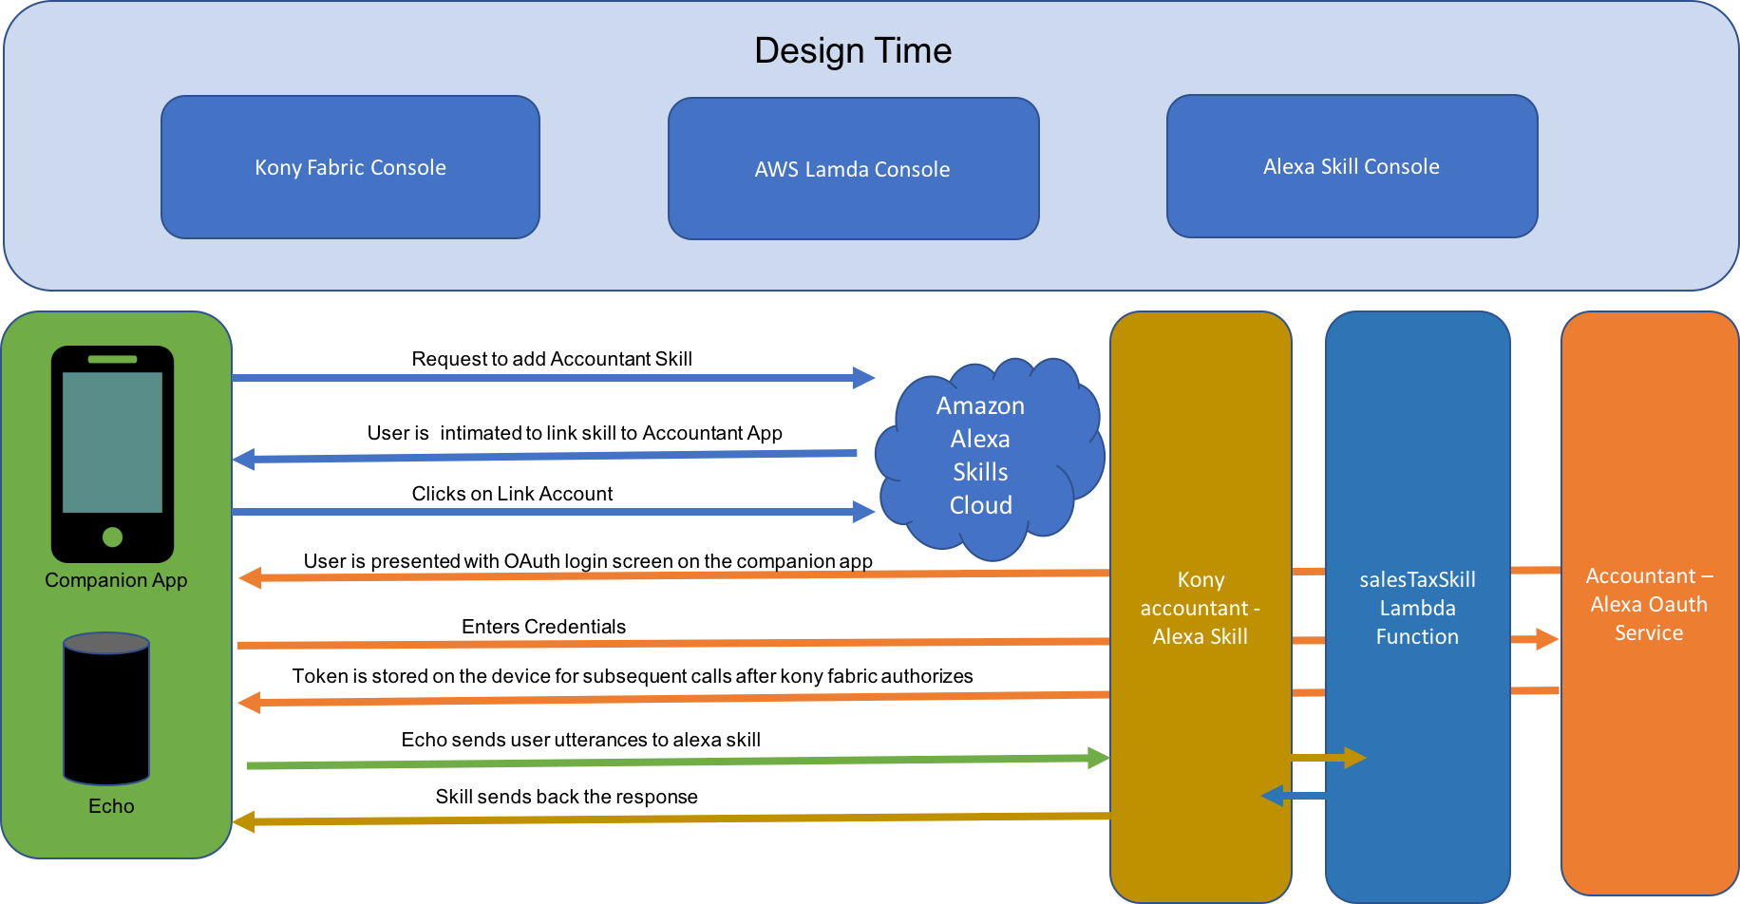

When a user tries to add the Alexa Skill, the typical steps followed are represented above.

* The user opens the Alexa companion app and selects the skill he wants to install.
* If the skill requires account linking (which is the case with our app), the user is presented with the OAuth login screen.
* User enters the credentials
* Kony Fabric authorizes the user and a token is sent back to the device
* Token is stored on the device and will be used in subsequent calls