**19-04-2024, v1.0.0**

# AI Textraction App

**AI Textraction App** uses a powerful AI-powered text parser that extracts custom user-defined entities from unstructured text. It can extract exact values (examples: prices, dates, names, emails, phone numbers), semantic answers (examples: main topic, diagnosis, customer’s request), and it is pretty much limited by the imagination.

# Pre-requisites

Before you start previewing the AI Textraction app on your device, ensure that you have the following:

1. A [Volt Foundry](https://manage.hclvoltmx.com/) Account
2. Volt Iris
3. [Rapid API Account](https://rapidapi.com/sohailglt/api/ai-image-generator3)
4. X-RapidAPI-Key, X-RapidAPI-Host

# App Functionality

## **Overview**

The landing page of the AI Textraction App is the Home screen. The Home screen displays the 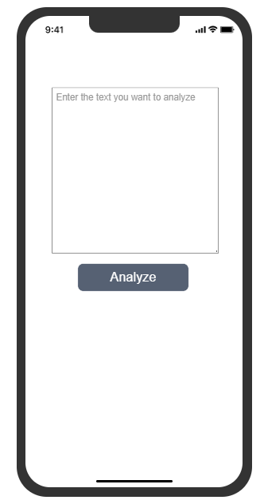following input and button:

To analyze text, simply enter it in the textbox and click "Analyze." The results will be displayed based on your chosen parameters.

## **Features**

This app utilizes a robust AI Textraction API. To ensure optimal performance, you'll need a RapidAPI account and subscription to [AI Textraction API](https://rapidapi.com/TextractionAI/api/ai-textraction). Creating an account is free and grants you access to your unique API key. This key acts as your authentication token within the app's header, allowing you to unlock the full potential of the AI.

# Importing the App to Volt Iris

To import the **AI Textraction app** into your workspace, there are two ways of doing it:

## From Volt Iris

1. Open **Volt Iris**.
2. Click **Project** **> New Project**and enter the **project name**.
3. Select the Project Type, device, add Project Name and click **Create**.
4. On the main menu bar select**Forge > Browse**.
5. If you have not logged in to Volt Iris, you are prompted to log in with your Foundry credentials and subsequently open the Forge browser inside Volt Iris.

1. The HCL Marketplace window appears.
2. Search for the **AI Textraction app** and click the thumbnail to open the details page. Then click **Import to Workspace**. The app is imported to your workspace.

1. A dialog box is shown once the app is imported. Click **OK**.

## From HCL Marketplace

1. Open a web browser and enter
   1. <https://marketplace.demo-hclvoltmx.com/> if you have a demo/on-prem account.
   2. <https://marketplace.hclvoltmx.com/> if you have a paid cloud account.

in the address field. The Marketplace page displays the list of components.

1. Search for **AI Textraction App** and click the corresponding thumbnail. The App detail page appears.
2. Click Log in to Download (in case you have not logged in already) else click **Download**. The app (zip) file is downloaded to your local system.
3. Open **Volt Iris**.
   1. On the **Project** menu, point to **Import**, and click **Local Project > Open as New Project > From an Archive**.
   2. Browse and select the downloaded zip file.
   3. Click **Open**.

# Configuring the AI Textraction Service:

Once you have a **RapidAPI** account and respective key, follow these simple steps:

## **In Volt Iris:**

1. **Navigate to the Analyze Button Properties:** In Volt Iris, select the "**Generate**" button. On the right-hand side, locate the "**Properties**" section.
2. **Set the OnClick Action:** Within the "**Properties**" section, find the "**Action**" tab and select "**OnClick**" Action.
3. **Add Your Custom Headers:** After the action editor opens, under "**InvokeService**" action, look for the option to "**Add custom HTTP headers**." This is where you'll add your unique API key obtained from your RapidAPI account.

## **In Volt Foundry:**

1. **Log in** to your [Volt Foundry](https://manage.hclvoltmx.com/) Account
2. From the left navigation menu, select **Apps**.
3. Locate the application you imported from the marketplace and select it.
4. Within your chosen app, find the "**Configure services**" section and select "**Integration**."
5. In the **Integration** section, select the service associated with AI Textraction.
6. Once you've selected the service, navigate to the "**Operations List**" tab.
7. From the list, identify the operation named "**Textraction**".
8. On the Operation Page, locate the **Request Input** tab. Under **Header** type your X-RapidAPI-**Key** & X-RapidAPI-**Host values**.
9. **Save** the operation.

# Building and previewing the app

After performing all the above steps, you can build your app and run it on your device. For more information, you can refer to the [Building and Viewing an Application](https://opensource.hcltechsw.com/volt-mx-docs/docs/documentation/Iris/iris_user_guide/Content/Cloud_Build_in_VoltMX_Iris.html#cloud) section of the Volt MX User Guide.

You can then run your app to see the AI Textraction App work in real time.

For more information on HCL Volt MX App for previewing your app, you can refer the [Volt MX App Documentation](https://opensource.hcltechsw.com/volt-mx-docs/95/docs/documentation/Iris/iris_app_viewer/Content/FunctionalPreviewStarter.html).

For more information on AI Image Generator adapter used in this app, you can refer the [Volt MX Marketplace](https://marketplace.demo-hclvoltmx.com/items/ai-textraction?search=ai%20textraction).