Date :  26-02-2024

ai sentence expander

version: 1.0.0

# **Overview**

The AI Sentence Expander API is a powerful tool designed to enhance and elaborate on existing text. This API takes simple, concise sentences and rewrites them into more detailed and expanded versions, maintaining the original meaning while adding depth and complexity. It’s ideal for content creators, writers, and marketers looking to enrich their text and make it more engaging. The API employs advanced natural language processing techniques to ensure that the expanded sentences are not only grammatically correct but also contextually appropriate, making it a valuable asset for improving the quality of written communication.

The AI Sentence Expander API is an innovative tool designed for enhancing textual content. It utilizes state-of-the-art natural language processing techniques to transform concise sentences into more elaborate and detailed versions. This transformation is done while maintaining the original meaning and context of the sentence, which is a crucial aspect of its functionality.

**Use case:**

This API is particularly valuable for a wide range of users including writers, marketers, educators, and anyone involved in content creation or editing. Its ability to enrich sentences with synonyms, adjectives, and relevant descriptive phrases significantly improves the depth and readability of the text, making it more engaging and informative. This is especially useful in content writing for SEO optimization, where detailed and keyword-rich text is favoured.

One of the key advantages of this API is its time-saving aspect. It automates the process of text expansion, which can be a tedious and time-consuming task when done manually. This feature is particularly beneficial for professionals who handle large volumes of text and need to maintain a high standard of writing quality. The consistency in the quality of the expanded sentences ensures that the outputs are professional and coherent.

The AI Sentence Expander API is also versatile in its applications. It can be used to enhance blog posts, articles, and product descriptions, making them more informative. In the academic sector, it assists students and researchers in elaborating their ideas for papers and reports. In the realm of marketing, it can be used to enrich advertising copy or social media posts, thereby enhancing their impact and engagement level.

From a technical standpoint, the API is built on robust machine learning models that have been trained on a vast corpus of text. This training allows the API to understand various contexts and styles of writing, making it adaptable to different types of content. The API is designed for easy integration into existing content management systems, writing tools, or websites, making it a flexible solution for many businesses and individuals.

In conclusion, the AI Sentence Expander API is a transformative tool in the field of content creation and natural language processing. It combines efficiency, quality, and versatility, making it an essential tool for anyone involved in writing or text editing. Its ability to maintain the essence of the original text while expanding its detail and richness makes it a unique and valuable asset in various writing and editing scenarios.

# **Getting Started**

## **Prerequisites**

* Volt Foundry
* [**Rapid API Account**](https://rapidapi.com/firdavscoder1/api/ai-sentence-expander)
* X-RapidAPI-Key, X-RapidAPI-Host.

## **Importing the adapter**

**To import the Data Adapter to Volt Foundry, do the following:**

1. Sign in to the  [HCL Foundry](https://manage.hclvoltmx.com/).
2. From the left navigation menu, select **API Management**.
3. In **API Management**, select **Custom Data Adapters**.  
   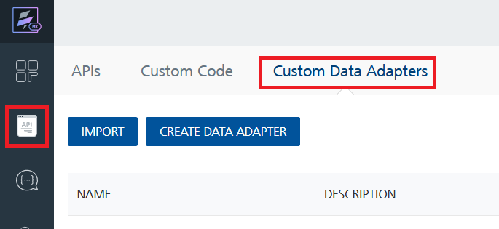
4. Click **IMPORT** to import a custom data adapter.  
   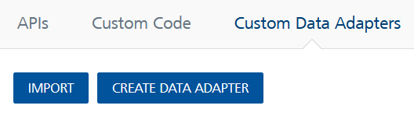
5. On the Import Data Adapter dialog box, click browser to import.  
   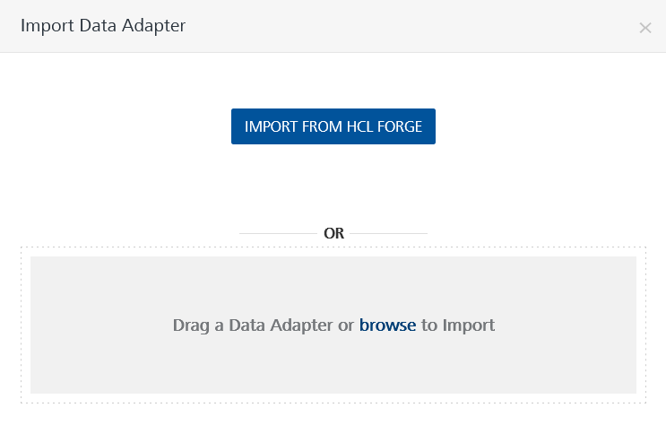
6. Select **AI Sentence Expander zip** file and click **IMPORT**.

After you import the data adapter, Volt Foundry opens a window that shows the metadata of the data adapter.

After you import the data adapter, you can view it on the Custom Data Adapters page and use it to create services on Volt Foundry.

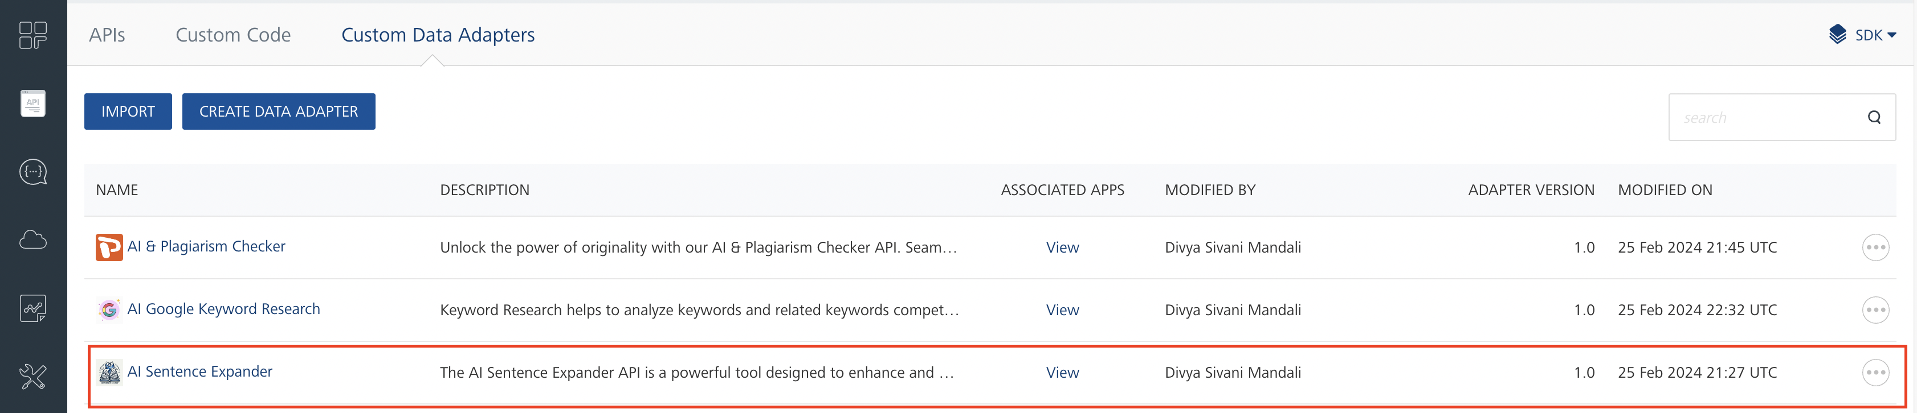

## **Creating an Integration service**

After you import the data adapter into Volt Foundry, you can use it to create an Integration Service.

Follow the given steps to create an Integration service using the **AI Sentence Expander** Adapter.

1. Sign in to the [HCL Foundry](https://manage.hclvoltmx.com/).
2. From the left navigation menu, select **API Management**.
3. In **API Management**, select **Integration**.

1. To create a new service, click the **+** button or the **CONFIGURE NEW** button.

1. On the Service Definition tab, select the service type as**AI Sentence Expander,** and click **SAVE**.

Alternatively, you can also create a Foundry app and create an Integration service inside it.

## **Creating and Executing operations**

After you create an integration service, you can create and execute operations using the service.

#### **Creating an Operation**

* In **API Management/Foundry app you created**, in the **Integration** section, select the service that you created.
* After you select the service, navigate to the **Operation List** tab.  
  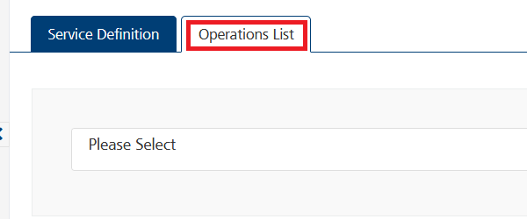
* From the drop-down list, select an operation that you want to execute, and click **ADD OPERATION**.

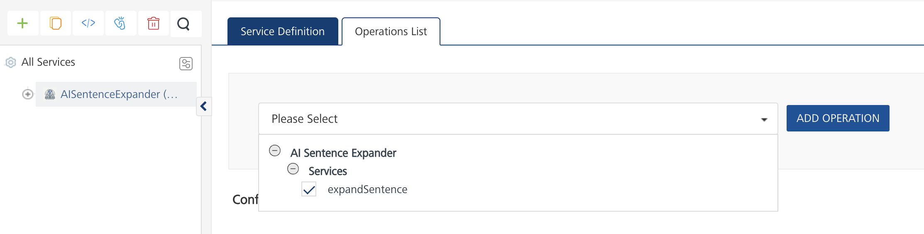

#### **Executing an Operation**

* From the **Operations List** tab, in the **Configured Operations** section, select the operation you want to execute.

* On the Operation Page, in the **Request Input** tab, in the **Body** section, for the following parameters, specify the values in the respective boxes under the **Test Value** column.

**Mandatory Parameters**

* + **X-RapidAPI-Key, X-RapidAPI-Host [in header]:**  API Key associated with your RapidAPI account, required for authentication.

To get keys – Login in to [**Rapid API Account**](https://rapidapi.com/firdavscoder1/api/ai-sentence-expander)-> You can view your keys.

* + **sentence:** The sentence to be expanded.

* Select a run-time environment and click **Save and Fetch Response** to get a response based on your inputs.

## **Publishing your application**

If you want to use the services in client applications, you need to publish an app to a run-time environment. You can create the service (as described above) in an application or import the service into an application and publish the application.

# **References**

## Endpoint Documentation

## **Requests Input Parameters**

|  |  |
| --- | --- |
| **Parameter** | **Description** |
| X-RapidAPI-Key(string) | **[Required]** **[Header]**API Key associated with your account. |
| X-RapidAPI-Host (string) | **[Required]** **[Header]** The host parameter specifies the domain name or IP address of the RapidAPI endpoint. In the context of the AI Sentence Expander, the default host is set to 'ai-sentence-expander.p.rapidapi.com'. This parameter is necessary for routing the request to the appropriate API endpoint. |
| sentence (string) | **[Required]** The sentence to be expanded. |

### **Response Output Parameters**

|  |  |  |
| --- | --- | --- |
| **Object Property** | **Data Type** | **Description** |
| expanded_sentence | String | The expanded sentence generated by the AI Sentence Expander API. |

**Reference Document:**  [AI Sentence Expander API Documentation (firdavscoder1) | RapidAPI](https://rapidapi.com/firdavscoder1/api/ai-sentence-expander)

# **Revision History**

Adapter version 1.0.0:

## **Known Issues**

* No Known Issues

## **Limitations**

* No limitations