Date :  20-10-2023

Airport info (1.0.0)

# Overview

Fastest and most complete database of airport codes and data, including address, phone number, website and more.

# Getting Started

## Prerequisites

* Volt Foundry
* Api key from <https://rapidapi.com/Active-api/api/airport-info>

Note:Provide this Api-Key in header part.

## Importing the adapter

**To import the Data Adapter to Volt Foundry, do the following:**

1. Sign in to the  [HCL Foundry](https://manage.hclvoltmx.com/).
2. From the left navigation menu, select **API Management**.
3. In **API Management**, select **Custom Data Adapters**.  
   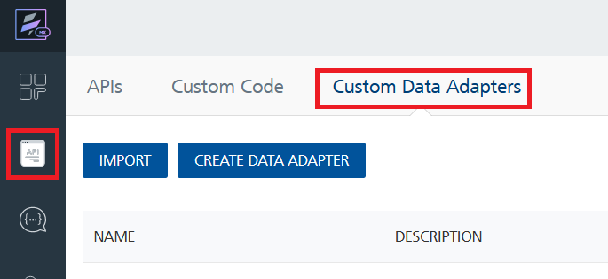
4. Click **IMPORT** to import a custom data adapter.  
   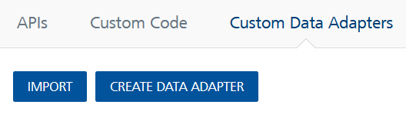
5. On the Import Data Adapter dialog box, click browser to import.  
   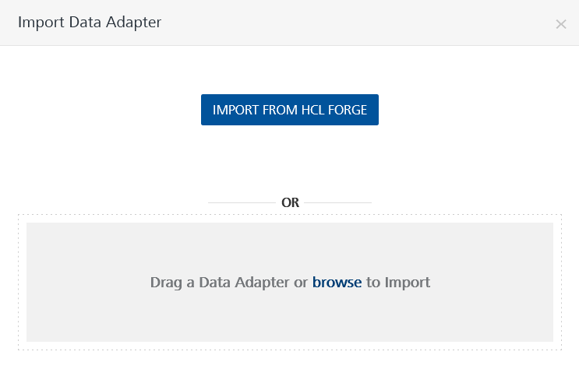
6. Select Airport Info zip file and click **IMPORT**.

After you import the data adapter, Volt Foundry opens a window that shows the metadata of the data adapter.

After you import the data adapter, you can view it on the Custom Data Adapters page and use it to create services on Volt Foundry.

## [Creating an Integration service](javascript:void(0);)

After you import the data adapter into Volt Foundry, you can use it to create an Integration Service.

Follow the given steps to create an Integration service using the AirportInfo Adapter.

1. Sign in to the [HCL Foundry](https://manage.hclvoltmx.com/).
2. From the left navigation menu, select **API Management**.
3. In **API Management**, select **Integration**.  
   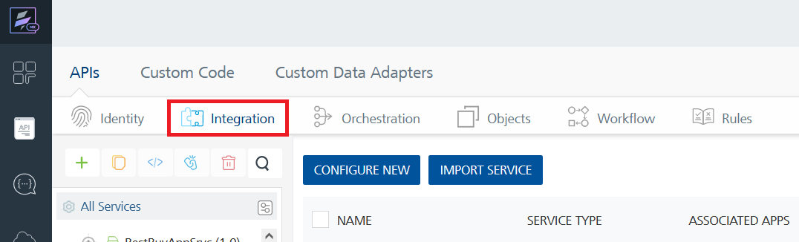
4. To create a new service, click the **+** button or the **CONFIGURE NEW** button.  
   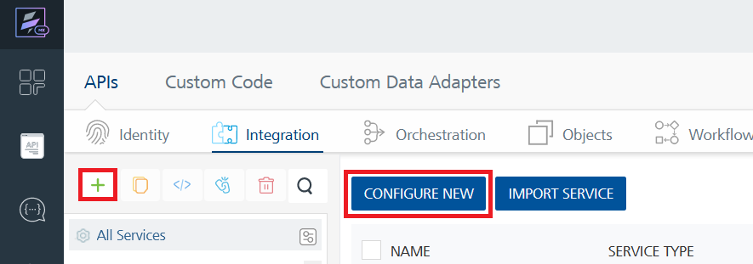
5. On the Service Definition tab, select the service type as AirportInfo and click **SAVE**.

Alternatively, you can also create a Foundry app and create an Integration service inside it.

D. [Creating and Executing operations](javascript:void(0);)



After you create an integration service, you can create and execute operations using the service.

#### **Creating an Operation**

* In **API Management/Foundry app you created**, in the **Integration** section, select the service that you created.
* After you select the service, navigate to the **Operation List** tab.  
  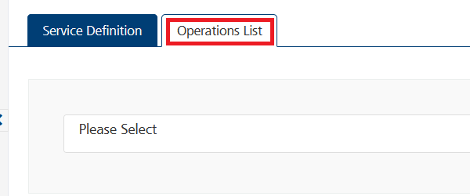
* From the drop down list, select an operation that you want to execute, and click **ADD OPERATION**.  
  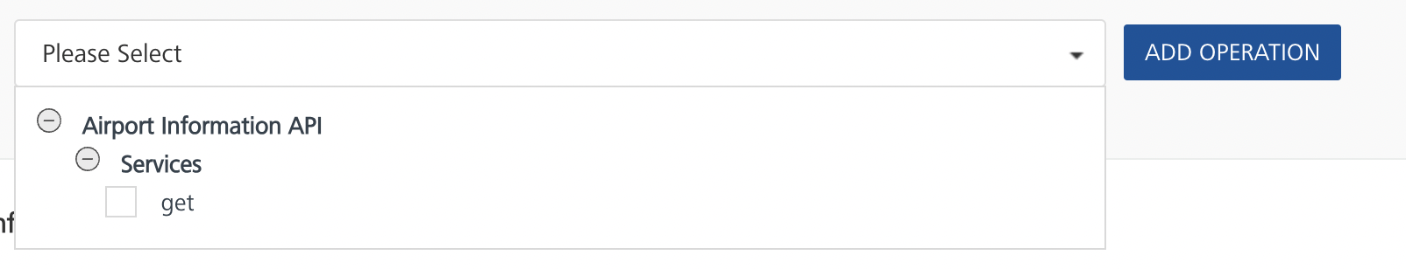

#### **Executing an Operation**

* From the **Operations List** tab, in the **Configured Operations** section, select the operation you want to execute.

* On the Operation Page, in the Request Input tab, enter a TEST VALUE for all the fields.

* Select a run-time environment and click **Save and Fetch Response** to get a response based on your inputs.

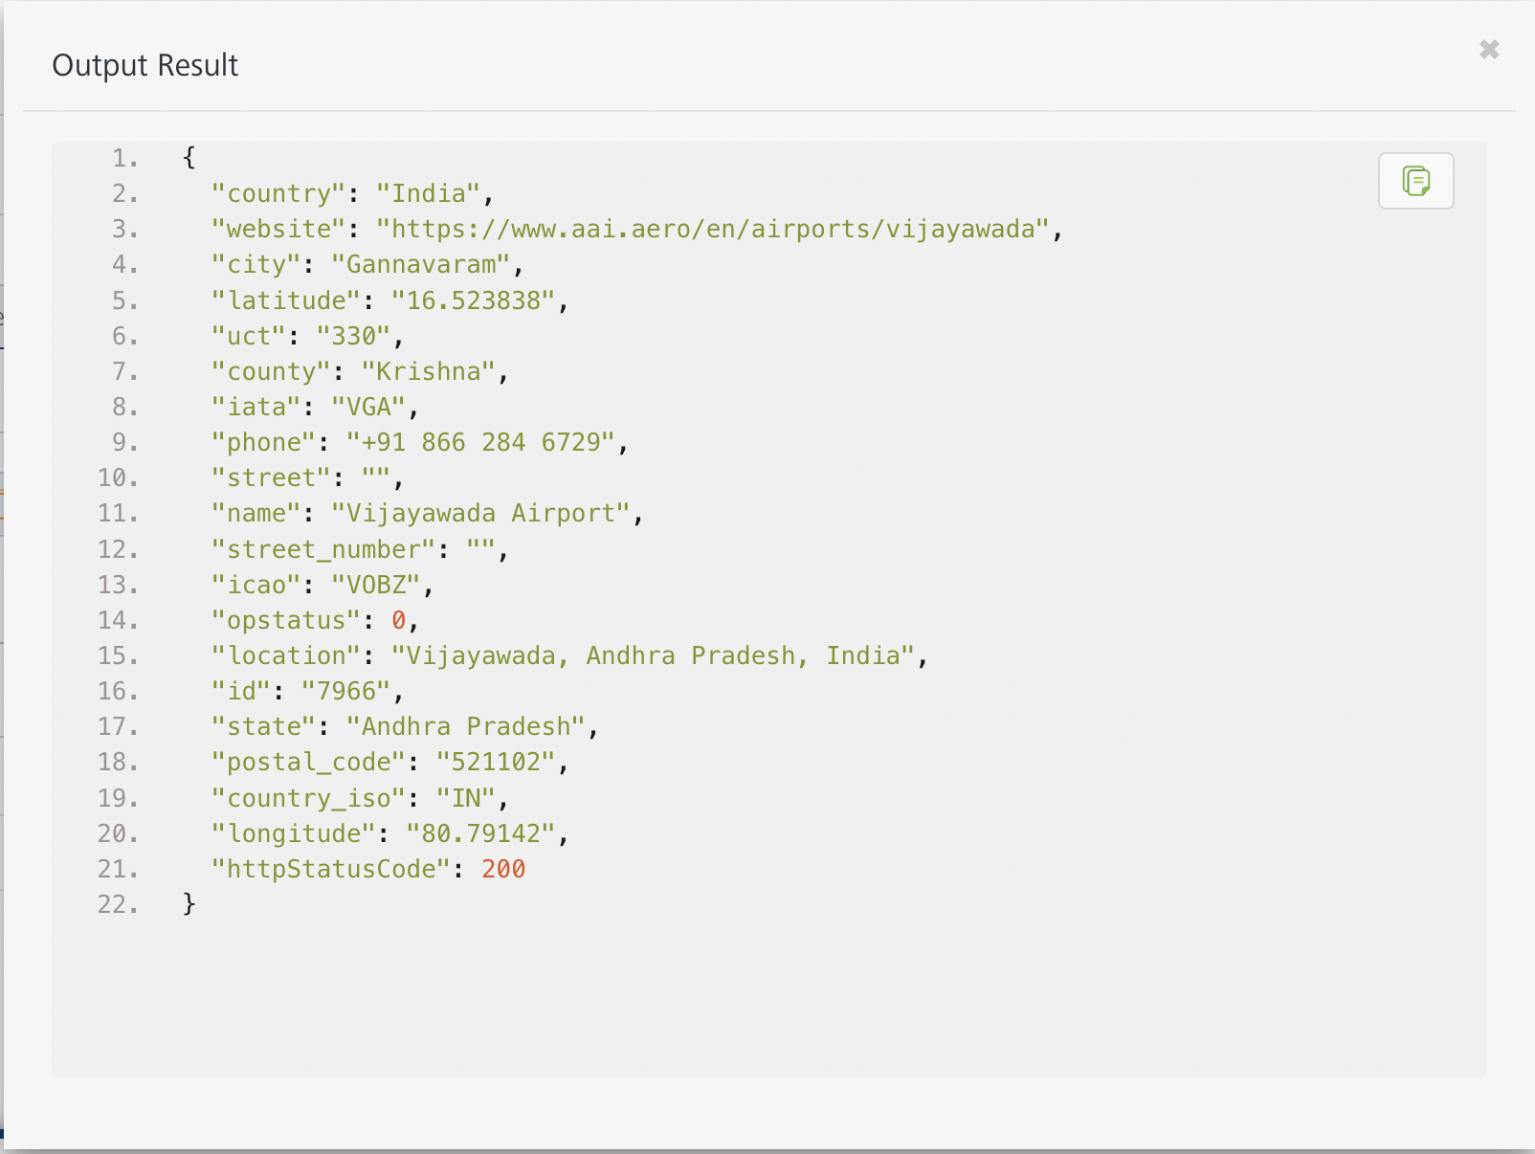

## [Publishing your application](javascript:void(0);)

If you want to use the services in client applications, you need to publish an app to a run-time environment. You can create the service (as described above) in an application or import the service into an application and publish the application.

# References

## Endpoint Documentation

# Get Airport Information

## This endpoint enables users to get airport codes and data, including address, phone number, website and more.

## The endpoint is available through this URL:

## GET <https://rapidapi.com/Active-api/api/airport-info>

## **Parameters**

When calling this endpoint, please refer to the following parameters.

|  |  |  |  |
| --- | --- | --- | --- |
| **Parameter** | **Description** | **Types** | **Required** |
| Iata code | Iata code of the Airport | String | Yes |
| Icao code | Icao code of the Airport | String | Yes |

# Revision History

Adapter version 1.0.0:

## Known Issues

-

## Limitations

-