Date : 31-Mar-26

AION APPLICATION

VERSION: 1.0.0

OVERVIEW
The AION Application provides access to HCL Software’s AI lifecycle management platform through both REST APIs and a mobile application interface. It allows organizations to seamlessly consume pre-trained machine learning models by sending simple HTTP requests to AION’s prediction backend.
The Real Estate application, developed using Volt MX Iris, showcases AION’s machine learning inference capabilities. It predicts the market price of a residential property based on user-provided inputs such as:
- Number of bedrooms
- Number of bathrooms
- Total square footage
- Year the property was built
The application integrates with the AION prediction service (Use Case ID: AI261) via an Orchestration Service in Volt MX Foundry. This orchestration layer manages the complete workflow by:
- Handling authentication
- Invoking the prediction API
- Returning the predicted result to the application
This architecture demonstrates how AION simplifies the integration of AI into applications. Developers can build AI-powered mobile and web solutions without needing to manage or deploy machine learning models themselves, making it highly efficient for real-world use cases.

Use case:
- Real Estate Price Prediction – Predict the market value of a residential property by providing the number of bedrooms, bathrooms, square footage, and year built, using an AION-hosted ML regression model.
- AI-Powered Mobile Applications – Integrate AION's REST prediction API into Volt MX mobile apps to deliver real-time ML inference results to end users on iOS and Android.
- Automated Property Valuation – Enable real estate agents, buyers, and sellers to instantly estimate property prices without manual appraisal, improving decision-making speed.
- ML Model Consumption via API – Enable developers to consume AION-hosted ML models using simple REST API calls with structured JSON input.

Features:
- User-Friendly Input Interface – Allows users to enter property details such as bedrooms, bathrooms, square footage, and year built.
- Real-Time Prediction – Provides instant property price predictions by calling AION’s backend services.
- Orchestration Service Integration – Uses Volt MX Foundry to handle authentication and prediction API calls in a seamless workflow.
- Secure API Communication – Ensures secure interaction with AION services through token-based authentication.
- Structured JSON Request/Response – Sends well-defined input payloads and receives prediction outputs in JSON format.

Percentage of re-use:
80%

GETTING STARTED

Prerequisites
Before you start using the AION Application, ensure you have the following:

- HCL Foundry
- VoltMX Iris
- AION Account – Register at: https://aion-uat.hcl-software.com/login and create an account. Store your username and password, as these credentials are required to authenticate with the AION login endpoint and generate an access token for invoking prediction APIs.

- After a successful login, the HCL AION landing page will be displayed.
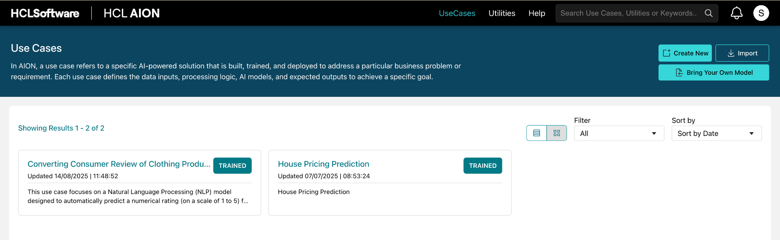
- Click on Create New, then enter the Use Case Name and Description.
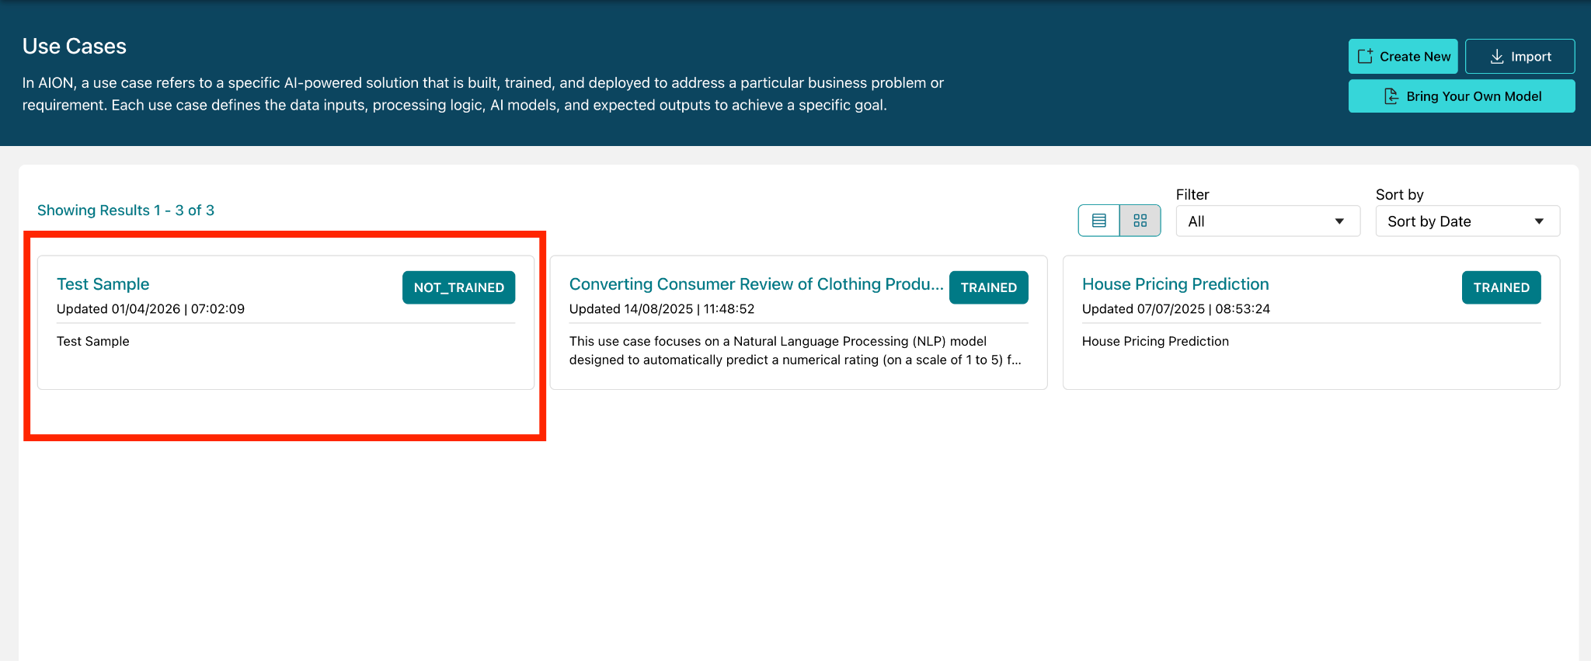
- Click on the created Test Sample Use Case.
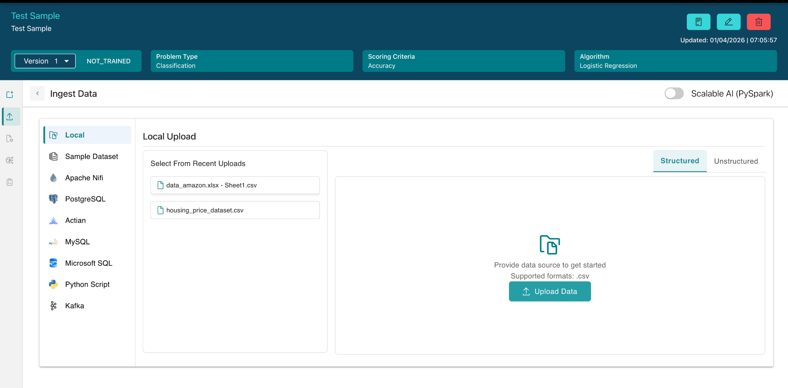

- Upload Dataset in.csv format
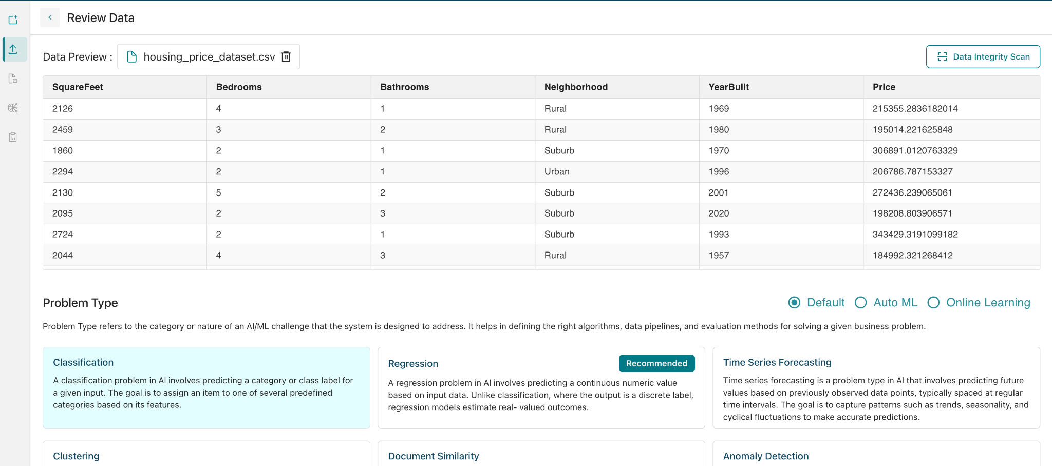
- Select Problem Type , Target Feature, Model and click save and proceed.
- 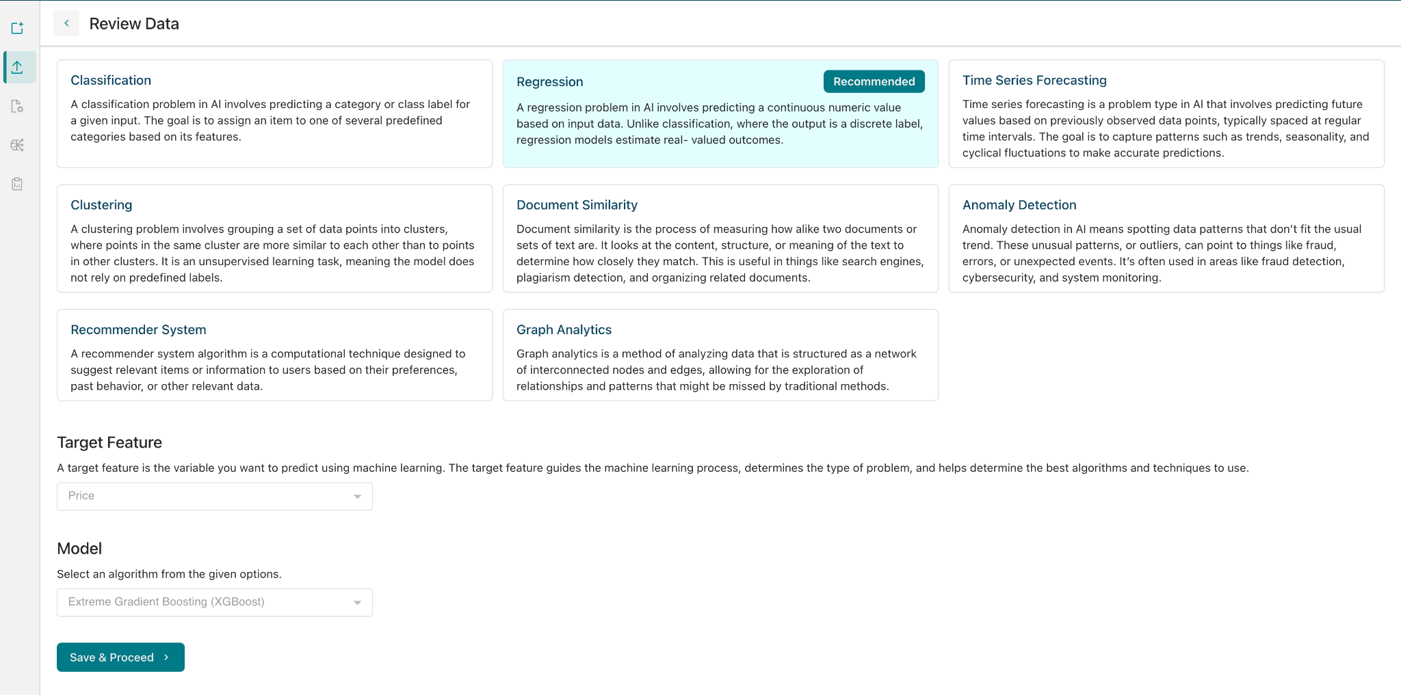
- Click Review configurations to train model.
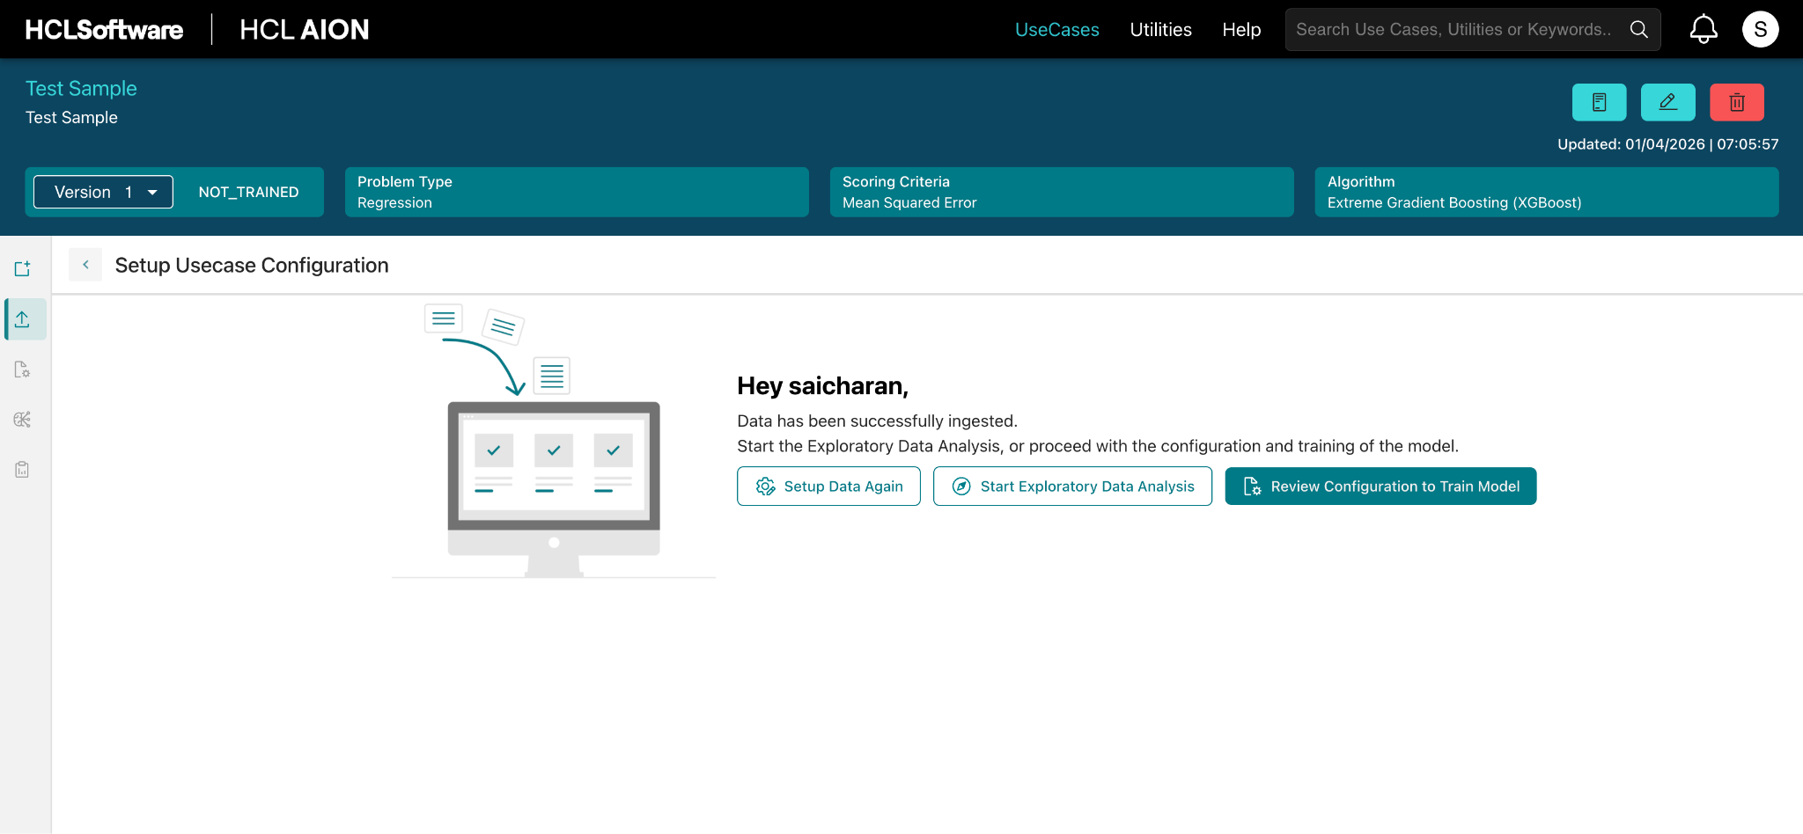
- After Training Completed , click Test Predictions
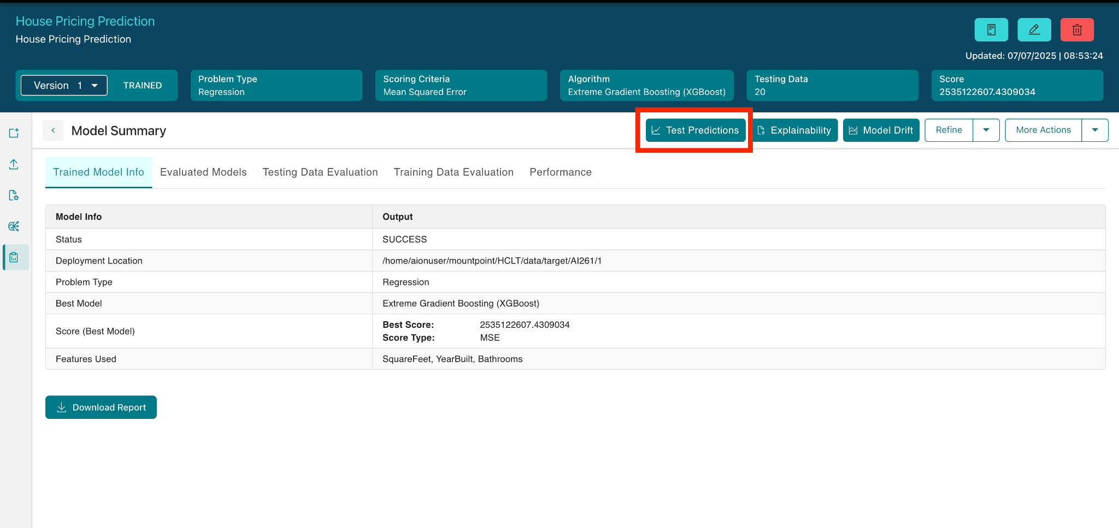
- Enter the number of bedrooms, bathrooms, square feet, and year built, then click the Predict button. The AI-predicted property value will be displayed.
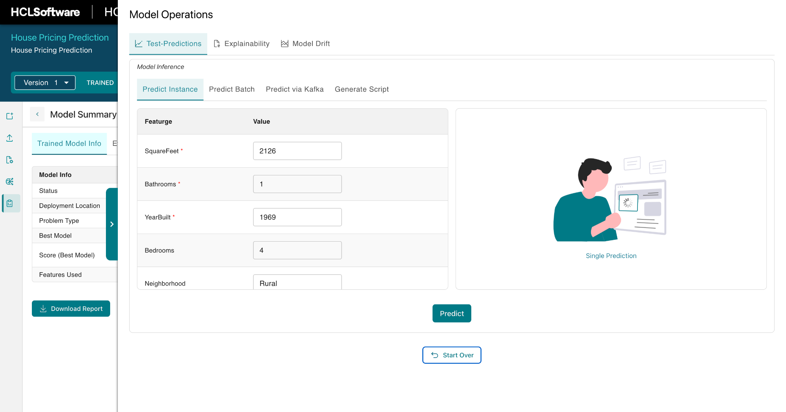
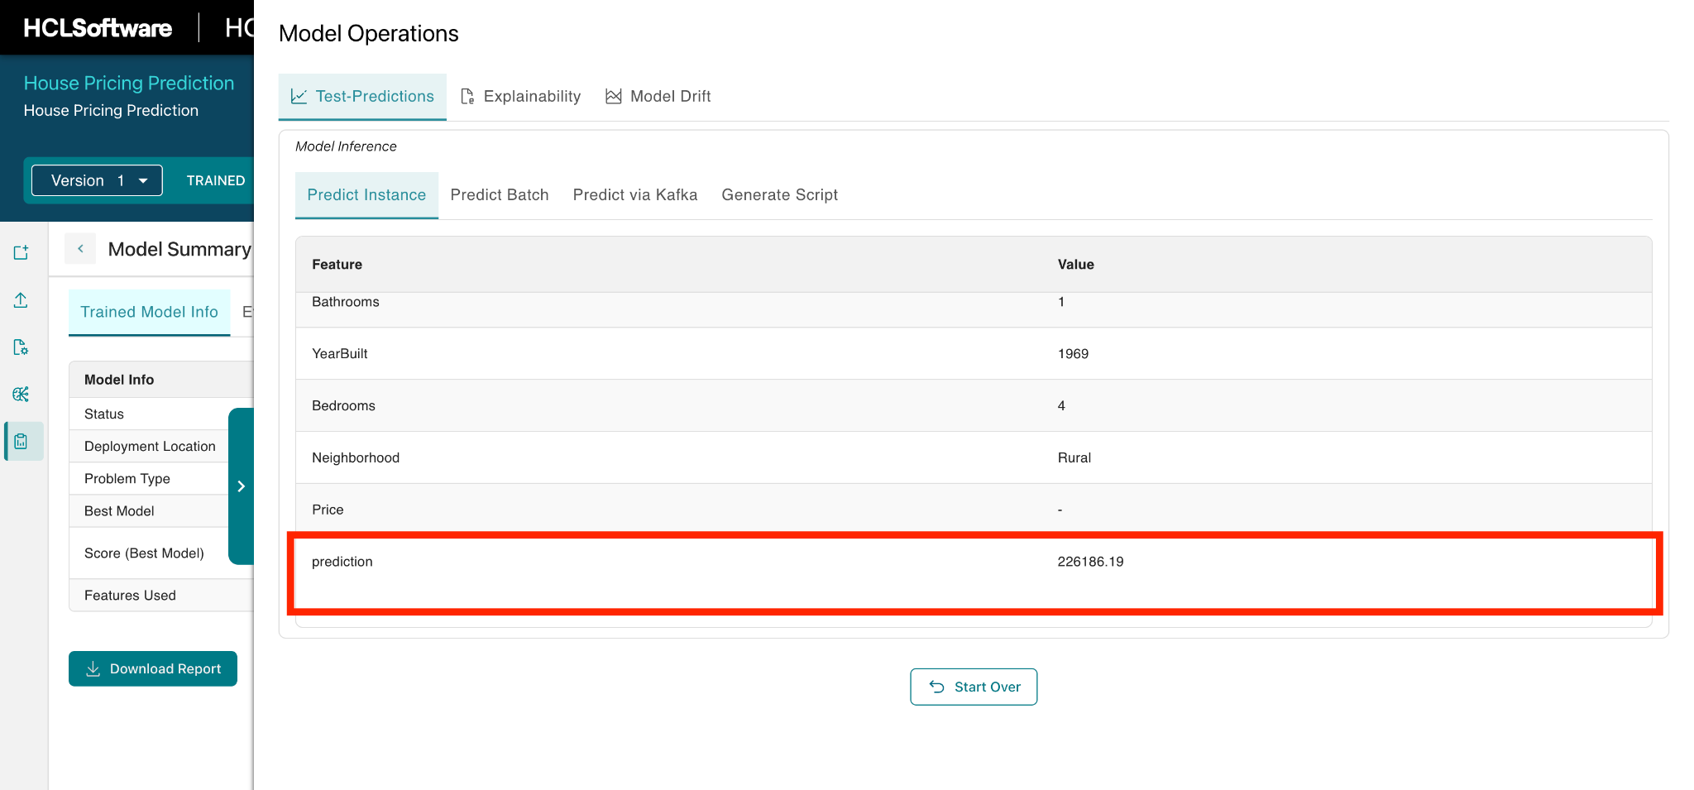

Devices
- Mobile

Platforms
- Android
- IOS

Importing the App
To import the AION App to Volt MX Iris, do the following:

To import the AION App, do the following:
- Launch Volt MX Iris.
- Click project, and then select Import. The Import dialog box appears.
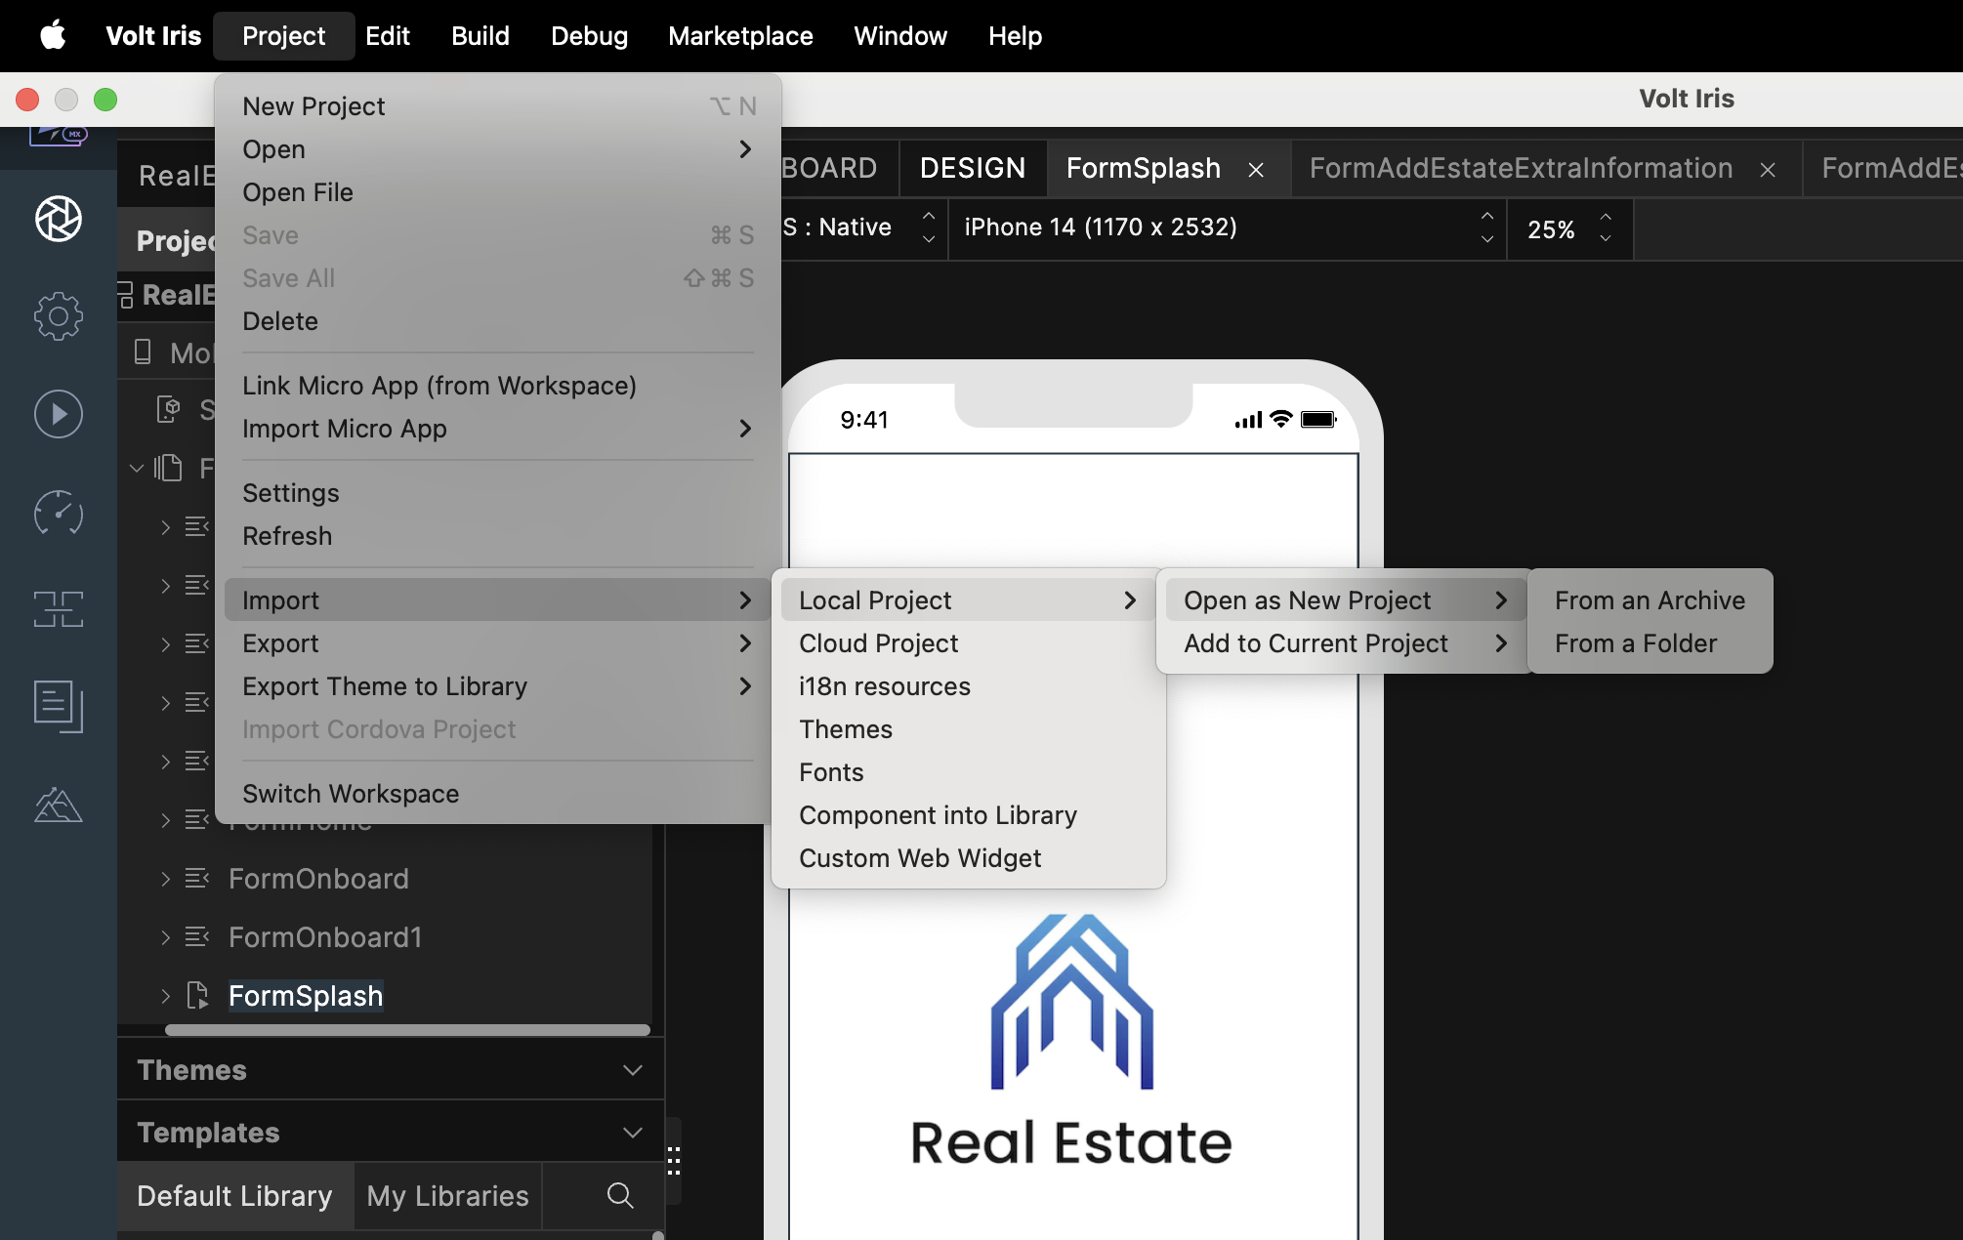

- Click From an Archive to navigate to the location of the project, select the files, and then click Import.
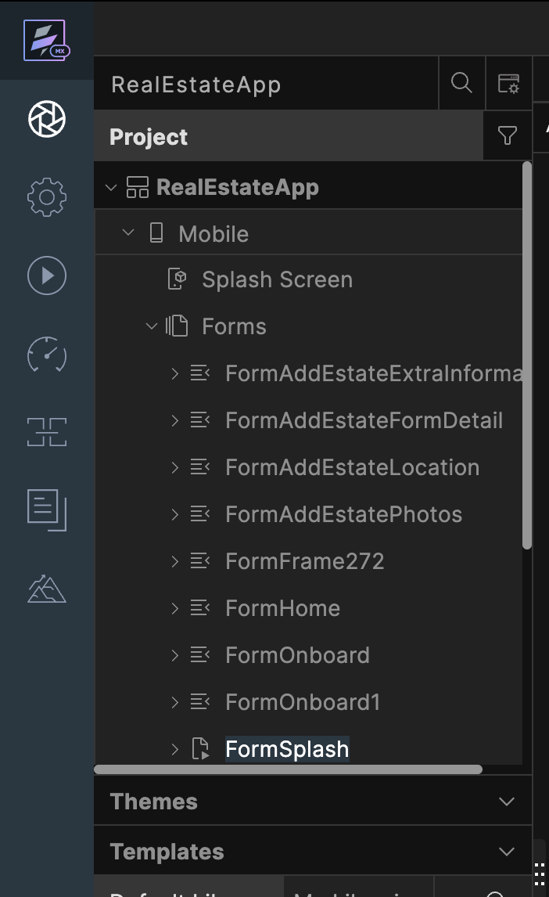
After you import the application, you can view the associated Foundry app connected at the in Data & Services section.
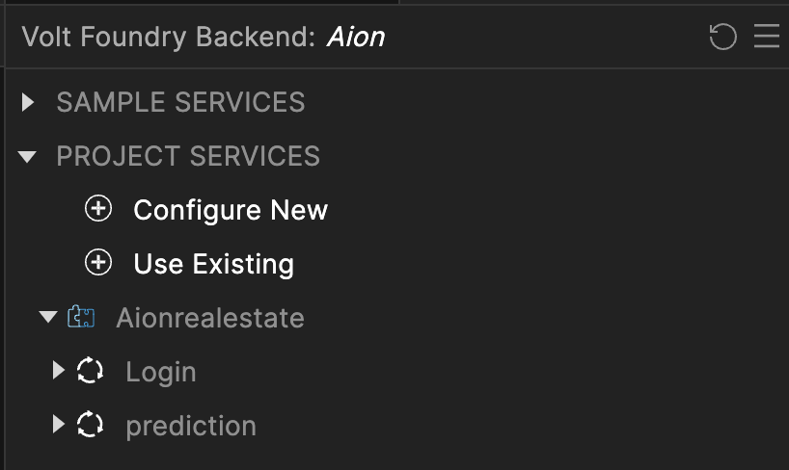

Aion Volt MX Foundry Services:
When you import the application to your Volt MX Iris project, the HCL Volt MX Foundry services of the Aion are added to the HCL Volt MX Foundry app, which is associated with the Volt MX Iris project. While importing the Real estate App to your Volt MX Iris project, if there is no HCL Volt MX Foundry app associated with the existing Volt MX Iris project, a new HCL Volt MX Foundry app is automatically added to your HCL Volt MX Foundry environment and is associated with your Volt MX Iris.
To set up the Foundry app, follow these steps:

1. Click the HCL Volt MX Foundry app associated with your Volt MX Iris project from the Project Explorer. Click on DATA & SERVICES.

2. Under the Configure Services tab, click Integration and can see the Aionrealestate Integration service. Click on that Integration service to add the keys.

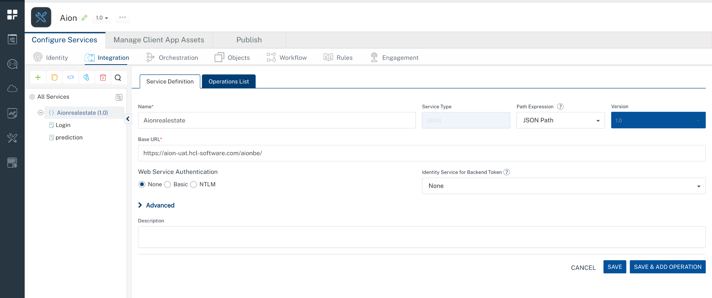

3. Click the Operations List tab. The Operations List tab opens with the list of operations available.
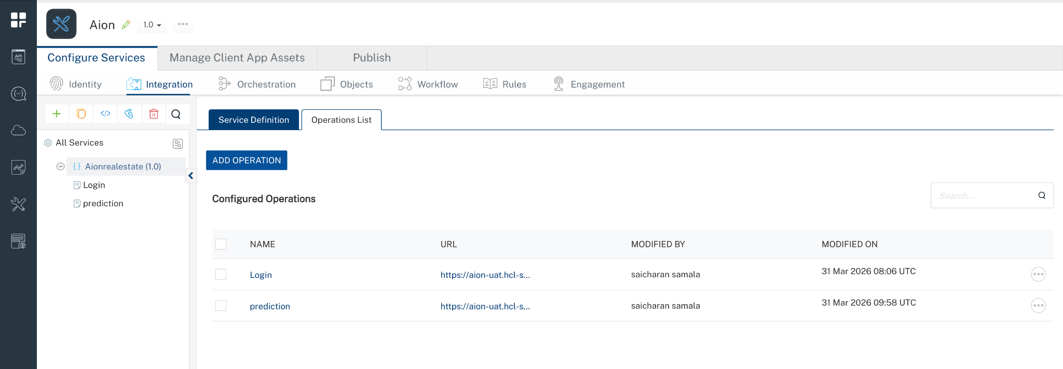

4. Executing an operation
A) Login
Under the Configured Operations section, click the Login operation. The Request Input sub-tab opened by default. Provide Body and Headers.
- Provide the required parameters, such as username and password.
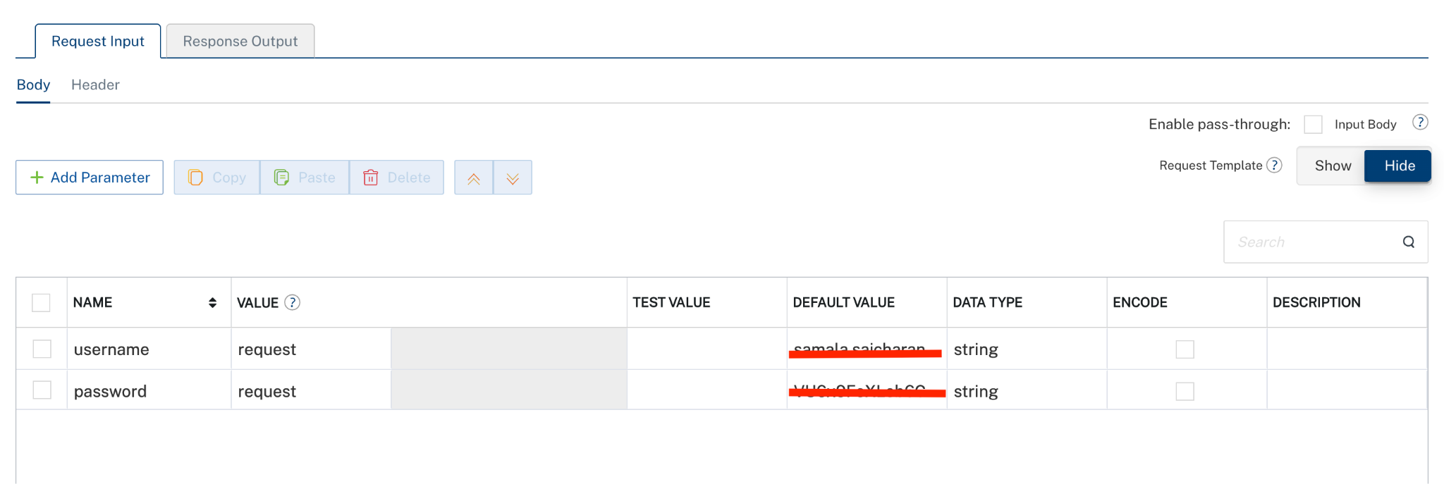
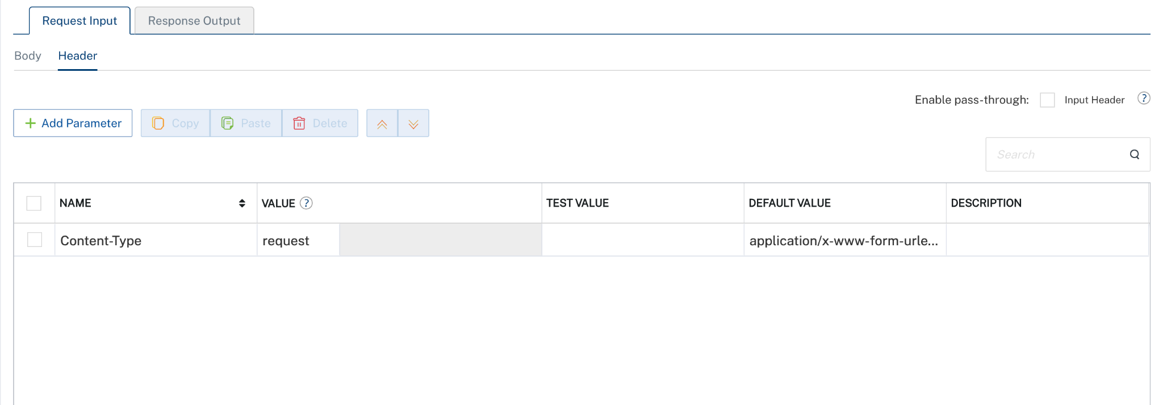
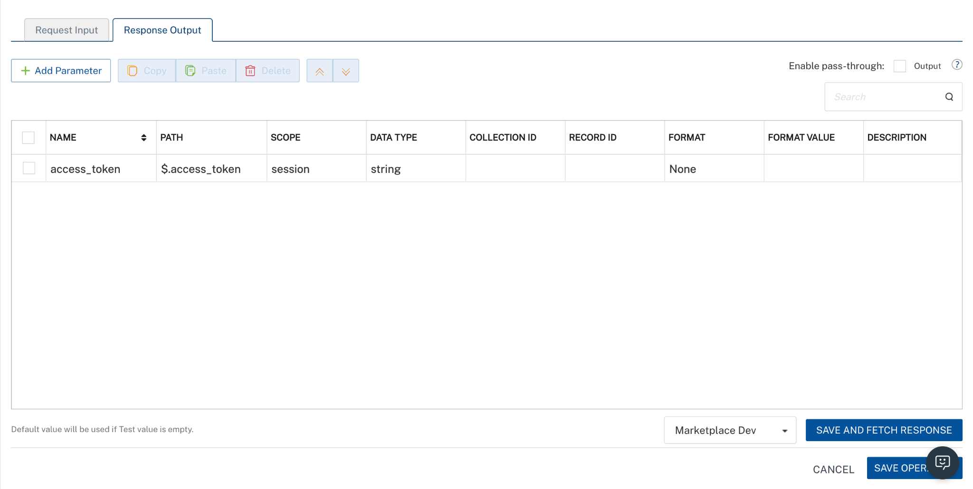
- Click Save Operation.
B) prediction
Under the Configured Operations section, click the Login operation. The Request Input sub-tab opened by default. Provide Body and Headers.
- Provide the required parameters, such as input_data ,usecaseVersion and usecaseId.
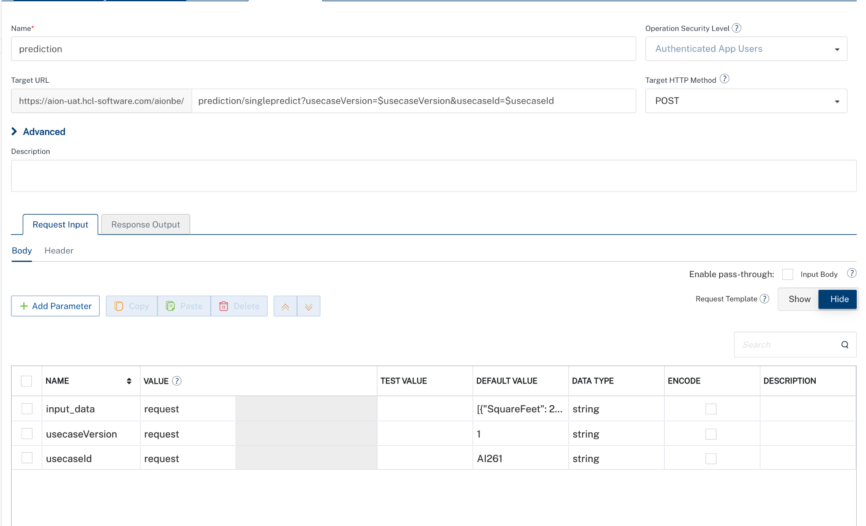
- Headers
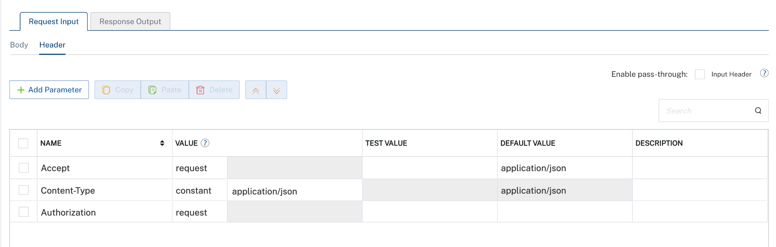

- Response Output
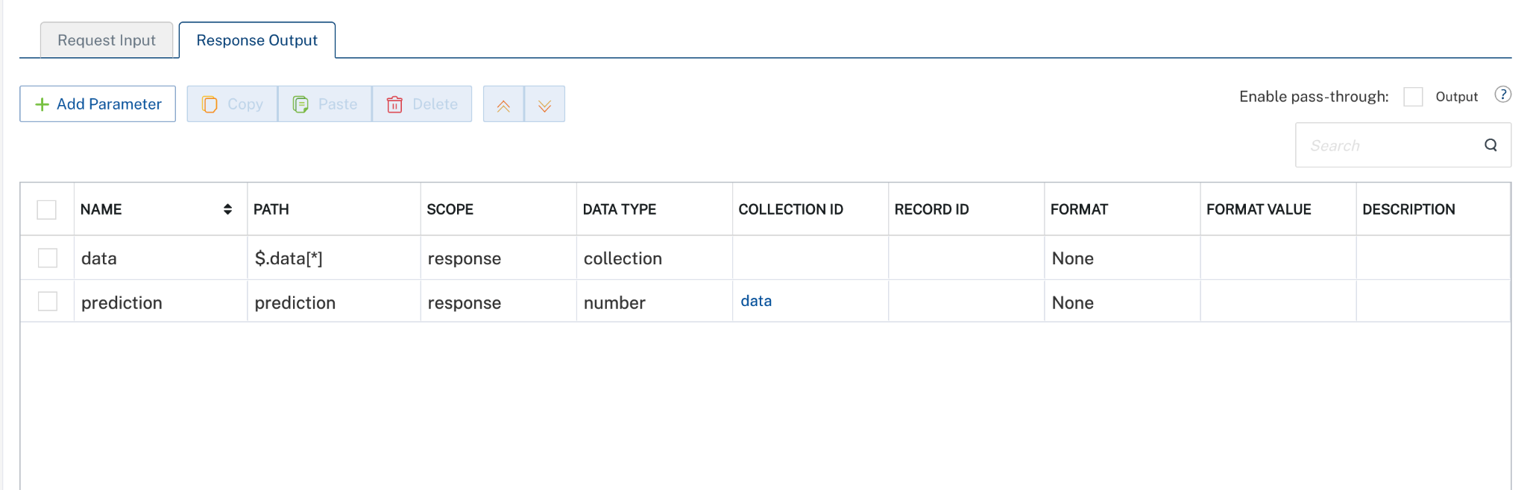
C) Select Orchestration service
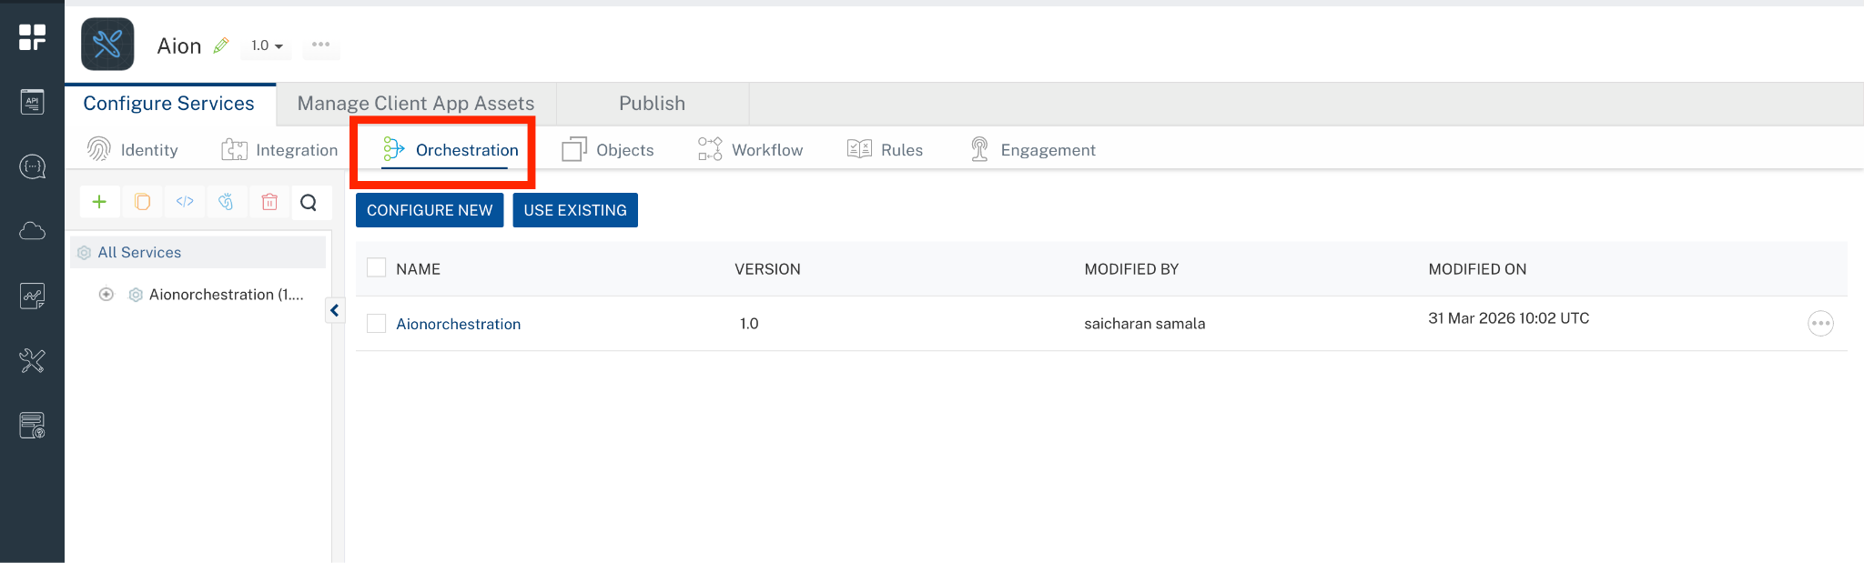
- Select Aionorchestration Orchestration service.

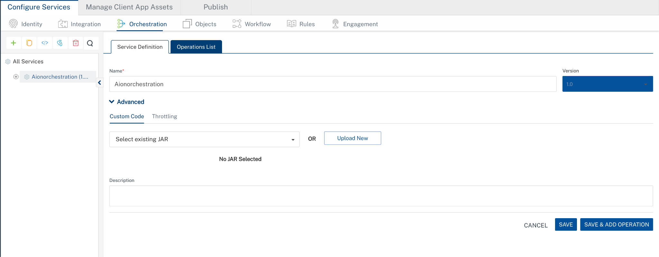

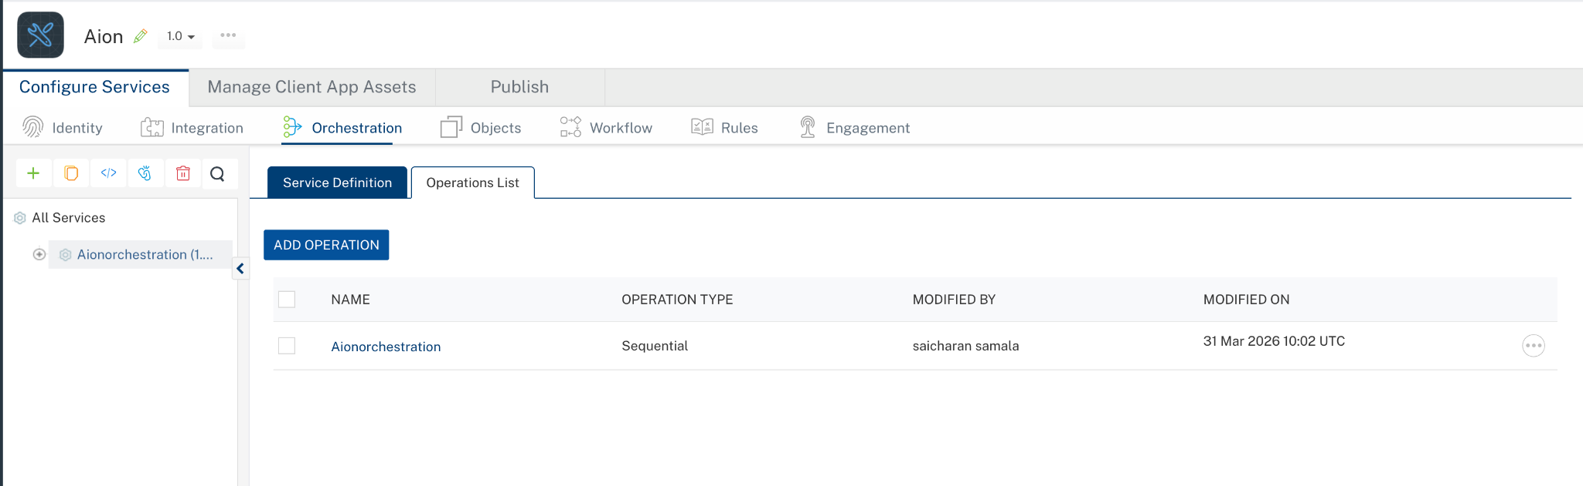
- Select Aionorchestration operation

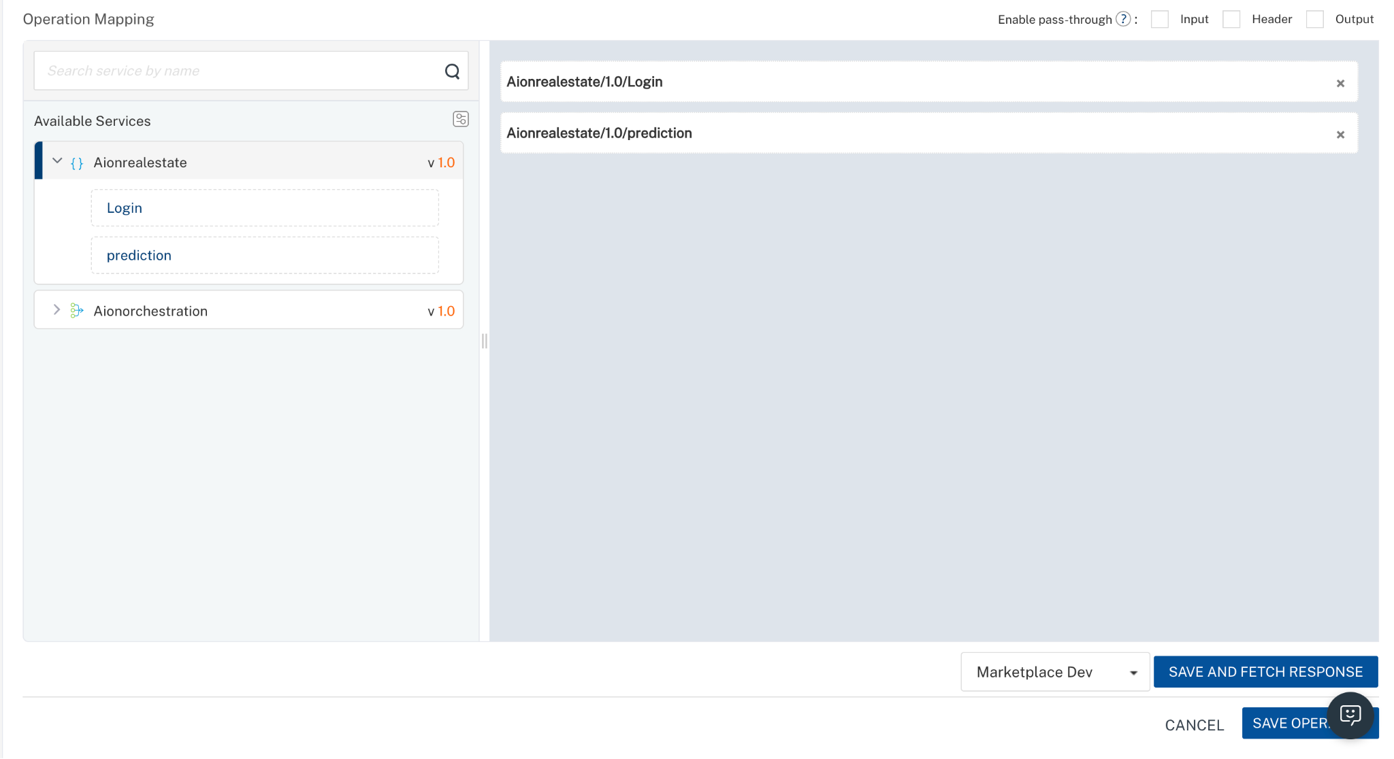
- Click save and fetch response

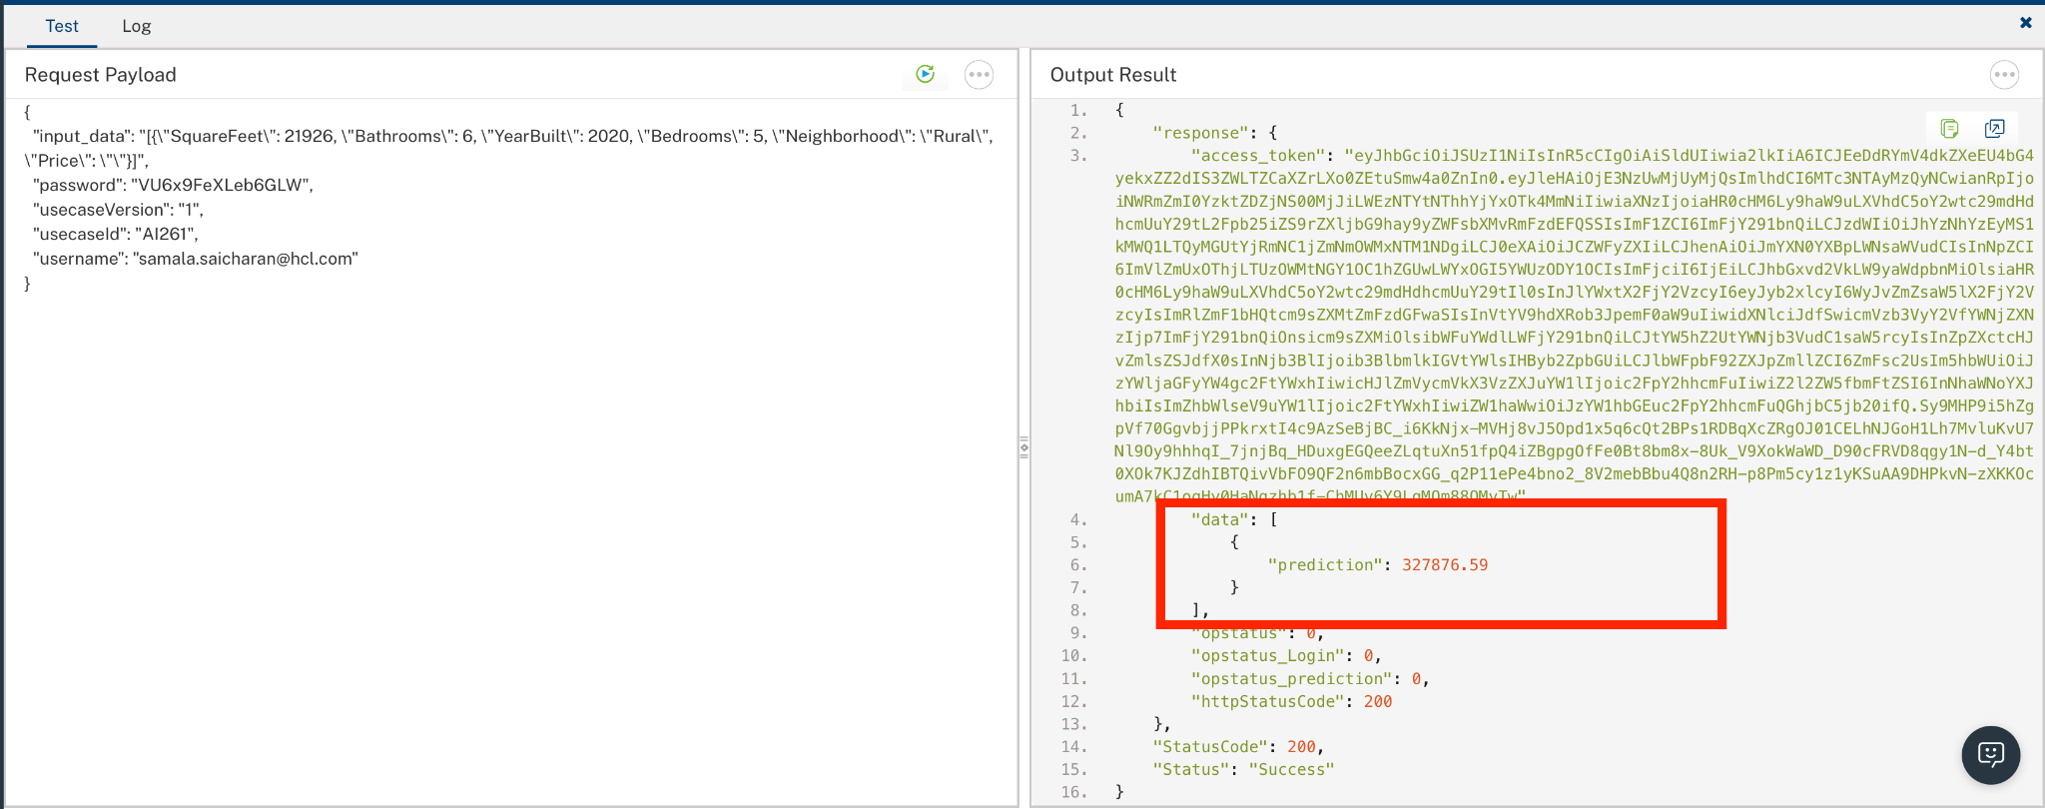

5.Publishing your application
After you set the Operation Security Level, you must publish the HCL Volt MX Foundry app. To publish the HCL Volt MX Foundry, follow these steps:

In Volt MX Iris, click DATA & SERVICES, and then click Publish Project Services to Publish to your foundry app.

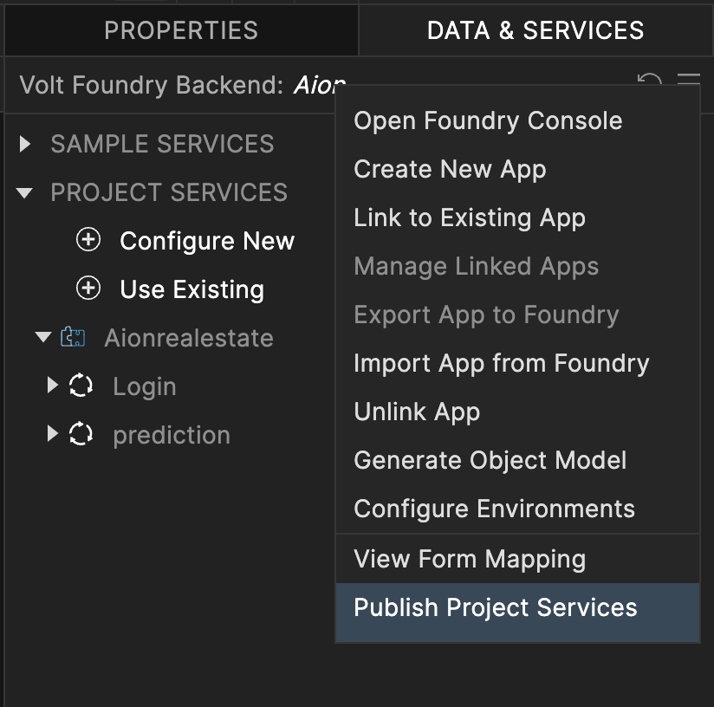

Select the environment to which you want to publish your app, and then click Publish. After the app is published to your environment, the following window appears confirming the publish.

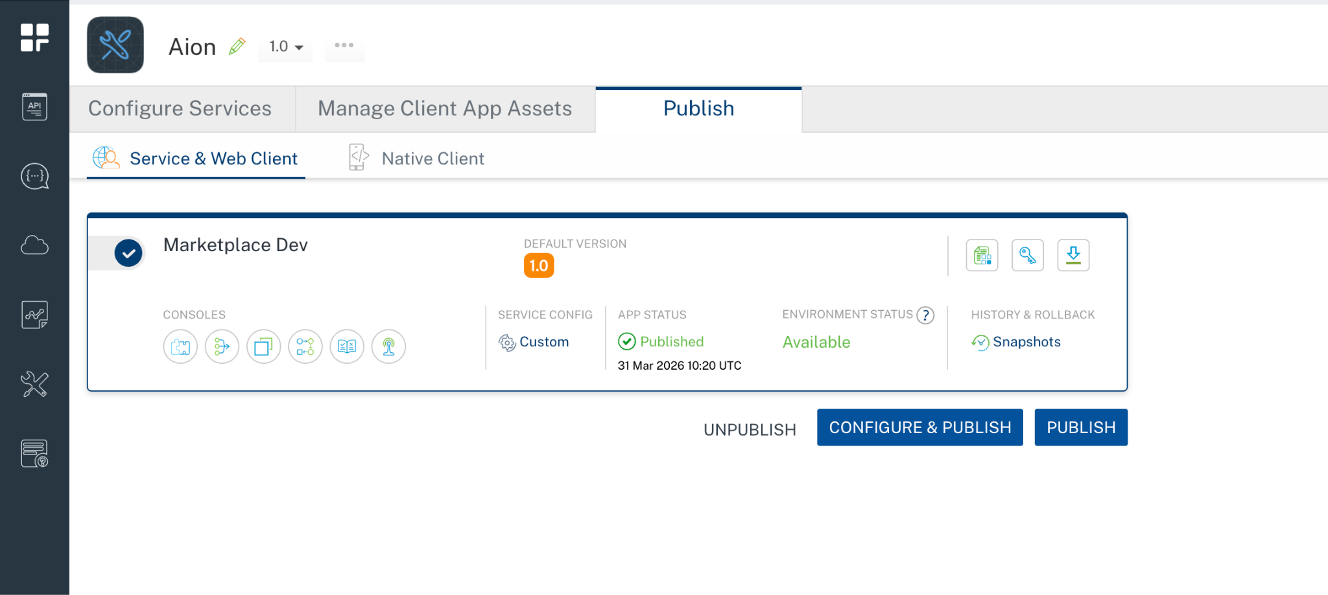

Building the app
From the menu bar, go to Build and then select Build Native Local.

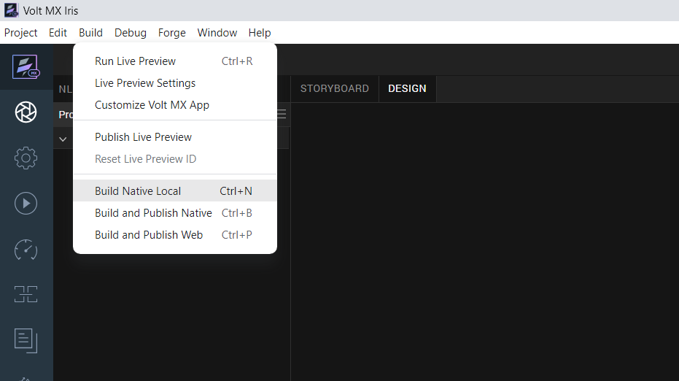

For Mobile, select Android and iOS. Click Build.
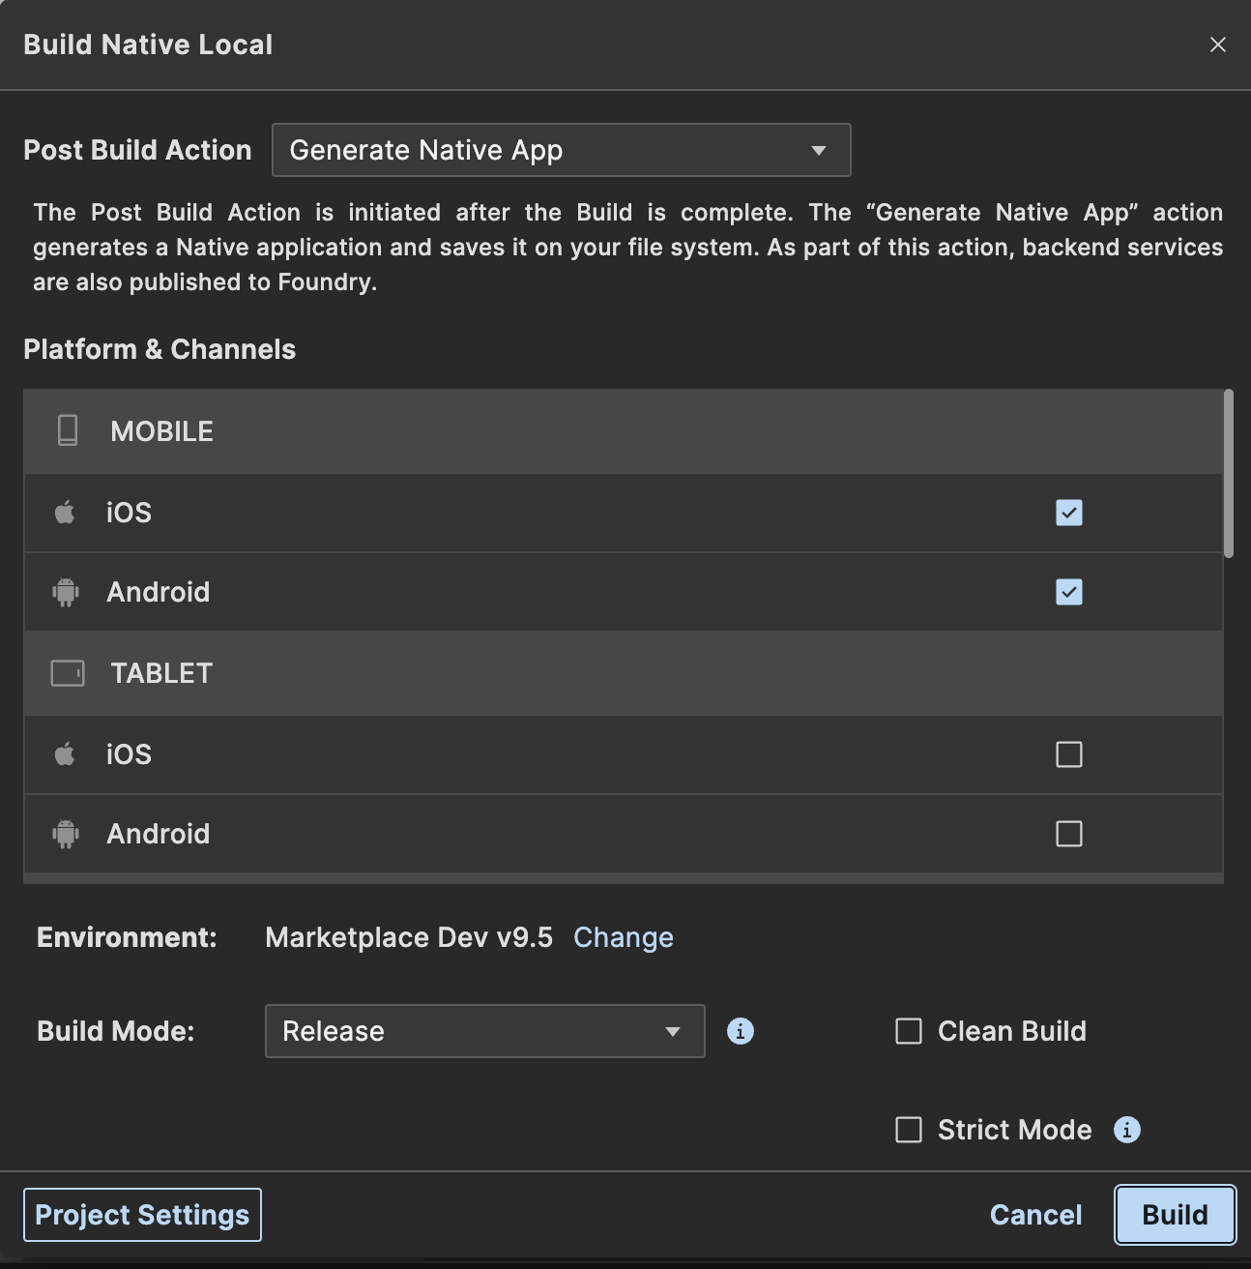

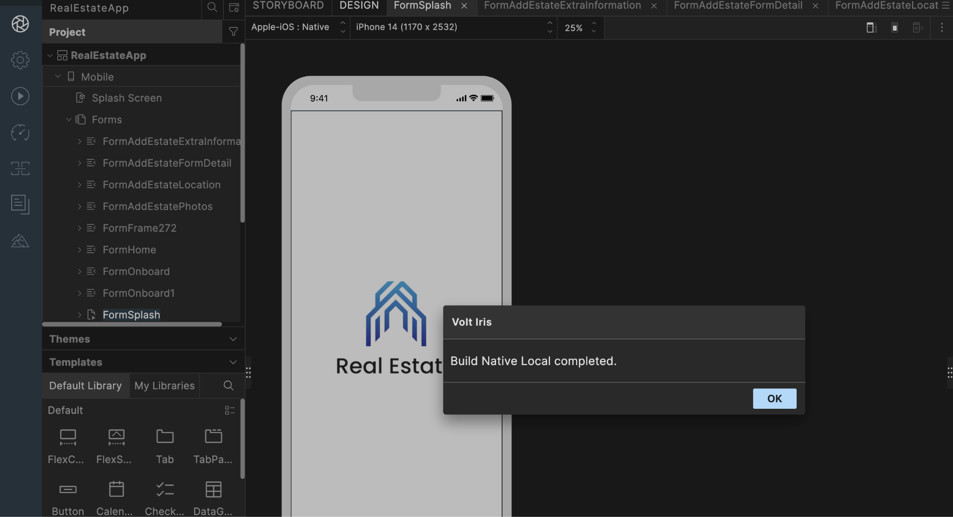

After the build is successful, run the app on your mobile device.

H. Application Flow
The landing page for the app is as follows:

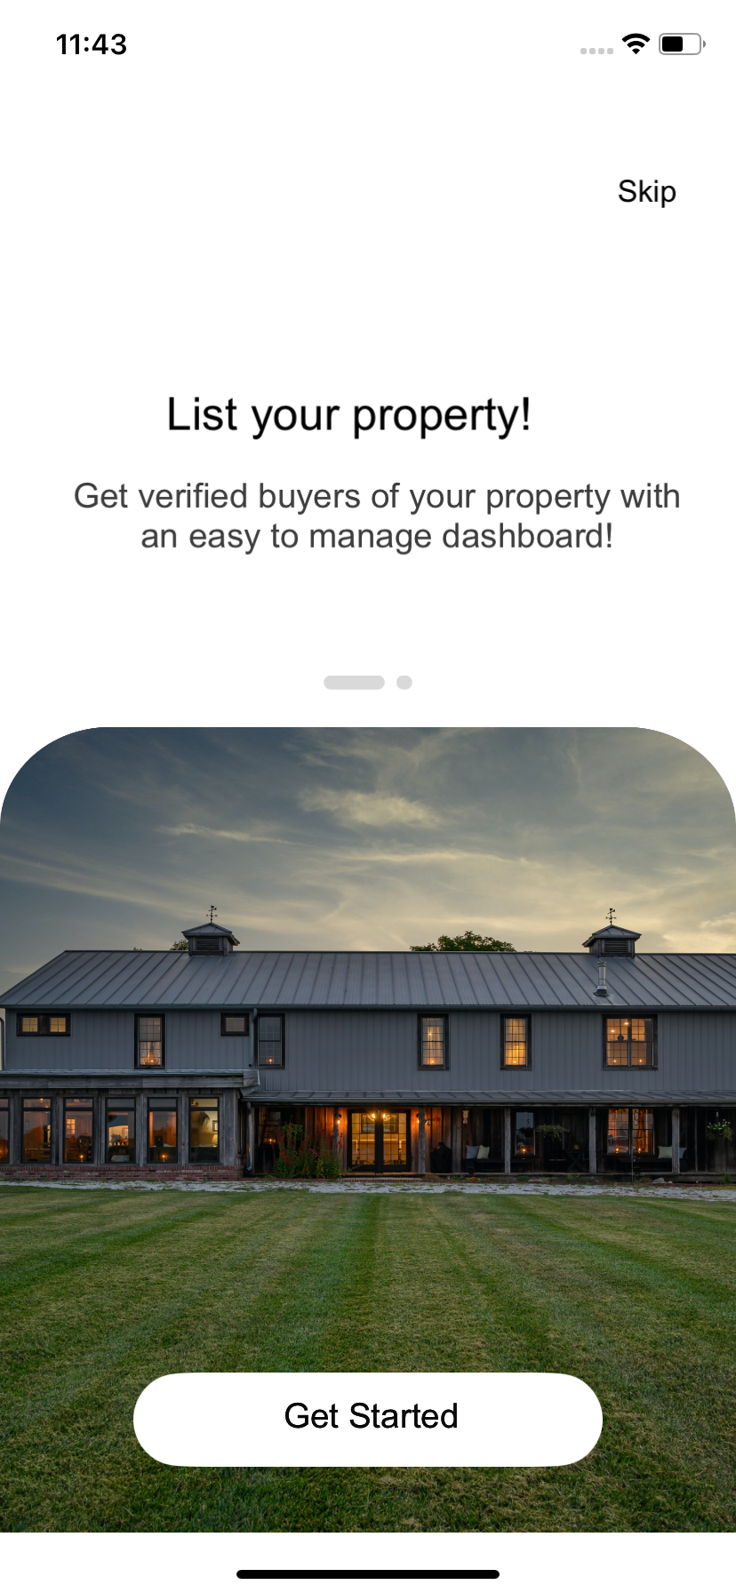
Click on Skip to navigate to the next form.

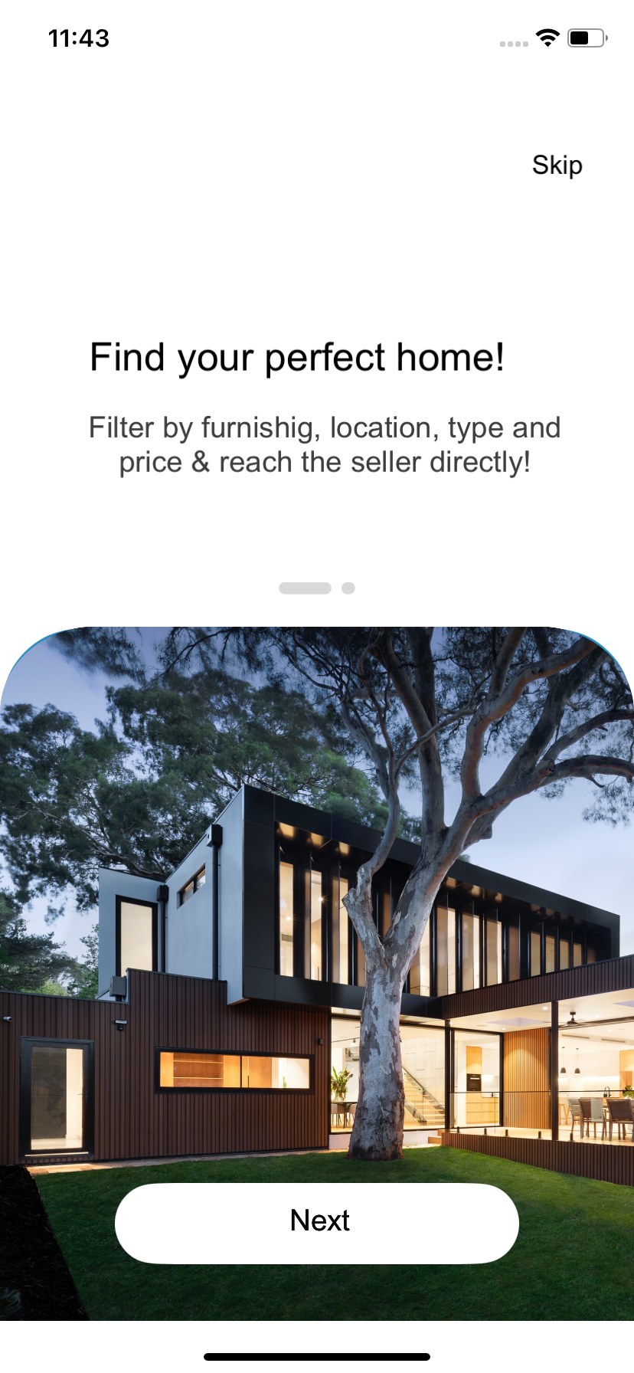
- Click on Skip to navigate to the next form.
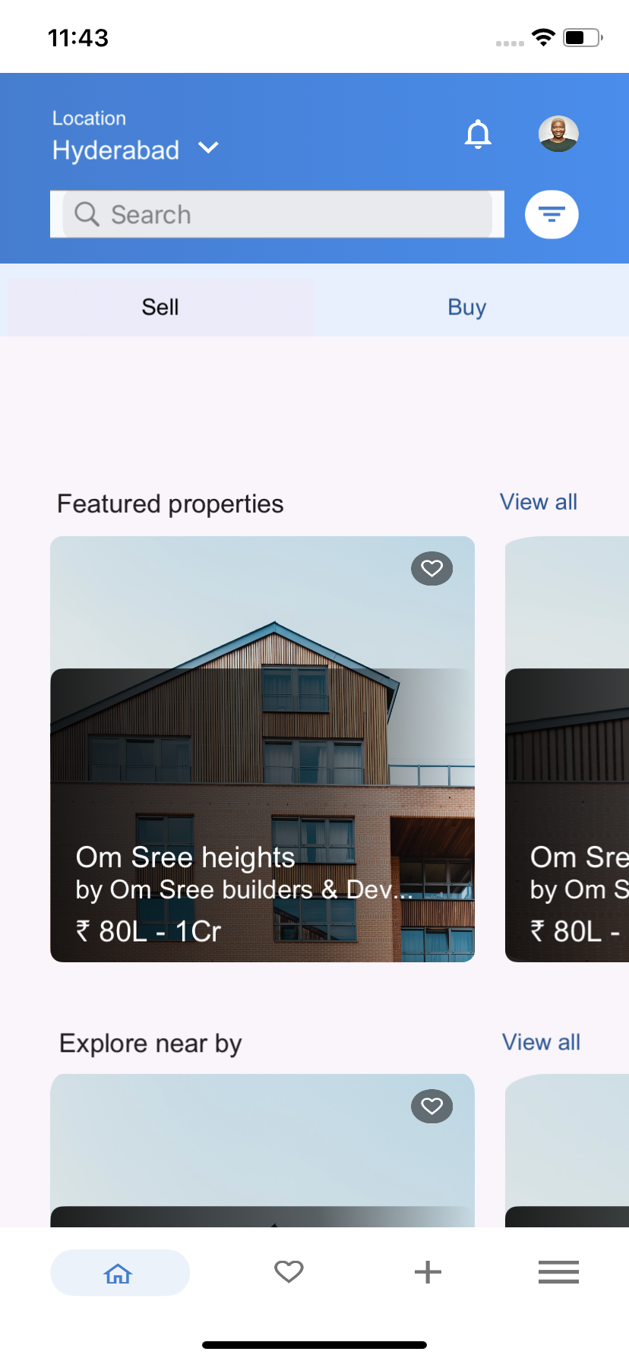
- Click Plus sign(+) to navigate to next form.

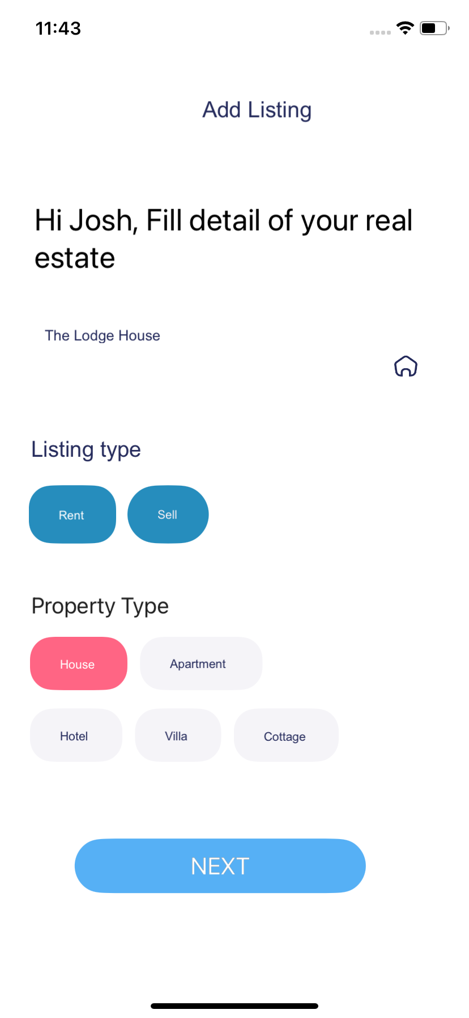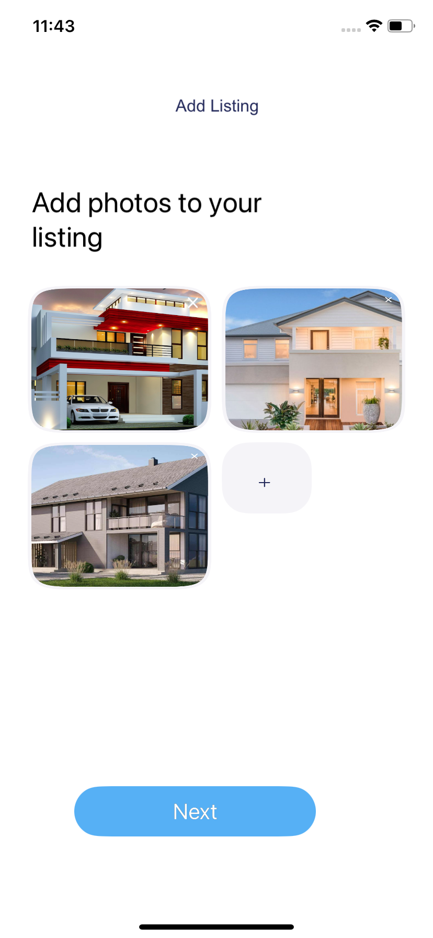

- Click next to navigate to next form

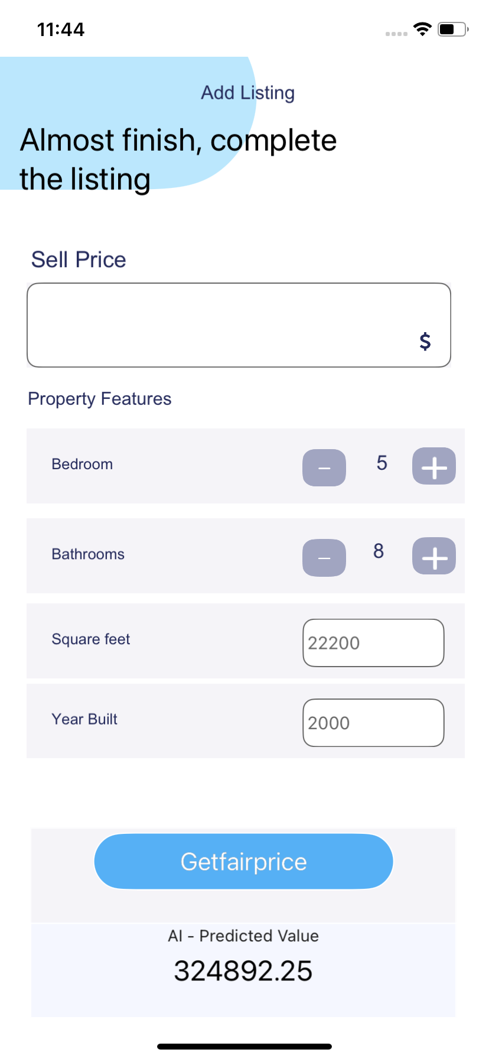
- Enter the number of bedrooms, bathrooms, square feet, and year built, then click the Get Fair Price button. The AI-predicted property value will be displayed.

4.REFERENCES

Endpoint Documentation
Aion Portal
Aion Document

5.REVISION HISTORY
App version 1.0.0:
  - Known Issues
None
  - Limitations
None

