Date :  23-02-2024

AI List Generator

version: 1.0.0

# **Overview:**

Introducing the AI List Generator API: a groundbreaking tool that enables effortless creation of structured lists from user input. By simply providing a subject or concept, this advanced API leverages artificial intelligence to generate an array of JSON objects tailored to your specifications. With the AI List Generator, you can easily define the keys and let the powerful AI engine handle the rest. Experience the convenience of automated list creation as the API intelligently generates the data, eliminating the need for manual entry. Seamlessly integrate this powerful tool into your applications and enjoy the efficiency and accuracy of AI-powered list generation at your fingertips.

# **Getting Started:**

**A. Prerequisites:**

* Volt Foundry

**B. Importing the adapter:**

**To import the Data Adapter to Volt Foundry, do the following:**

1. Sign in to the  [HCL Foundry](https://manage.hclvoltmx.com/).
2. From the left navigation menu, select **API Management**.
3. In **API Management**, select **Custom Data Adapters**.

1. Click **IMPORT** to import a custom data adapter.  
     
   A blue and white box with text

   Description automatically generated
2. On the Import Data Adapter dialog box, click browser to import.  
     
   A screen shot of a computer

   Description automatically generated
3. Select AI List Generator zip file and click **IMPORT**.

After you import the data adapter, Volt Foundry opens a window that shows the metadata of the data adapter.

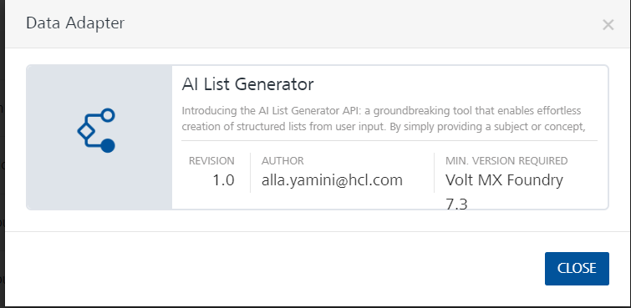

After you import the data adapter, you can view it on the Custom Data Adapters page and use it to create services on Volt Foundry.

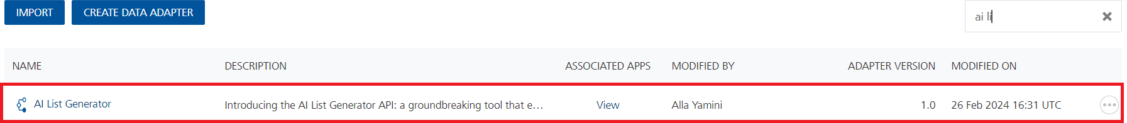

### **[Creating an Integration service](javascript:void(0);)**

After you import the data adapter into Volt Foundry, you can use it to create an Integration Service.

Follow the given steps to create an Integration service using the AI List Generator Adapter:

1. Sign in to the [HCL Foundry](https://manage.hclvoltmx.com/).
2. From the left navigation menu, select **API Management**.
3. In **API Management**, select **Integration**.

1. To create a new service, click the **+** button or the **CONFIGURE NEW** button.

1. On the Service Definition tab, select the service type as AI List Generator and click **SAVE**.  
     
   A screenshot of a computer

   Description automatically generated

Alternatively, you can also create a Foundry app and create an Integration service inside it.

[Open](javascript:void(0);)**D.** [**Creating and Executing operations**](javascript:void(0);)

After you create an integration service, you can create and execute operations using the service.

#### Creating an Operation

* In **API Management/Foundry app you created**, in the **Integration** section, select the service that you created.
* After you select the service, navigate to the **Operation List** tab.

* From the drop-down list, select an operation that you want to execute, and click **ADD OPERATION**.

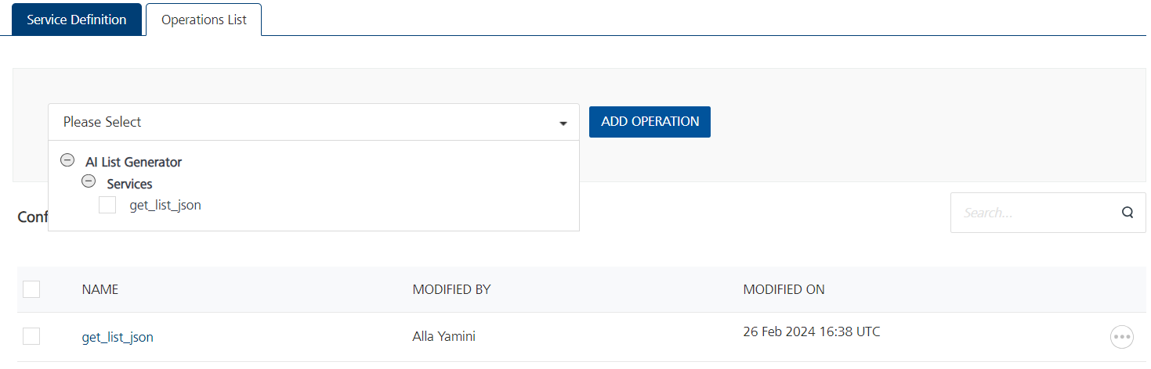

#### Executing an Operation

* From the **Operations List** tab, in the **Configured Operations** section, select the operation you want to execute.

* On the Operation Page, in the Request Input tab, enter a TEST VALUE for all the fields in body and header.

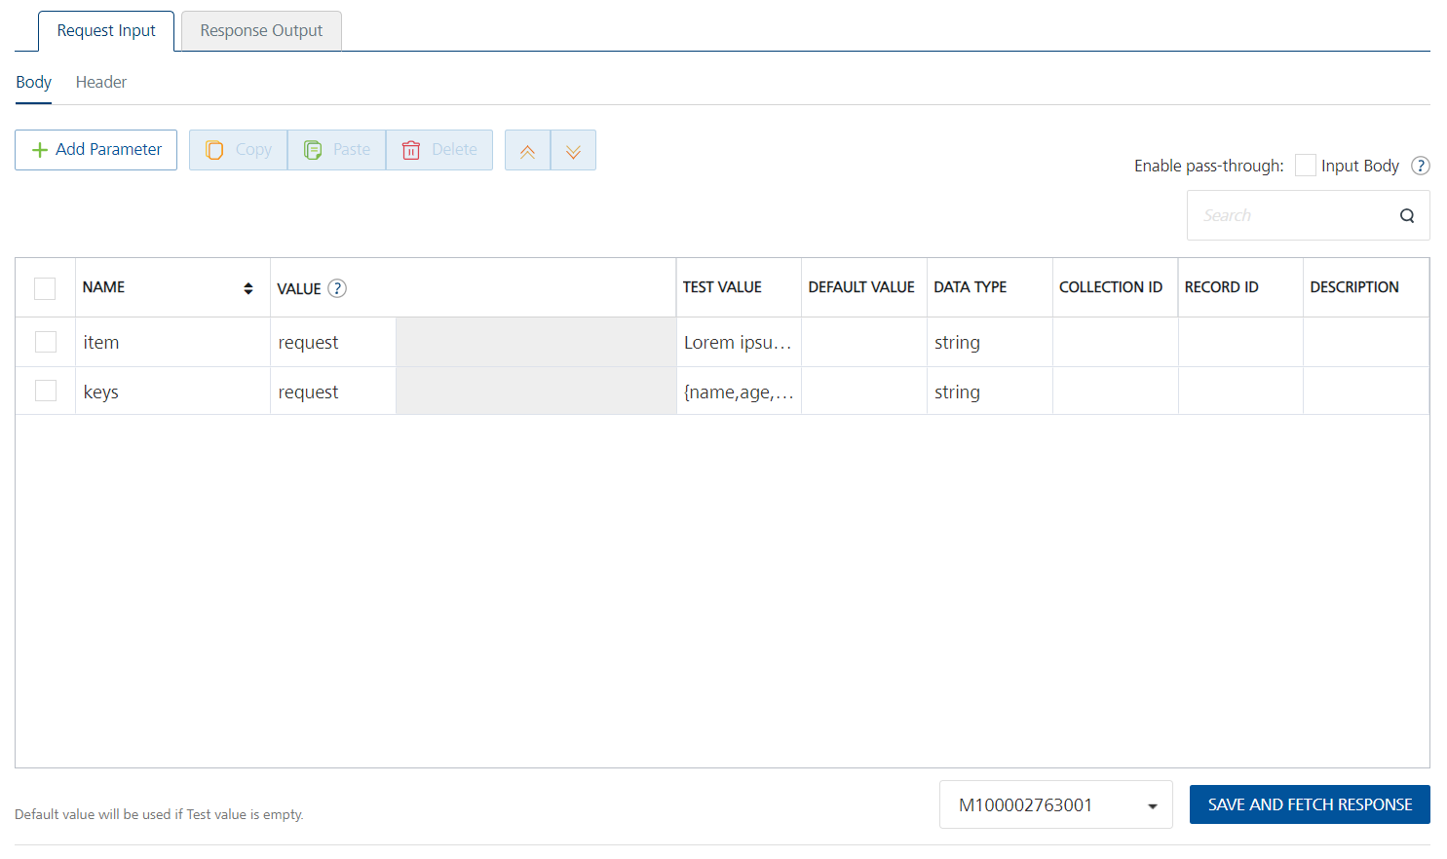

* Select a run-time environment and click **Save and Fetch Response** to get a response based on your inputs.  
    
  A screenshot of a computer

  Description automatically generated

## **E**. [**Publishing your application**](javascript:void(0);)

If you want to use the services in client applications, you need to publish an app to a run-time environment. You can create the service (as described above) in an application or import the service into an application and publish the application.

# **References**

## Endpoint Documentation

## **Reference Link:** [AI List Generator API Documentation (nathancox90) | RapidAPI](https://rapidapi.com/nathancox90/api/ai-list-generator)

# **Get list_json**

## This endpoint generates an array of JSON objects based on user input text and keys.

## **Authentication:** not required

**Request Parameters:**

items (string): The subject or concept from which the list will be generated.  
keys (string): Comma-separated list of keys for the output JSON objects.  
Example Request:

**json code:**  
/list-generator  
{  
"text": "Lorem ipsum dolor sit amet",  
"keys": "name, age, occupation"  
}

Response:

Status: 200 OK

Body: Array of JSON objects representing the generated list.  
**Example Response:**  
[  
{  
"name": "John Doe",  
"age": 30,  
"occupation": "Engineer"  
},  
{  
"name": "Jane Smith",  
"age": 28,  
"occupation": "Designer"  
}  
]

## The endpoint is available through this URL:

GET https://ai-list-generator.p.rapidapi.com/list_json

## **Parameters**

When calling this endpoint, please refer to the following parameters.

|  |  |  |  |
| --- | --- | --- | --- |
| **Parameter** | **Description** | **Types** | **Required** |
| X-RapidAPI-Key | Give details of the rapid Api key | String | Yes |
| X-RapidAPI-Host | Give details of the rapid Api host | String | Yes |
| item | The subject or concept from which the list will be generated. | String | Yes |
| keys | Comma-separated list of keys for the output JSON objects. | String | Yes |

# **Revision History**

Adapter version 1.0.0:

## **Known Issues**

**-**

**B. Limitations**

**-**