Date :  01-03-2024

AI Image Generator  
Version: 1.0.0

# **Overview**

AI art and image generator API service empowers developers and designers to unlock their creativity by harnessing the power of artificial intelligence. With our cutting-edge technology, you can seamlessly integrate our API into your applications or platforms, enabling you to effortlessly generate stunning and unique art pieces or images. Whether you’re looking to automate the creation of digital art, enhance visual content, or explore new artistic horizons, our API service provides a user-friendly solution that unleashes limitless possibilities. Experience the fusion of human creativity and AI innovation with our API service today.

# **Getting Started**

## **Prerequisites**

* Volt Foundry
* [Rapid API Account](https://rapidapi.com/sohailglt/api/ai-image-generator3)
* X-RapidAPI-Key, X-RapidAPI-Host

## **Importing the adapter**

**To import the Data Adapter to Volt Foundry, do the following:**

1. Sign in to the  [HCL Foundry](https://manage.hclvoltmx.com/).
2. From the left navigation menu, select **API Management**.
3. In **API Management**, select **Custom Data Adapters**.

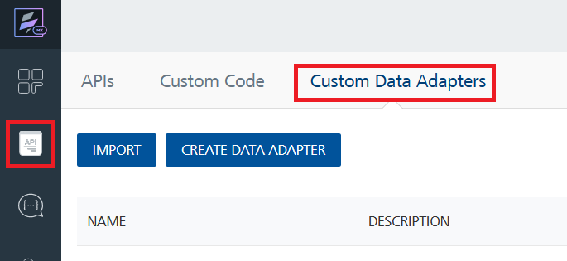

1. Click **IMPORT** to import a custom data adapter.

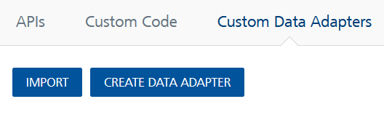

1. On the Import Data Adapter dialog box, click browser to import.

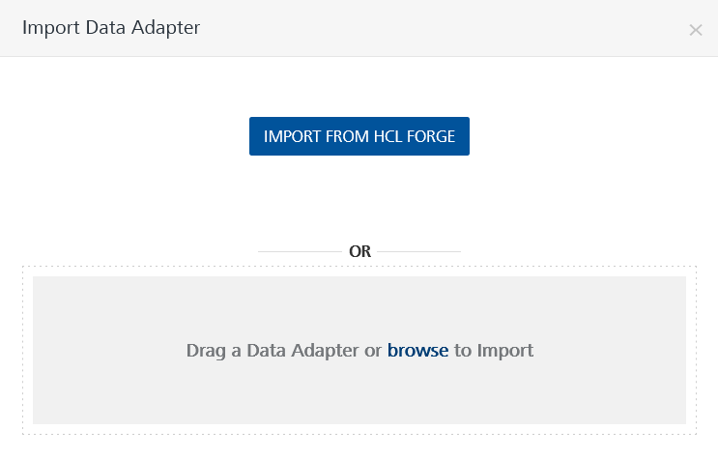

1. Select AI Image Generator API zip file and click **IMPORT**.

After you import the data adapter, Volt Foundry opens a window that shows the metadata of the data adapter.

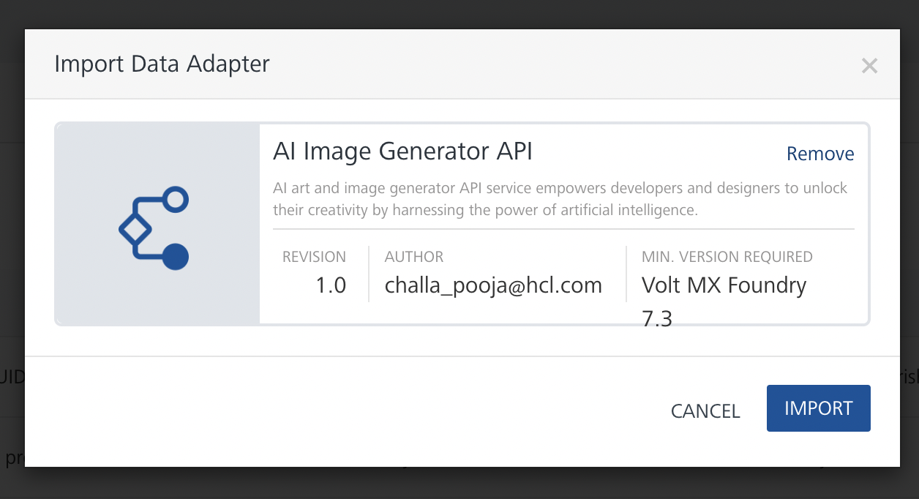

After you import the data adapter, you can view it on the Custom Data Adapters page and use it to create services on Volt Foundry.

## **Creating an Integration service**

After you import the data adapter into Volt Foundry, you can use it to create an Integration Service.

Follow the given steps to create an Integration service using the AI Image Generator API Adapter.

1. Sign in to the [HCL Foundry](https://manage.hclvoltmx.com/).
2. From the left navigation menu, select **API Management**.
3. In **API Management**, select **Integration**.

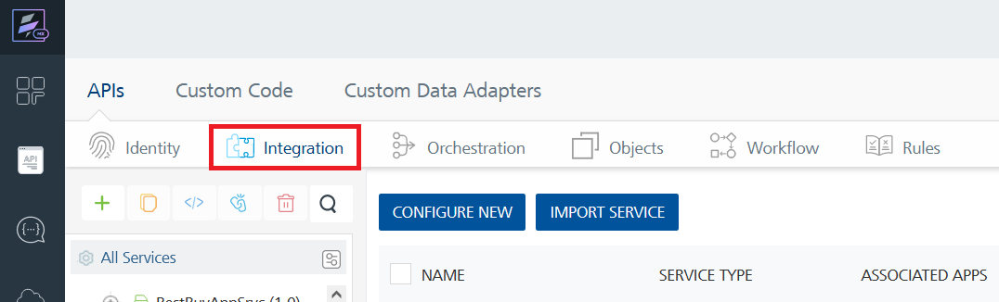

1. To create a new service, click the **+** button or the **CONFIGURE NEW** button.

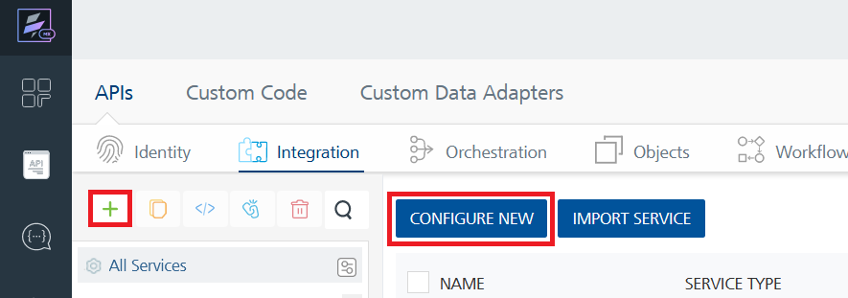

1. On the Service Definition tab, select the service type as AI Image Generator API and click **SAVE**.

Alternatively, you can also create a Foundry app and create an Integration service inside it.

1. **Creating and Executing operations**

After you create an integration service, you can create and execute operations using the service.

#### **Creating an operation**

* In **API Management/Foundry app you created**, in the **Integration** section, select the service that you created.
* After you select the service, navigate to the **Operation List** tab.

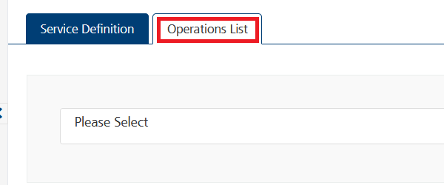

* From the drop down list, select an operation that you want to execute, and click **ADD OPERATION**.

#### **Executing an operation**

* From the **Operations List** tab, in the **Configured Operations** section, select the operation you want to execute.

* On the Operation Page, in the Request Input tab, enter a TEST VALUE for all the fields.

**Request Header:**

**Authorization:** X-RapidAPI-Key, X-RapidAPI-Host [in header]: API Key associated with your RapidAPI account, required for authentication. To get keys – Login in to [Rapid API Account](https://rapidapi.com/sohailglt/api/ai-image-generator3) -> You can view your keys.  
  
* Select a run-time environment and click **Save and Fetch Response** to get a response based on your inputs.

## **Publishing your application**

If you want to use the services in client applications, you need to publish an app to a run-time environment. You can create the service (as described above) in an application or import the service into an application and publish the application.

# **References**

## **Endpoint Documentation**

### **Request Input Parameters for GenerateAIArt_Image operation.**

| **Field** | **Data Type** | **Description** |
| --- | --- | --- |
| prompt | string | The prompt for the desired image or description. |
| page | integer | The page number for paginated results. |

### **Request headers Parameters for GenerateAIArt_Image operation.**

| **Parameter** | **Description** |
| --- | --- |
| X-RapidAPI- Key(string) | [Required] [Header]API Key associated with your account. |
| X-RapidAPI-Host (string) | [Required] [Header]The host parameter specifies the domain name or IP address of the RapidAPI endpoint. In the context of the AI Image Generator, the default host is set to 'ai-image-generator3.p.rapidapi.com'. This parameter is necessary for routing the request to the appropriate API endpoint. |

## **Response Output Parameters for GenerateAIArt_Image operation**

| **Field** | **Data Type** | **Description** |
| --- | --- | --- |
| total | null | Total number of results (null indicates not provided in this response). |
| page | integer | The page number of the returned results. |
| results | array | An array containing image variations with their descriptions and URLs. |

## **Reference Document:** Refer this document[AI Image Generator - Rapid API](https://rapidapi.com/sohailglt/api/ai-image-generator3) for more information.

# **Revision History**

Adapter version 1.0.0:

## **Known Issues**

* No Known Issues

## **Limitations**

* No Limitations