Date : 20-Mar-2024

Accuweather

VERSION: 1.0.1

Overview
AccuWeather Data Adapter allows you to make AccuWeather API calls directly from VoltMX Foundry. You can import the data adapter into VoltMX Foundry. Upon successful import, you can use the VoltMX Foundry console to make the API calls and view the responses by creating and executing required operations.

Use case:
Consider a case of a customer who wants the following services from AccuWeather:
- Get weather forecast of a specified location hourly
- Get weather forecast of a specified location daily.

Features
- Ready-to-use adapter and simple to import.
- Easy to attain details through simple interaction directly from MobileFoundry.
- Flexible to define custom parameters and obtain essential Data specific to the requirement.
In the above use case, you can develop the user interface and functionality of the mobile app using VoltMX Iris. To fetch the search results from AccuWeather, you can use VoltMX Foundry with AccuWeather Data Adapter. In the VoltMX Foundry console, you can create an integration service with the AccuWeather Data Adapter and create operations with the following AccuWeather APIs:
- Get weather forecast hourly with location key: Returns forecast data for the next hour or next 12 hours (depending upon the period) for a specific location.
- Get weather forecast daily with location key: Returns daily forecast data or next 5 days (depending upon the period) for a specific location.
After you create the necessary operations, you can integrate your mobile app with the integration service that you created with AccuWeather Data Adapter.
The following sections help you use the AccuWeather Data Adapter:

Percentage of re-use:
70% (Data can be customizable and customer need to implement UI by themselves).

Getting Started

Prerequisites
Before you start using the AccuWeather Data Adapter, ensure you have the following:
- An AccuWeather account
- An app created in your AccuWeather account
- apikey issued by AccuWeather when you created an app
- A HCL Foundry
- Volt MX Iris

Importing the AccuWeather Data Adapter
- Log on to your HCL Foundry. The Dashboard page appears by default.
- In the left pane, click the API Management menu. The APIs tab opens by default.
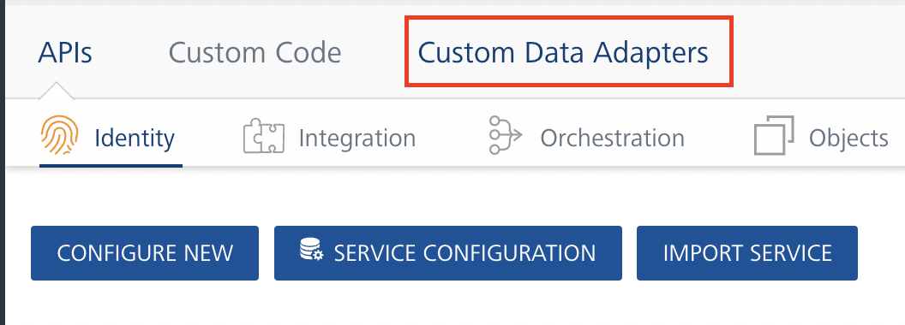

- Click the Customer Data Adapters tab. The Custom Data Adapter page appears.
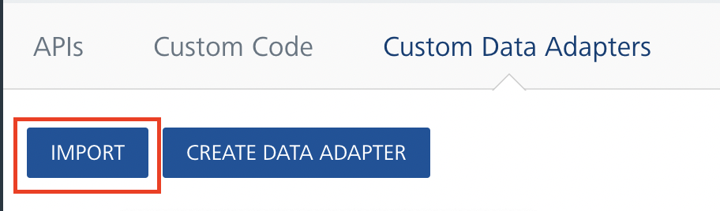
- Click Import. The Import Data Adapter dialog appears. 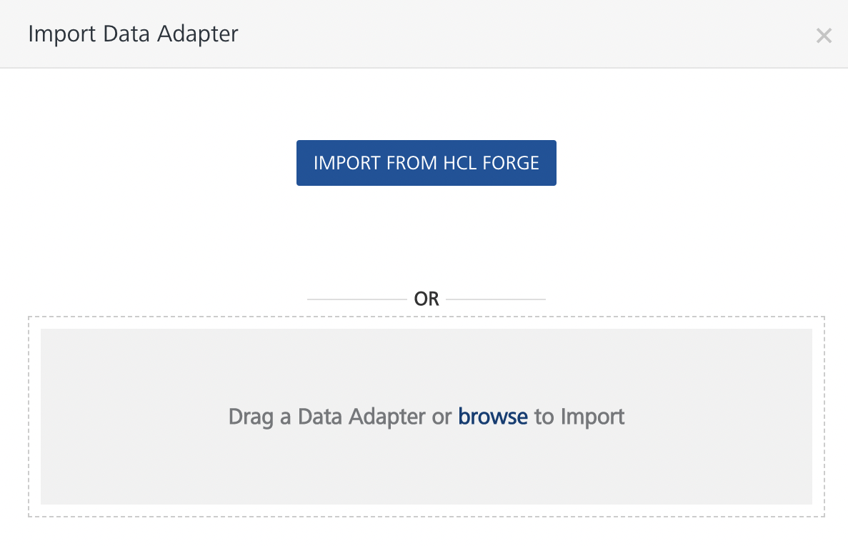
- Click IMPORT FROM HCL FORGE. The Import Data Adapter from HCL Forge dialog appears with a list of available data adapters.
- Find and select the AccuWeather data adapter, and click IMPORT. The AccuWeather data adapter is listed on the Custom Data Adapters page.

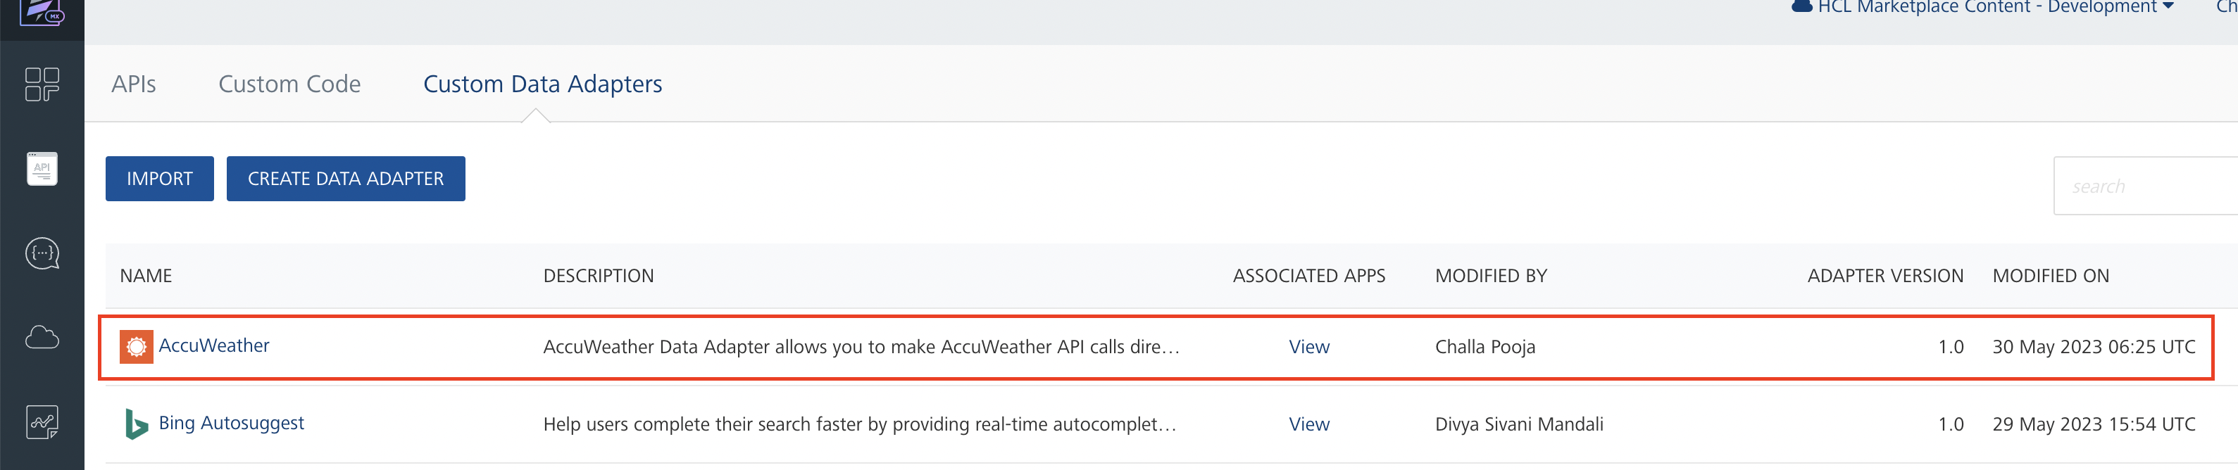

To import the data adapter zip file, do the following:
- Perform steps 1 through 4 in the above procedure.
- Drag the data adapter zip file into the Drag a Data Adapter box.
Alternatively, click browse. The Open dialog appears.
Navigate to the location where you downloaded the data adapter (zip file) on your computer, select the data adapter, and click Open. The Import Data Adapter dialog shows the selected data adapter.
Note: If the selected data adapter zip file is not the one that you want to import, click Remove.
- Click Import. The AccuWeather data adapter is listed on the Custom Data Adapters page.

Creating an Integration Service with AccuWeather
After you import AccuWeather Data Adapter into VoltMX Foundry, you must create an integration service with service type as AccuWeather to connect with your AccuWeather account.
To create an integration service with AccuWeather, do the following:
- Log on to your HCL Foundry. The Dashboard page appears by default.
- In the left pane, click the API Management menu. The APIs tab opens by default.
- Click the Integration tab. The Integration tab opens with a list of existing integration services.
- Click CONFIGURE NEW. The Service Definition tab opens.
- In the Name box, type a unique name for your service.
- From the Service Type list, select AccuWeather.
Note: The AccuWeather is listed only after you import the AccuWeather Data Adapter into VoltMX Foundry.
- In the apiKey box, type the access key provided by the AccuWeather.
- Click Save.
If the details provided are valid, the VoltMX Foundry service connects to your AccuWeather application and allows you to make the API calls.
Refer to Integration Services for more information on creating and using integration services.

Creating an Operation
To make any API call in the VoltMX Foundry console, you must create an operation for the respective API and then execute the operation. Executing an operation involves making the API call and displaying the response. For more information, see Executing an Operation.
This section provides steps to create an operation for the getLocation Key API.
Steps to create an operation for the getLocation Key API
- Log on to your HCL Foundry. The Dashboard page appears by default.
- In the left pane, click the API Management menu. The APIs tab opens by default.
- Click the Integration tab. The Integration page appears with a list of existing integration services.
- From the list of integration services, select the integration service that you have created with service type as AccuWeather. The Service Definition tab of the selected integration service opens by default.
- Click the Operations List tab. The Operations List tab opens.
- Click the context menu arrow to expand the Please Select list. The AccuWeather is displayed.
- Click the plus icon to expand the AccuWeather list.
- Click the plus icon to expand the Services list, and select getLocation Key Searching.

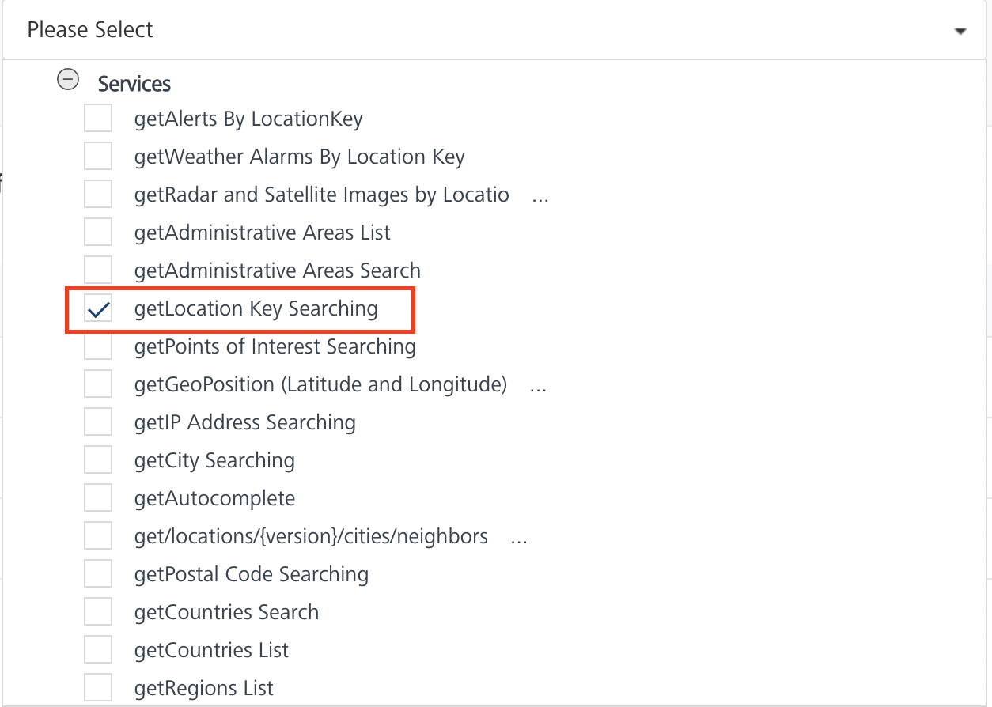
- Click ADD OPERATION. The getLocation Key Searching operation is listed in the Configured Operations section.
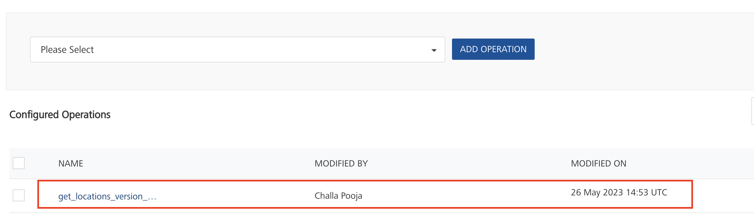
Note: You can follow the same steps to create operations for other methods, but ensure that you select the required API.
You can create multiple operations with required APIs and save them in the Configured Operations section. You can then execute the operations when ever required.

Executing an Operation
Executing an operation involves making the API call by setting the necessary parameters and displaying the response. The procedure to execute any operation is same, but the request parameters of the APIs vary. For more information on request parameters of each API, refer AccuWeather API Catalog.
This section provides steps to execute the getLocation Key Searching operation (explained in Creating an Operation).
Steps to execute the getLocation Key Searching operation:
- Log on to your HCL Foundry. The Dashboard page appears by default.
- In the left pane, click the API Management menu. The APIs tab opens by default.
- Click the Integration tab. The Integration tab opens with a list of existing integration services.
- From the list of integration services, select the integration service that you have created with service type as AccuWeather. The Service Definition tab of the selected integration service opens by default.
- Click the Operations List tab.
- Under the Configured Operations section, click the getLocation Key operation. The getLocation Key tab opens with the Request Input sub-tab opened by default.
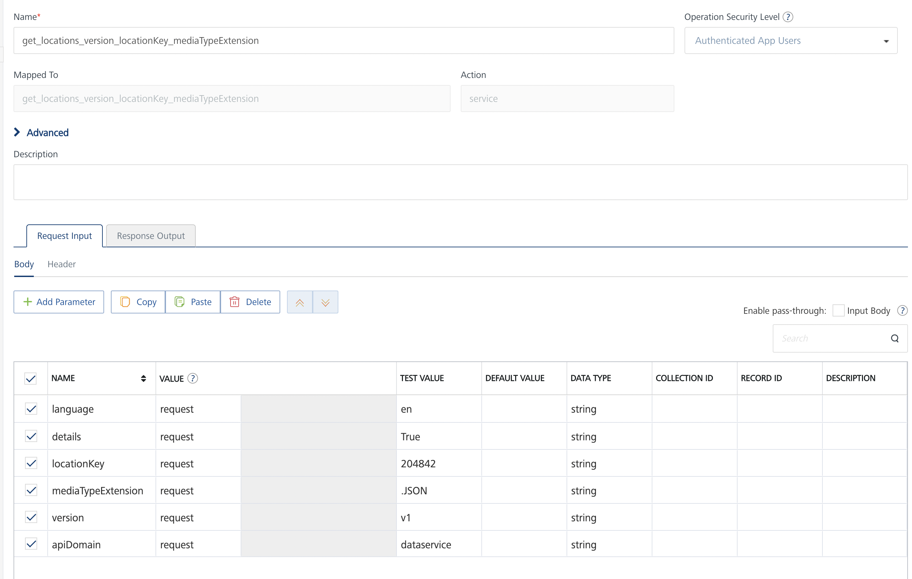
- In the Name box, the name of the operation is displayed by default. If you want, you can change the name.
- On the Request Input tab, in the Body section, for the following parameters, specify the values in the respective boxes under the Test Value column.
  - language: specify the language to return the resource.
  - details: Boolean value. Specify the value as true to include all details available in the specified location name in the response. Specify the value as false to retrieve no data.
  - apiDomain: Specify the value as dataservice.
  - locationKey: Provide latitude and longitude seperated by a coma.
  - mediaTypeExtension: Provide the value as .json.
  - version: Provide the value as v1.
- Click Test and SAVE AND FETCH RESPONSE. The Output Result dialog appears with the response.
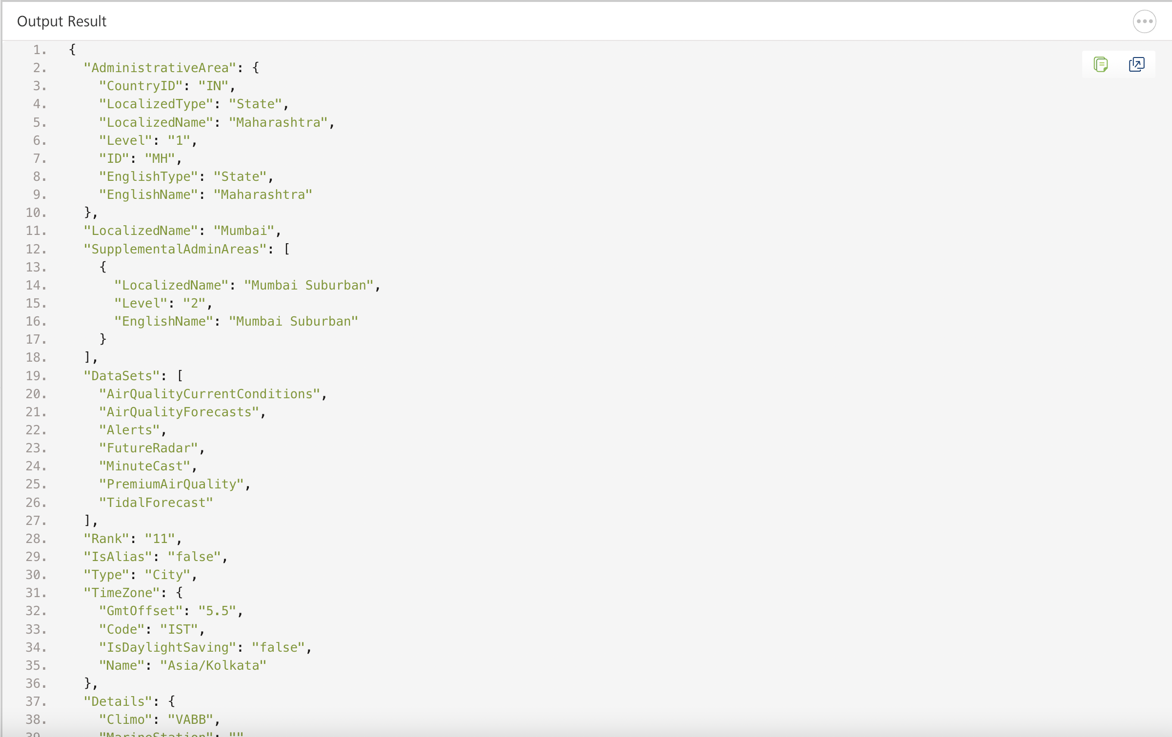

Publishing the App in VoltMX Foundry
After adding the AccuWeather Data Adapter to your app and configuring the necessary configurations, you must publish the app to VoltMX Foundry. For more information, refer to Publish a Project to VoltMX Foundry.

Revision History
App version 1.0.1:

Known Issues

N/A

Limitations

N/A

